Southwestern Business College
NEWSLETTER ASAR 2078
INDIVIDUAL FOCUS SERIES—3RD of 2078 (CORONA SECOND ROUND)
Dr. Jayahari Raj Pandey
There are good news and bad news. Life has again started to move forward- the momentum gathering speed slowly. It has provided new hope to all that we will not face the scenario like previous time since we are experienced now and we will not repeat our previous mistakes.
Bad news is of the new variant. There are several accounts and news items relating to Delta variant. An example can be of the following headline which appeared on 21st July 2021: “Delta variant accounts for 83% of new cases in US, CDC director says”.
People are extremely worried since Delta variant is assumed as the most transmissible one of the variants till-date. It is also suspected, though without enough research, that Delta may also be able to partially evade the antibodies made by the immune system after a corona virus infection or vaccination.
New information is pouring in constantly. Now, comparatively larger percentage of the population seems to have realized the necessity of vaccination. There are information on the variations and workings of different vaccinations in terms of ‘ how certain vaccination works?’, required doses, age one can have it, ‘ when to speak with the Dr.?’, side effects, costs, initial trial effectiveness, ‘ when to seek medical attention?’ etc. They have helped a lot to us in being aware of all the related aspects of the available vaccines, determining the related courses of actions to be taken, as well as maintaining preventive courses of actions at all times ( vaccine or no-vaccine).
Amid this general scenario, we all are trying to readjust ourselves seeking possible extents with feasible adjustments. Relatively, in the front of education, our University is clear in terms of the modalities set for the colleges to follow while conducting online classes, and we are strictly pursuing all of the suggested guidelines. Most of all, the weekly report being sent to the University with the information on all the aspects of the daily happenings including the number of classes, the students’ attendance, examinations, other activities etc. are the solid examples of effective monitoring for all. Here, it will be mentionable that our University had shown its far-sightedness last year through circulation of guidelines of online classes to all the colleges almost six months before the actual online class date due to which the colleges were able to arrange the necessary preparation well on time. We all can very well understand that the guidelines had to be challenging for the colleges who were the implementers of the guidelines and for the monitoring body (the University) who could ensure that the college had met the criteria. In a way, the guidelines and the set criteria had to be the measuring instruments of the number of classes, their durations, status of the courses, students’ presence and their patterns, internal examinations, presentations, and other activities.
It is a widely accepted practice that quality in all the streams or projects comes out from the maximum efforts from all involved, and in an affiliation-related adventure like ours the governing rules and inregulations need to be effort-initiating and result-producing. The effort-maker should be able to clearly see the rationale behind the rule due to which the situation of getting frustrated by the unnecessary rule or seeking some excuse of non-performance get vanished. Presently, all stake holders in the forms of effort-makers seem to have found the new mechanism working silently but smoothly. The management people are in the college premise ensuring the smooth running of the classes; monitoring them; fulfilling all the academic roles as usual including being in contact with all the students as well as being fully watchful towards the entire happenings, conducting exams and declaring results on time, implementing all the calendar-based activities on time, fulfilling other intra-coordinating roles (between students and teachers, students and University etc.), and maintaining the records as well as preparing/ submitting reports. The students are, as in other times, attending the classes, giving presentations on the established style of schedule, maintaining note-copies fully meeting the established criteria of regular checking by the respective Faculty member/s, participating as well as giving healthy involvement in the activities based on the annual academic calendar ( many of which are in virtual format excluding those which is also recommended in the present context like hiking etc.), and appearing in the term examinations. Similarly and significantly, the Faculty members are taking their respective classes fully utilizing the avenues provided by the ‘virtual-education-providing system’ and ‘online learning platform’ – all as experts. All these are contributing towards restricting a situation that has happened recently in California, USA as reported by a famous magazine- as given below

“Unvaccinated teacher infected half her students with Covid, CDC finds | Coronavirus | The Guardian
Teacher read to class without a mask despite Covid symptoms and infected 26 people at California elementary school” – reported in TradeBriefs International dated 30th August 2021.

Right now, in the second year of our semi-shift to online system of education, it can be believed that the education providers (the Universities, the Schools/Colleges, and other institutions) have shown their dynamism in giving true value towards the education sector. Notwithstanding, the Government is very keen in this subject not only by providing various supports and decisions but also by entering into various kinds of value-based and quality-based understandings with international bodies and countries. One recent example is the Government’s $60 million agreement with the World Bank to improve Nepal’s higher education sector. A statement made in this regard by the Finance Secretary might make it clearer:

“Investing in human capital is a key priority of the Government of Nepal to help young people in Nepal realize their development potential,” stated Mr. Madhu Kumar Marasini, Finance Secretary. “This project supports the government’s focus on recovery from the COVID-19 pandemic by strengthening the higher education sector and ensuring students all across Nepal including those from disadvantaged groups have access to quality education amid the pandemic’s challenges.”

==================================================================================

SPEECH COMPETITION: 2078/ASAR/04
TOPIC: EFFECTIVENESS OF ONLINE CLASS IN NEPAL
5th Semester
Participants of First Round
Pawan Neupane, Ashma Rai, Sushmita Shahi, Sushmita Panjiyar, Sangam Acharya, Laxmi Sherma
The considering points while judging the over-all aspects of the speech were ‘command on language and voice, fluency, expression throughout the period, time management, segments of the contents, total contents, other niceties such as starting and ending style’.
The Result will be declared after the conclusion of another ROUND. | ( The students were sent Individual notes with comments and suggestions)
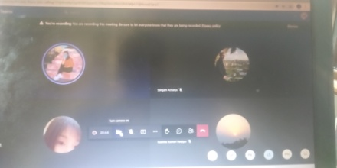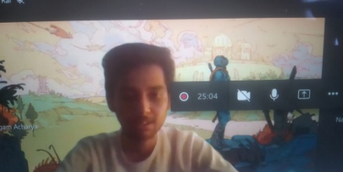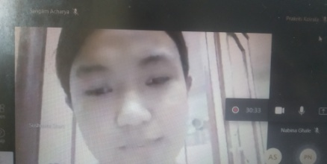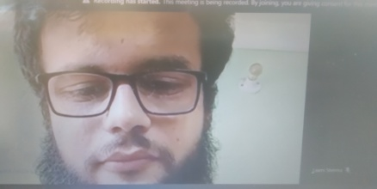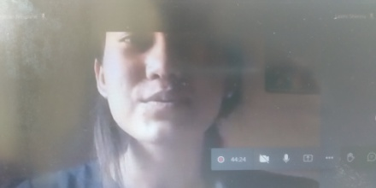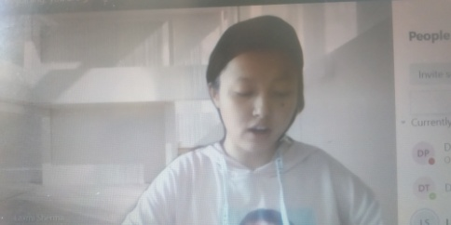
===================================================================================

SANITATION PROGRAM : Asar 6, 2078 (20th June 2021)
1st Sem: PARTICIPANTS: ABHASH LAMICHHANE, BIBIDH KHATRI, BINAYA THAPA MAGAR, NIRMALA KHADKA, NISHA CHHANTYAL, POOJA LAMA, SUSMA LAMA, POOJ THAPA MAGAR, MANASHI ADHIKARI, AASTHA KARKI, GHANENDRA K PANJIYAR, PRAKRITI BHATTA, REEYAZ MANANDHAR, ROSHNI NEUPANE, RUBINA SUBBA, SAISA KOIRALA, SUVANI SINGH, ANJILA RAI, AMISHA TAMANG
Guest Speaker: PRAMILA KARKI; Nurse, Social Activist.
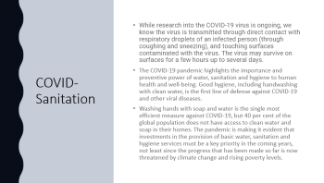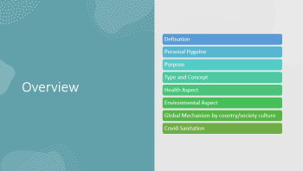
The Program met the objective of educating all on the basic aspects of cleanliness and hygiene which was more relevant at the current phase of Covid 19 – even to those with Asymptomatic situation. The presenter’s vast experience and ability to put stress on the most needed issues were praiseworthy. Initially, we were confused by the lack of interactions (expected from the students’ side). Later, feedbacks from the students confirmed our assessment that many of the information were new as well as they had been put in an understandable manner.

INDUSTRIAL VISIT  3rd SEMESTER | ASHAD 11TH
DELTA AIRLINES | USA

Management learning has, since long, begun an approach of Holistic erudition with the target of taking the students out of four walls.
Objective:
1. Experience through talking with experienced people
2. Learning through sharing from directly involved people
3. Exposure through seeing the Reality
In the same regard, our College has this set practice of letting our students have an insight into the real world of corporations, Business, and Industries. We have given continuation to this practice in the present situation also through presentation of the Tour in the Virtual Mode in line with the best practices being accomplished around the world. In a way, it had the comparative advantage of being able to visit the highly famous Industry in the world the Tour of which was prepared with the involvement of Top Class Experts and Technologies. It was prepared in 360 visibility mode.
Participation:
Seema Bhurtel | Anju Ghale | Manisha Timalsina | Usha Chhantyal
Rachana Pokharel | Pooja Biswakarma | Salina Pyakurel | Jharna Gurung
Dinesh Bhandari | Kanchan Shrestha
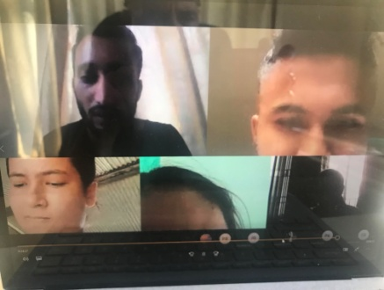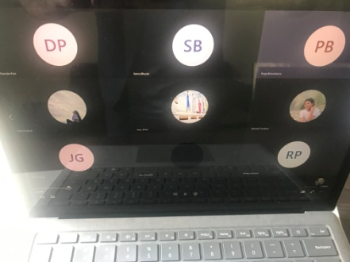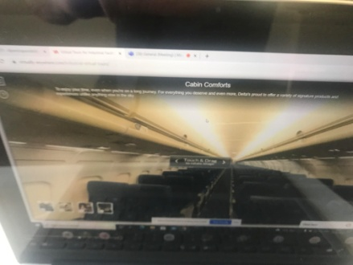
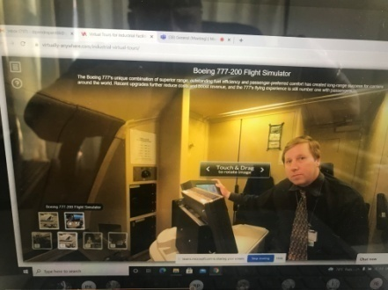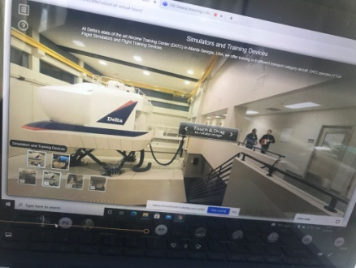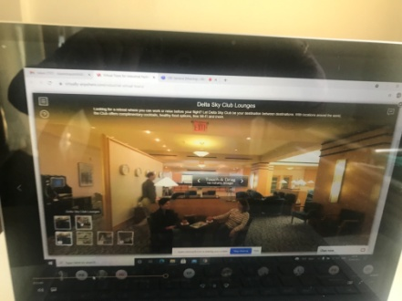
Participants were suggested, later, to develop three slides of their own on “most striking aspect?”, “lesson learnt?”, and “Conclusion”.
PRESENTATION Competition : 5th Semester: Date: Asar 13, 2078 (27th June 2021)

Competition on Presentation: IMPACT OF DIGITAL MEDIA ON SOCIETY
Preamble
Our College has been organizing this competition since beginning. The objective is to make our students competent in Presenting other issues than the course contents.
Introduction
Presentation involves simply two sides of the same coin: (a) Put the intended materials in the slides (b) be able to deal the slides effectively
Participants
AASMA RAI, RONISHA SHRESTHA,
Following are the slides presented by Aasma Rai ( First Round):
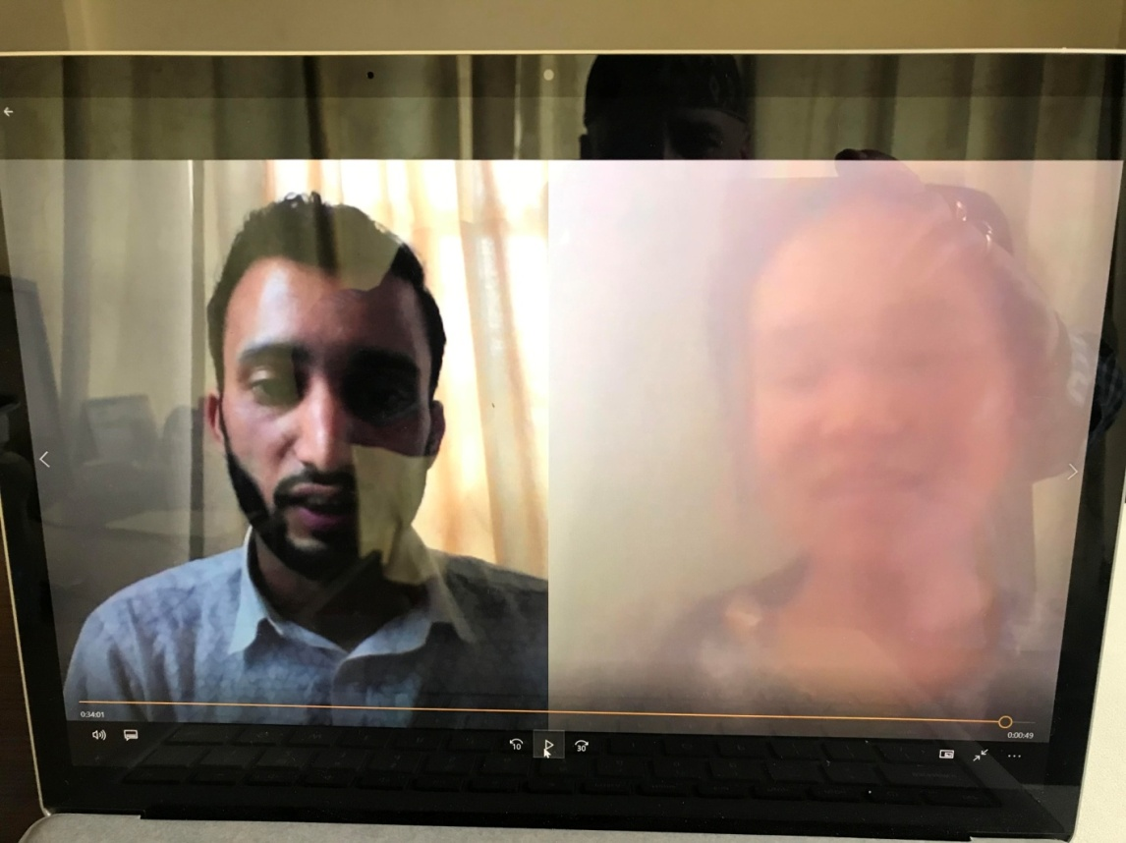

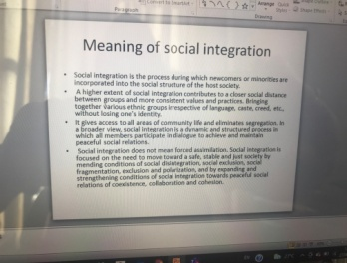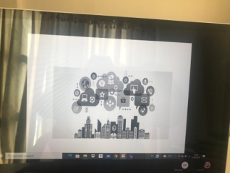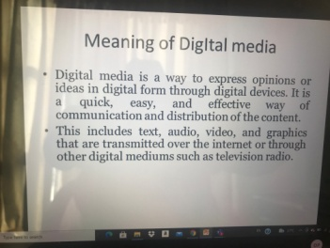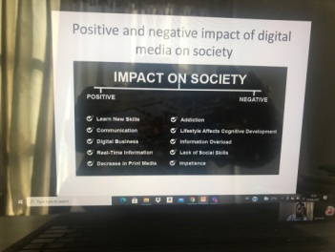
The slides were able to cover the matter in a brief but desired way. The choice of relating the slides on the exact meaning of the two sides of the subject ( Digital media and social integration) and then showing the two sides of the Impact ( both Positive and Negative) were praiseworthy. She was able to elaborate on each slide.

( The Result will be declared after completion of all the rounds)
Quiz Competition: 3rd Semester: Date: 2078.03.03 (17th June 2021)

GROUP-A  1st POSITION | GRPOUP-B  4th POSITION | GROUP-C  3rd POSITION | GROUP-D  1st POSITION
Anju Ghale  Dinesh Bhandari  (6 Points) | Nabin Poudel  Pooja B.K.  ( 3 Points) | Rachana Pokharel  Salina Pyakurel  ( 4 Points) | Sujita Baniya  Usha Chhantyal  ( 6 Points) | NOTE: Total number  of questions= 30;  Total round = 6
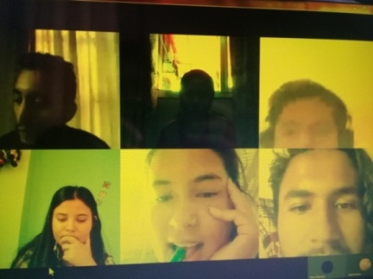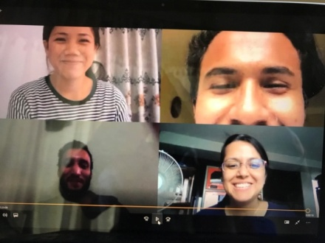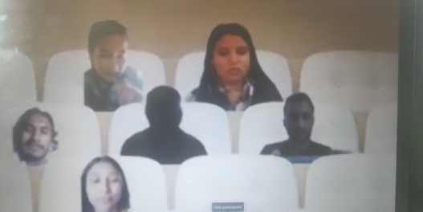

INDUSTRIAL VISIT  1st SEMESTER | 15th ASHAD 2078
DELTA AIRLINES | USA

Preamble: The visit organized for the Third Semester earlier this month was also repeated for the First Semester. Third semester students had the previous experience of Industrial Visit in the Physical mode due to which we had not to relate them about the main objective.
Subject Information: Delta air lines, Inc., typically referred to as Delta, is one of the major airplanes of the United States and a legacy carrier. It is headquartered in Atlanta, Georgia. The airlines, along with its subsidiaries and regional affiliate, including Delta connection, operates over 5,400 flights daily and serves 325 destinations in 54 countries on six continents. Delta is founding member of the SKY TEAM AIRLINE ALLIANCE.
Main Objective:
Make them understand that: People will forget what they are told, they might remember what they are shown, but they will learn if they are involved. Such visits have the effects of all these three segments of teaching.
Objective:
1. Experience: conversation with skilled people
2. Learning: tips from directly involved people
3. Exposure: being in the Reality
Participation:
RIYA RIMAL | NISCHA CHHANTYAL | REEYAZ MANANDHAR | ALISHA BARAL
AAYUSH SHRESTHA | POOJA LAMA | RUBINA SUBBA | PRAKRITI BHATTA
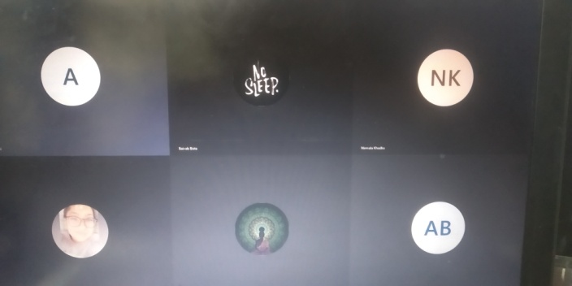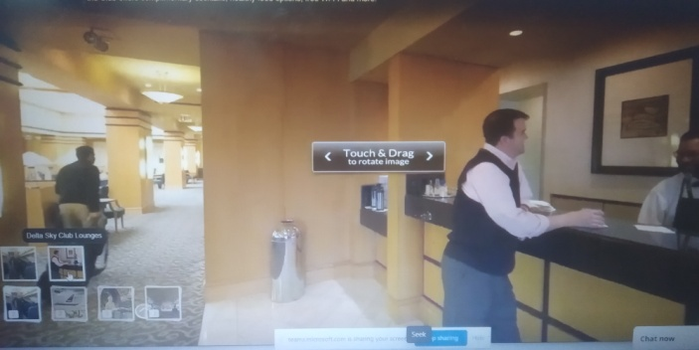

Participants were suggested, later, to develop three slides of their own on “most striking aspect?”, “lesson learnt?”, and “Conclusion”.

ACTIVITY NAME  Guest Lecture | PARTICIPANT NAME
Date: 2078-03-25, Friday at 2: pm.  BBA- 3rd Semester  Guest Speaker: ANIL KHADKA, BANKER. NEPAL BANK LIMITED. | - ANJU GHALE  - DINESH BHANDARI  - MANISHA TIMILSENA  - NABIN POUDEL  - POOJA B.K  - RACHANA POKAREL  - REJINA DAHAL  - SALINA PYAKUREL  - USHA CHHANTYAL  - USHA POKHAREL  - USHA THAPA  - SUJITA BANIYA
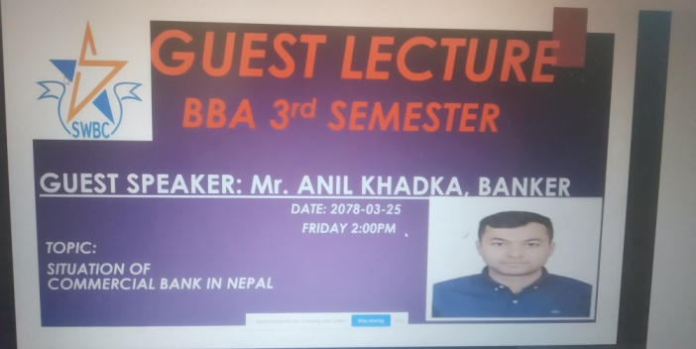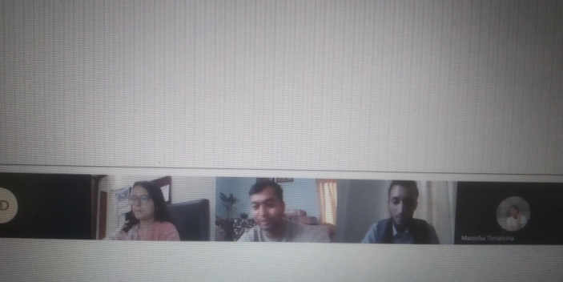
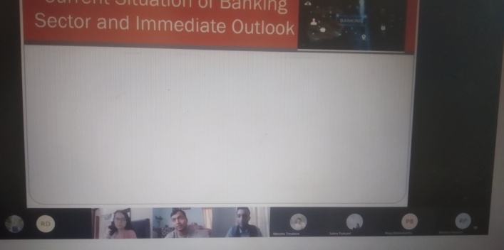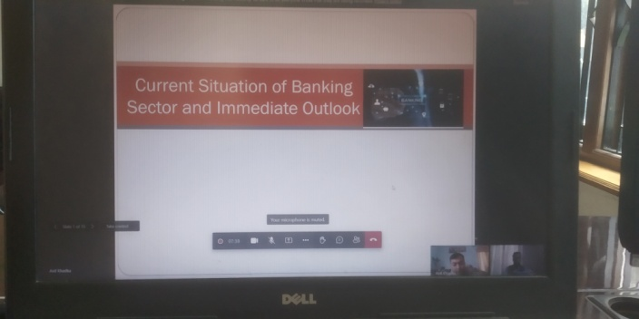
After welcoming the Guest Lecture, Branch Manager of Nepal Bank Limited, the significant session started. It covered the current aspects of Banking in our country which was the situation in the midst of the ongoing pandemic situation. It concluded on the chance of liquidity crunch in the days to come.
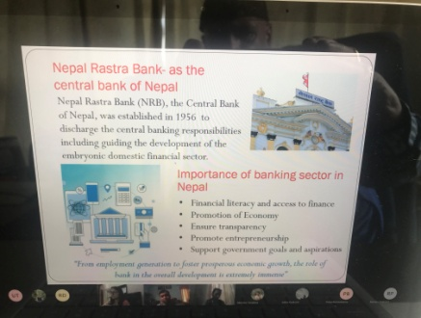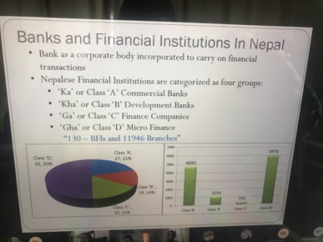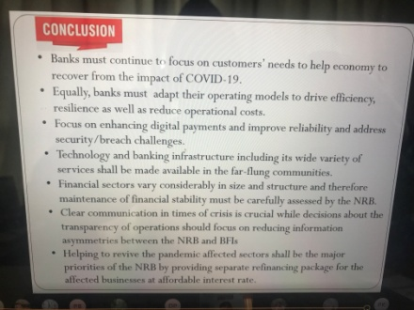
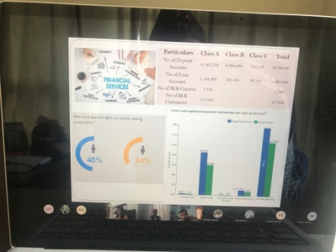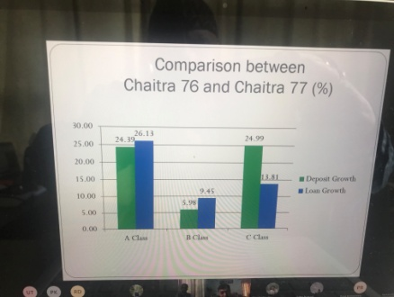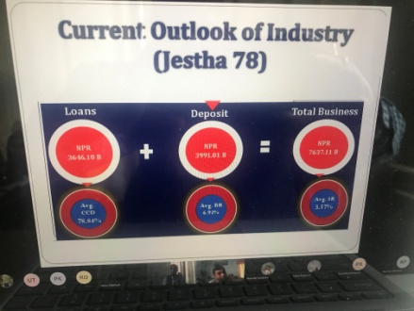
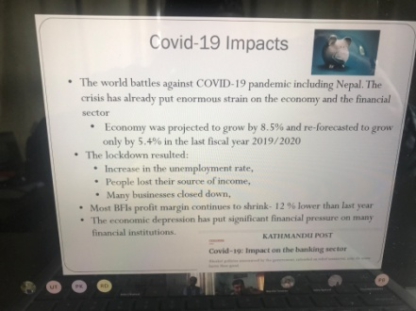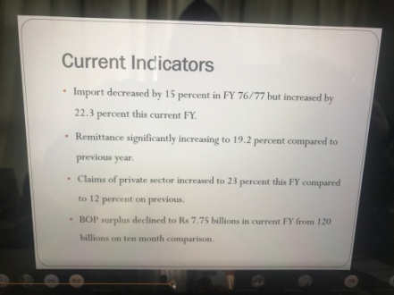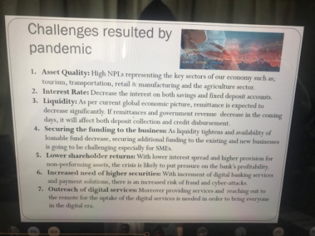
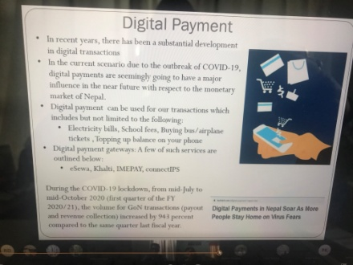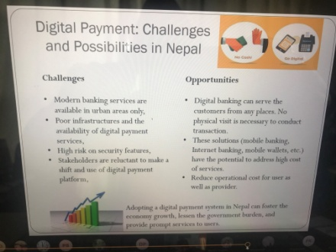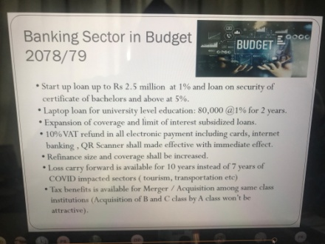

TOUR (Virtual) PROGRAM
Date: 2078.03.23 (7th July 2021), Wednesday Time:12.30 pm - 1.30 pm GUIDE: Dipendra Panta Medium: Virtual ( Zoom)
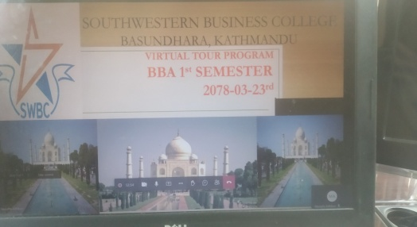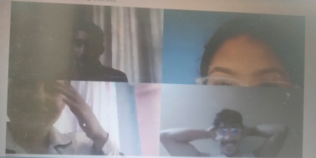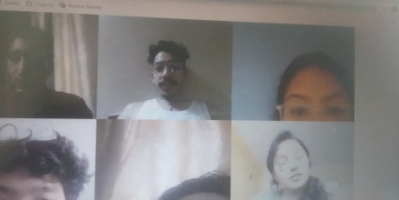
A brief description of the TOUR BY: Prakriti Koirala, Vice Campus Chief
The Tour, in realization of the present pandemic circumstances, was organized keeping in mind the month-wise calendar of activities which did not permit skipping. However, some completely impossible activity could be postponed. We are in this situation comparable to epidemic since last one and half years, and the long time span has also brought out other modes (online-based) of accomplishing things.
The Tour selected was of TAJ MAHAL- the famous Agra based historical site. The slides, prepared effectively in 360 visibility mode, covered the entire outside area and view as well as each nooks and corners of the Palace. The Guide, after describing about the total route to reach there ( Kathmandu, Bhairahawa, Gorakhpur and then Agra) connected the Tour with its history related with Shahajahan who was the fifth Mughal emperor of India ( reigned from 1628 to 1658) and who had built Taj Mahal and entombed his wife Mumtaz within it. The reign of Shaha Jahan, the grandson of renowned Akbar Badshah, is considered as the golden age of Mughal architecture.
Participants
1. | AAYUSH SHRESTHA | 2. | PRAKRITI BHATTA | 3. | AMISHA TAMANG | 4. | PUJA THAPA MAGAR | 5. | ANUSKA CHAND THAKURI
6. | ASTHA KARKI | 7. | REEYAZ MANANDHAR | 8. | RUBINA SUBBA | 9. | ASTHA SUBEDI | 10. | SARITA DANGOL
11. | BINAYA THAPA MAGAR | 12. | SUSMA LAMA | 13. | GHANENDRA K PANJIYAR | 14. | ROSHNI NEUPANE | 15. | ICCHA TAMANG
16. | DIKSHYA TAMANG | 17. | MANASHI ADHIKARI | 18. | POOJA LAMA

