Southwestern Business College
NEWSLETTER SHRAWAN 2078 INDIVIDUAL FOCUS SERIES—29
Dr. Jayahari Raj Pandey
Time 100 was declared recently. The 100 most influential people of the world of 2021 were categorized under the titles of ICONS, PIONEERS, TITANS, ARTISTS, LEADERS and INNOVATORS. Started more than 18 years ago, the Time list has served to quench the appetites of the people around the world of knowing the remarkable personalities of the year. In a right way, the list of hundred personalities identifies the contribution made through various measures and the achievements made by them. People get enthused or motivated in many ways, and success stories are always attractive.
The topic centered on this aspect in this issue mainly because I was very recently in a program organized for the young entrepreneurs where many of the present youngsters thought it wise to bring the stories of the successful business personalities into analysis and discussion. Most of the participating entrepreneurs were students of BBA or MBA who either were already involved into something or were on the brink of a start. Though the information provided by the participating students on the famous/ successful personalities were of second-hand, the discussions on them were very positive. Of course, in a gathering like this there is always the room for other types of talks and queries. Here also, some of the topics were gambling through online, or money made in the song industry of India, or share markets. However, they were sidelined. I have found it worthwhile to put some of the names out of the Time’s list and the topics covered about them in our gathering.

Tim Cook is the CEO of Apple Inc. After MBA and a 12 years career in IBM, he had joined Apple in 1998 as a vice president (in between he was at Compaq Computer Corp. as vice president of Corporate materials for six months). We know that he had become CEO in 2011 after Steve Jobs. Now, the discussion centered on the abilities of the person, and the circumstances under which the person succeeded. In Cook’s case, he did have the ability to take the challenge. Then, the Company was not in good shape and it had been losing sales since long at that time. A few months before Cook joined Apple, Michael Dell (founder and CEO of Dell Computer) had responded “I’d shut it down and give the money back to the shareholders” when he was asked what he would do to fix Apple. But, immediately after joining Apple, Cook was able to make the Company see profit. Moreover, within 9 years since he took over the role of CEO, he was able to double the Revenue and Profit of the Company as well as increase the market value from US$ 348 billion to $ 1.9 trillion. Now, there were many analysis which surmised as the person being visionary on what people wanted, where the Company should focus on, and what were the corrections needed within the Company, its products, its channels, and its deliveries. None of the things attributed to him could be denied since the delivery was continuous. An upward graph for nonstop ten years is not a small thing, and that does not happen without firm grip on the required inside and outside mechanisms of the whole picture.

Jensen Huang is the CEO of Nvidia which is a well-known brand in the gaming industry. The discussions on this person centered mainly on his genius aspect. The Company’s work of enabling AI through neural networks was highly acclaimed. All participating in the discussion was talking about how Artificial Intelligence was able to give the world a new face and what more could there be. And it is due to the hardware which was made possible by Huang. There also was reciting of a quotation, as follows: “Huang’s gamble paid off largely because he is among the world’s most technically savvy CEOs.” There was also a discussion on what exactly is meant by a savvy CEO. A fictitious narrative story was able to present a suitable depiction. A farmer, once, was digging his field when suddenly he finds a stone. Impressed by the uniqueness of the stone, he fastened it on the neck of his bull. While returning home after work, he meets a vegetable hawker who also was going back home after the day-long work. The hawker asks the farmer the reason of hanging the stone on the neck of the bull. The farmer tells the truth upon hearing which the hawker offers Rs. 100 for the stone since he wanted to wear it on his neck. Farmer gave the stone willingly in exchange of Rs. 100. Next day, the hawker was sitting in front of his small shop, when a regular vegetable buyer saw the stone. The buyer was a jeweler and he instantly knew that it was a diamond. He started a small talk, and asked how much he paid for the stone. The hawker told him the truth, and the buyer could know that the hawker didn’t know the value of the diamond. He, not disclosing the reality of the stone, showed his own interest and wanted the stone for which he offered Rs. 300. Sensing that the buyer was really interested and he could get a few hundreds more from him, the hawker told the buyer that he will give in Rs. 500 only. The buyer thought that today he will do nothing, and tomorrow he will try for Rs. 400 and if needed will buy it in Rs. 500. During another hour or so after that, there were many customers many of whom also took notice of the stone, and some praised it and some tried to buy it in little more amount than the price hawker had paid for it. Then there was another jeweler who instantly recognized it, talked about it, and when he found out that the hawker wanted Rs. 500 for it, paid the amount and got the diamond. Next day, the first jeweler came at his usual time, and was shocked not seeing the diamond on the neck of the hawker. He was angry after knowing that somebody paid for it and got it. He hissed: “You Fool! Do you even know what you have done? You have sold a real diamond worth tens of thousands of rupees for just 500”. The hawker replied: “I am not a fool since I didn’t know its true value! It was a stone for me, and I sold it with Rs. 400 more than what I had paid for it. Rather, you are a fool since you left it trying to enter into a bargain just for 200 even knowing its true value!”. Exactly! The first jeweler did have a practical knowledge and was shrewd, but he could not make good judgment! The second one had also both the two qualities, and he had the ability to make good judgments!

Elon Musk is the CEO of Tesla and also CEO/ lead designer of Space X. During the time of discussion on this visionary entrepreneur, it could be felt that the students had keen interest on him as they knew about his involvement as the founder of Neuralink and the Boring Company as well as the co-founder of PayPal. They also knew about his successes through Zip2 and X.com at the young age. Some even told that it was the matter of genetic factor since his mother was a successful model and nutritionist, his father was an engineer, his brother is a venture capitalist and environmentalist and his sister is a well-known producer and director. There was one student who pointed out that Musk had been able to show that there is no need for a person to be successful to remain in only one area. Many were found to have the view that Musk did not care about what others say since he was successful in varied areas like PayPal, Tesla Motors, Solar City, and Space X. There was another student who was curious as regards why Musk was in favor of establishing human settlement on Mars.

Adar Poonawala is the CEO of Serum Institute of India. Success of a young person of around 40 years to this scale always arouses excitement among the people and that too especially among the youths. During the discussion, it was made known to all that after coming back from England upon completion of graduation, Adar had joined his father’s Company (the same). He came into the limelight in 2020 amid the pandemic challenge when he was able to tie up his company with AstraZeneca and manufactured the Anglo Swedish drug-maker’s vaccine (developed with the Oxford University) in India. Among the present youths, some talked of the size of the company which was owned privately. There were even talks on Sharon Stone Charity, race horses, sports cars, and private jets etc. which were the symbols of success as well as interesting subjects for gossips. On the subject of how he was regarded as very successful one student pointed out that Adar has been able to change the course of family business. He had added: had he not something, he would have been satisfied with what his father was doing. During the phase of agreement one added: ‘the company will become the largest manufacturer of vaccines in the world”.

Luiza Helena Trajano is the Chairman of the Board of Directors of Magazine Luiza. She is a Brazilian Businesswoman who was known as the richest woman of the country last year. Apart from many companies she is related with retail national magazine Luiza. It is now a retail giant. There were discussions on her ability to transform a small chain of stores into a big company. Significantly, there were also talks on how effectively she helped small business entities to be able to adapt digital commerce in the midst of pandemic.
Today’s theme can be said as centered on the area being closely watched and followed by the entrepreneur minds. Due to the increase in such exposures and availability of exchange of ideas and healthy sharing, we can see the multiplication in the number of new entrepreneurs.
There is another side as well, and that is the workforce or human capital. Hence, before finishing the main topic, it would be worthwhile to also know about other main issues that revolve around the heads of many of the youths. And the issues are salaries and salaries. There were curiosities as regards Fresher’s salary for a BBA degree holder. And there were many answers. Some of the answers are: Fresher’s salary, generally, are low, but the increase in the salary or rather jump is determined by an individual’s skills, location, execution of roles, and a few other factors based on situation and the company. Individual’s skills and ability of execution of roles largely depended on the exposure the student had during her/his college years. In other words, the college always has a great role in transforming the student into a real BBA degree holder. BBA degree is a challenging degree in the sense that the corporate world can’t go ahead without BBA degree holders and by BBA degree-holder we mean such person who has both theoretical and practical knowledge of the business world.
HIKING PROGRAM Shrawan 30, 2078 (14th August 2021), Saturday
By Prakriti Koirala, Vice Campus Chief
PARTICIPANTS:
Prakriti Koirala, Sudarshan Jammarkattel, Anisha Shrestha, Dipendra Panta, Salina Pyakurel, Anju Ghale, Rachana Pokharel, Seema Bhurtel, Shusma Lama, Pooja Lama, Pooja Thapa Magar, Sarita Dangol, Reeyaz Manandhar, Abhas Lamichhane, Manashi Adhikari

It was a covid 19-related program. We had organized an awareness Program on Covid-19 as early as November 2019 when the news of its spread across Europe surfaced. Then, it was a Walkathone program in which students and college staffs took a ‘round – walking’ clad with T shirts ( especially prepared for the same program and distributed to all) with Covid-19 related messages on both sides of the T shirts, and distributed pamphlets on ‘what to do and what not to do’ as a precautionary measure. This Hiking Program was the second one of the Covid-19 series with the similar objective of educating all on the health aspects closely related with the virus. By now, we all know that this virus has direct connection with our immune system, and hiking is one of the best exercises for the immunity. We had opted for this form because of the fact that there is a chance of lower risk transmission in outdoor space. Of course, we had taken the precaution of avoiding large-gathering-possible place, and the mask wearing was made compulsory.

Place: Tarakeswar, Kathmandu ( Route: Basdundhara, Machhapokhari, Dhaneswar, )

- To reach the Base of the hiking place, it took half an hour from Bashundhara
- The hiking took around 3 hours to reach the famous Temple

QUIZ COMPETITION: FIFTH SEMESTER
DATE: 2078/04/18
GROUP OF PARTICIPANTS | POSITION
GROUP- A  - NABINA GHALE  - DEBINA THAPA | TOTAL QUESTIONS ASKED= 5  TOTAL RIGHT ANSWERS = 2  GOT 4th POSITION
GROUP-B  - SOBIT PANTA  - MANITA RANABHAT | TOTAL QUESTIONS ASKED= 5  TOTAL RIGHT ANSWERS= 3  GOT 3rd POSITION
GROUP- C  - AASMA RAI  - SUSMITA K PANJIYAR | TOTAL QUESTION ASKED = 5  TOTAL RIGHT ANSWERS= 2  GOT 4th POSITION
GROUP- D  - ANUPA BISHWOKARMA  - LAXMI SHERMA | TOTAL QUESTION ASKED = 5  TOTAL RIGHT ANSWERS= 4  GOT 2nd POSITION
GROUP-E  - SANGAM ACHARYA  - SAGAR KHADGI | TOTAL QUESTION ASKED=5  TOTAL RIGHT ANSWERS= 5  GOT 1st POSITION

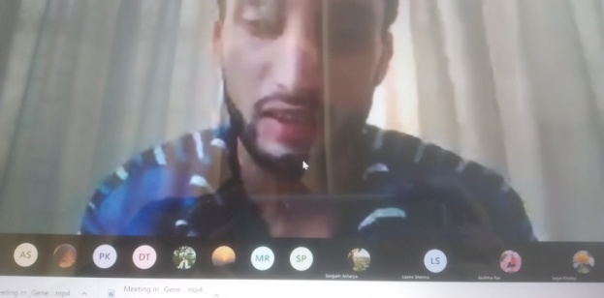
AGENDA OF THE PROGRAM:
- WELCOME to Students and staffs
- BRIEF INFORMATION ABOUT THE PROGRAM with emphasis on the rules
- QUIZ COMPETITION START (GROUPS)
- Declaration of the positions
- ADJOURNMENT

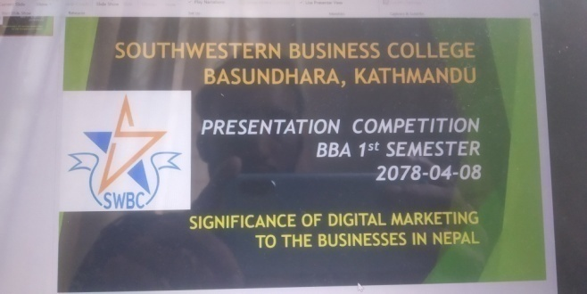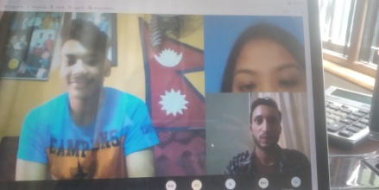
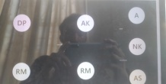
Participants:
- Riyaz Manandhar 2. Astha Subedi
- Astha Karki 4. Nirmala Khadka
5. Riya Rimal 6. Sushma Lama
It was an information-sharing program in which the participants were told about the essence of presentation on subjects related with every-day life.

DATE: 2078/04/06
PRESENTATION COMPETITION: THIRD SEMESTER
TITLE: Problem Faced by Businesses in the Current Situation
AGENDA OF THE PROGRAM:
- WELCOME
- BRIEF INFORMATION ABOUT THE PROGRAM ( number of slides and time suggestion )
- PRESENTATION START (ALPHABETICAL ORDER)
- Closing words from the ECA Coordinator
- ADJOURNMENT

POOJA BISWOKARMA

RACHANA POKHAREL
SAMIKSHYA TAMANG
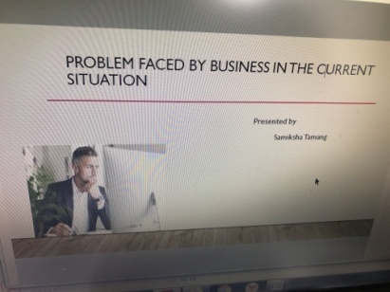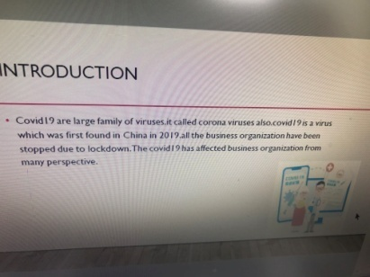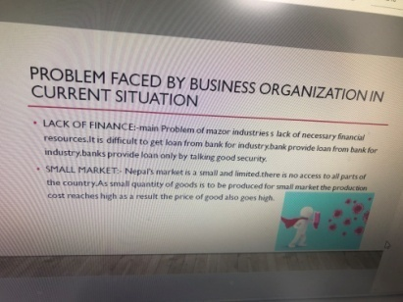
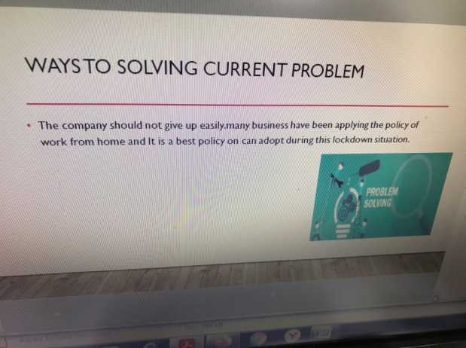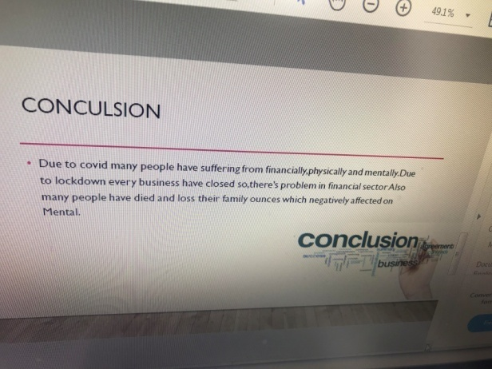

USHA CHHANTYAL

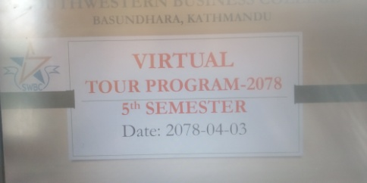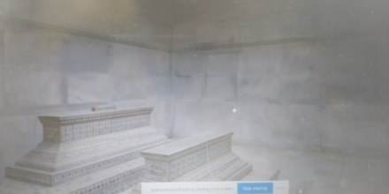
ACTIVITIES NAME PARTICIPANTS NAME  VIRTUAL TOUR PROGRAM TO TAJ MAHAL, AGRA, INDIA | - AASHMA RAI  - DEBINA THAPA  - LAXMI SHERMA  - ANUPA BISHOKARMA  - NABINA GHALE  - PAWAN NEUPANE  - RONISHA SHRESTHA  - SANGAM ACHARYA  - SUSMITA K PANJIYAR

Management learning has, since long, begun an approach of Holistic erudition with the target of taking the students out of four walls.
Objective:
1. Experience through talking with experienced people
2. Learning through sharing from directly involved people
3. Exposure through seeing the Reality
In the same regard, our College has this set practice of letting our students have an insight into the real world of other interests than course books and careers. They vitalize us and give more meaning to what we are doing by being able to see other aspects of life relatively and thus broaden our outsights. We have given continuation to this practice in the present situation also through presentation of the Tour in the Virtual Mode in line with the best practices being accomplished around the world. In a way, it had the comparative advantage of being able to visit the highly famous Heritage in the world the Tour of which was prepared with the involvement of Top Class Experts and Technologies. It was prepared in 360 visibility mode.
A Brief Description Of The TOUR
The Tour, in realization of the present pandemic circumstances, was organized keeping in mind the month-wise calendar of activities which did not permit skipping. However, some completely impossible activity could be postponed. We are in this situation comparable to epidemic since last one and half years, and the long time span has also brought out other modes (online-based) of accomplishing things.
The Tour selected was of TAJ MAHAL- the famous Agra based historical site. The slides, prepared effectively in 360 visibility mode, covered the entire outside area and view as well as each nooks and corners of the Palace. The Guide, after describing about the total route to reach there ( Kathmandu, Bhairahawa, Gorakhpur and then Agra) connected the Tour with its history related with Shahajahan who was the fifth Mughal emperor of India ( reigned from 1628 to 1658) and who had built Taj Mahal and entombed his wife Mumtaz within it. The reign of Shaha Jahan, the grandson of renowned Akbar Badshah, is considered as the golden age of Mughal architecture.

DISCUSSION ON ARTICLE PUBLISHED:
3rd Semester: 2078.04.32/ 16th August 2021

The students were encouraged to come out with varied types of writings which could be printed in suitable outlets of the College! They were given the options of writing on subjects of personal experience, academic issues, and expressions of some or other sorts! The presenter had the advantage of showing previous issues of various publications I which our students had featured!

