Southwestern Business College
NEWSLETTER KARTIK 2078
INDIVIDUAL FOCUS SERIES—32
Dr. Jayahari Raj Pandey
In our last episode of Series No. 31, we had ended on a quotation from Peter Drucker. Here, we are starting from another quotation which is from Rick Maurer and tries to give the similar message, as follows:
“Before you can learn a new way of doing things, you have to unlearn the old way. So beginnings depend on endings.”
The quotations try to emphasize on the need to enhance our individualism through doing something new or doing the same thing in a new way by being able to get away from the old way totally. That is ‘Unlearn’ as the above quotation is trying to say. But, it is not so easy. There is a dear friend of mine, who repeatedly use the word ‘wiring’ in our system. As per his basic understanding and frequent preaching, what we eat, what we do regularly, how we behave, how we act etc. becomes ‘wired’ to our systems. It takes firm determination followed by actions to the same degree in a continuous and regular manner which only can change the ‘wiring’ by destroying the previous one completely. We can take few examples here. In the November 27, 2021 edition of Trade Briefs Editorial of Trade Briefs International, there was some writing based on the following data:
“In England, only 37% of adults ages 16 or older travel actively (walk, cycle, scoot, or wheel to get from place to place) at least twice a month. We need to find exciting ways to encourage more people to travel actively for the sake of population and planetary health.”
The question naturally arises as regards how the data came? We all know that data for publication comes only after a thorough research which is based on a sound mechanism of getting to the truth. The given percentage in the above example shows the habit of those people on the other side of the coin i.e. around 63 percent of the population were ‘wired’ in such manner which did not permit them for travelling or in other words travelling did not excite them or they were somehow discouraged towards travelling. Repeated habits made their individualism uninterested to travel. Such data or other issues and workings on them are gradually on the increase. Many of us have begun to realize that basic problems being faced by human beings seem different in different ways but still they can be either summarized into narrowed-down categories or the solutions of some category might lead to a clue to another category. We have learnt to share, and we have developed lots many ways of such sharing. Nothing is personal nowadays, and we have the opportunity, like never before and also on the increasing ratio with each passing day, to get the data on similar issues from varied sources- personal or collected data or analytical suggestion. We can take the above-mentioned data generated by some government-base agency in order to assist its people to shed some unnecessarily-developed personal habit which surely helps the economy as well. It is, in a way, comparable to our Individual Focus Series which aims at the overall development of our students. Purely, it is related with the human behavior. Our Series, through analysis of the available data and the personal meetings, try to bring out some suggestible solutions through the mechanisms of ‘why’ and ‘how’. As we have repeatedly discussed on the basic theme of our ‘Individual Series’ in the earlier sequences and as the basic theme will get more and more repeated in the forthcoming progressions, the fundamental theme revolves around the universal truth that each human being is quite different from one another with distinct uniqueness and newness. Naturally, potentiality and capability of one human being differs from another. This also indicates that when one person has strengths in some areas/ characteristics, there are also weaknesses or limitations in certain parts/ aspects. Such capacities, weaknesses etc. are controlled through boldness, courage, truth wisdom, love, honesty, like or dislike hatred, lies, deceit, anger, cowardice, ego, foolishness etc. Moreover, such human feelings, relatively, are backed by memory power, existing habit-making environment and their workings, and opportunities or controls.
Over the years, we have numerous experiences which again suggest that the analysis of individualism of our students point out to one single direction and that is that each and all of them are quite oblivious of the fact they have some unique qualities and that the realization of such inherent quality by each will help them all to work towards the best outcomes from their own individualism. I will take one example. There was a student who seemed somewhat timid since the beginning of the first semester. The counseling section, the interviewing person for the admission, the program coordinator, and the interviewing person for the second step of Individual Focus Program had sensed the timidity. We had gone through her file and found out that she had secured 92 percent marks in the SLC examination. However, the marked in her Plus Two examination had drastically got down to just 51 percent (aggregate). Such huge drop within two years was not an ordinary thing. It took a lot of efforts from our side to win her faith on us during the interview session. After she became quite comfortable, she revealed that her father had immediately re-married after a year of her mother’s demise due to cancer. The new mother was always torturing her and giving her names like idiot, dumb, fool, brainless, stupid etc. She had started to become nervous. We knew the reason of her poor results, and odd behaviors. We began to counsel her through different truths which also included quotations like the following.
Sadguru said: “Idiots do things that they do not like to do, and they suffer their whole life because they think it is needed or it is their duty. Intelligent people do what they love to do. They enjoy their life to some extent. But a Genius learns to do what is needed joyfully. That is when your genius flowers.”
When the student will realize self-individualism or his/her genius, then he/she will be able to focus on something intensely. He/she will realize the preciousness of his/her life, will be conscious of the limitedness of time in everybody’s life since nobody is immortal, and will want to invest the valuable life on something meaningful.
It took time, but our student was ultimately convinced of her unique individualism. By the time of her pass-out, she was quite different from what she was before, her individualism showed confidence on herself. The confusion was gone, and she was ready to focus on something.
SWBC is now ready to launch MBA
Prakriti Koirala, Vice Campus Chief
Successful life is our common agenda. Since long, education has been rightly recognized as the only vehicle to train our minds in some particular way. Recognition and implementation of some method or course of action provides immediate accomplishments, and also becomes a source of further improvements in the method/ course of action itself. That is through monitoring, evaluation and analysis. Many of the times, such analysis paves way for another course of action as the pure alternative for best results. Bachelor of Business Administration can be regarded as the outcome of such analysis which saw the need of such course which could carry theory and practice at a parallel level. Simultaneously, there were the additions of such subjects whose basic knowledge were deemed as necessary to all of us to ahead in a career. Naturally, BBA is regarded as the single course most in demand all over the world since last several decades.
Master of Business Administration is the higher level of BBA. Open to students of wider faculties, it is regarded as the most complete degree for a career person. Seminars, research, practical involvements through visits, guest lectures, and newer activities of high dimensions are the keys of shaping the students into a matured, knowledgeable, commanding, and active personality.
Hence, our MBA will focus on the following (of course, there will be many more):
- Preparatory Orientation
- Digital Marketing Training
- Industrial Visits
- Guest Lectures
- Thesis/ Internship
- Financial Management Practice
- Seminars/ Symposium

Visit of the Dean to SWBC 23rd Kartik, 2078(9th November 2021)
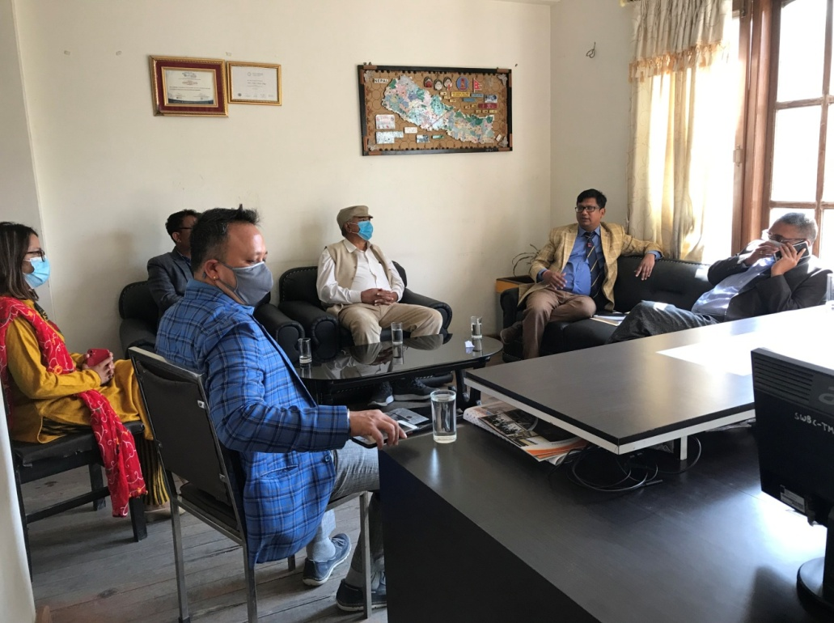

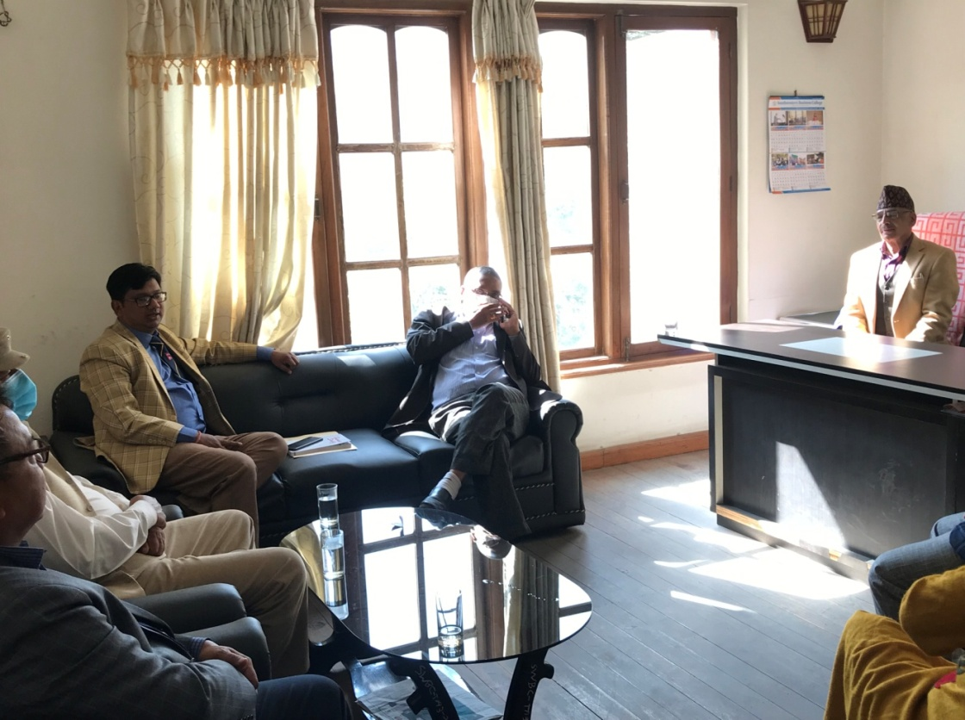
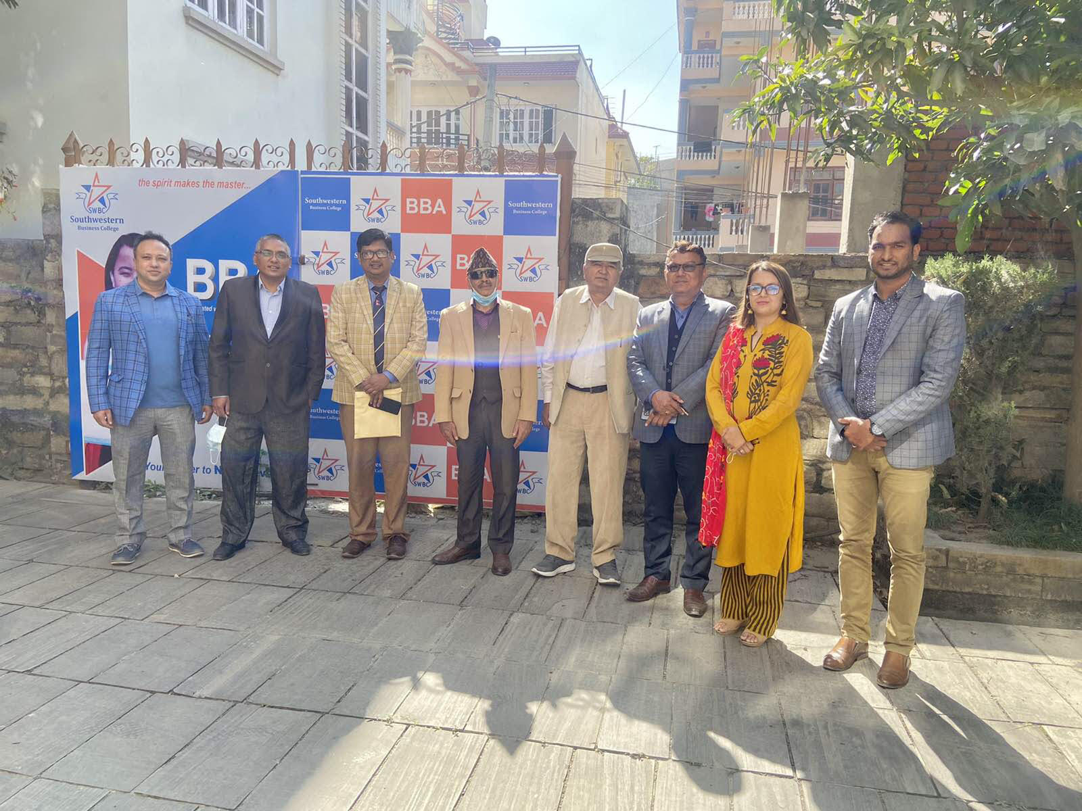
Dean of Faculty of Management of Purbanchal University Prof. Dr. Biju Kumar Thapaliya made a short visit to the College. Chairperson Dr. Krishna Bahadur Karki, Campus Chief Dr. Jayahari Raj Pandey, Board Director Bijaya Sagar Pradhan, Vice Campus Chief Prakriti Koirala, Campus Chief of Silk Road College, and Campus Chief of Gateway College were present on the occasion.
Discussion Topics
- MBA Program
- Delayed Examinations of all the on-going Semesters
- New Program Calendar developed by the Faculty of Management (for 4 years: 2078 Poush to 2082 Shrawan)
- Problems faced by the Colleges with Single program

Notices received from the Purbanchal University
