Southwestern Business College
NEWSLETTER POUSH 2078
INDIVIDUAL FOCUS SERIES—34
Dr. Jayahari Raj Pandey
Elon Musk of Tesla, the renowned business magnate, was talking about ‘Universal Basic Income’ or Global Pay Check during a talk. That means a time might come when unemployed people will be paid across the globe. He was foreseeing a situation of massive social challenge due to mass unemployment. His argument was “there will be fewer and fewer jobs that a robot can’t do better”. We can’t ignore its seriousness since we already know the growing grasp of artificial intelligence and machine learning.
During the seminars under Individual Focus Program, we are also touching upon the same theme, but slight differently. The takeover of many areas of business and other activities by the robots seem obvious. Yet, there certainly are some areas in which the machine lags behind. The smartness of the people towards which our BBA program works elaborately can be one of such areas in which the machine will be lagging far behind while bringing out newer ideas, planning fresh schemes, finding alternative solutions, taking calculated risks, and making the machines always obeying. In short, the products that BBA are and will be producing are and will be those who take full advantage of the enormous capabilities of human brain.
In our last episode, we had talked on seven hidden powers of the Individual Focus Program. We all know that brain, the three pound organ, is the focal role player in our existence. It interprets our senses, it initiates our body movement, it controls our thoughts/feelings/behavior, it produces our intelligence, and it brings out our creativity. It is in this connection that Robert Anton Wilson has made one very relevant quotation, as follows:
“You are precisely as big as what you love and precisely as small as what you allow to annoy you.”
One thing has amazed us throughout the years of our involvement with our BBA students – their progressive originality. There is always, evidently, vast changes or progresses within them to the direction of unrelenting search for their own aim. It is the gradual thing, and we feel proud to award credit of more than fifty percent of this phenomenon to our Individual Focus Program.
(One student was saying her story in Narration Program: You are not the main character of everyone’s story. You are the main character of your own story).
Another student was talking about some organizations where the practice of Invisible Employee was strong. In such organizations, the role of the invisible employee would be most valuable.
(The burning issue is: ‘What is gained and what is lost when we all are working from home?’ Do we need small School/ College spaces and Office rooms in future?’
Similarly, there are so many posts and news items in blogs and social sites which are responsible for creating fear and confusion among the mass. There is no concrete scientific evidence, but such items are based on the theories of ‘maybe’ and can be said as the products of negative thinking and spreading chaos. We can’t see the real benefits of such items even to the posters or writers. Rather, it is due to the absence of rules needed for the posters and creators of news. They are not trained, they know nothing about the norms of journalism, they are unaware of the consequences of their writings, and they are quite satisfied by whatever they are creating. That is ignorance, but the burning question is how to stop it. There was one item (for example) like this: “Findings raise possibility Covid may cause microscopic damage not detected by normal tests”. This news, without any evidence whatsoever, only tries to create sensation at the expense of installing unnecessary fear within the people.
Evidently, during the discussion in our induction program many participants said: “such news is generally spread by those people who do not know the prime responsibility of their job. It also can be said that they were educated in wrong way.” There is one relevant story. Three persons were on a boat enjoying the spread of water around them. Suddenly one of them started a conversation with the boatman in local language. After the exchange of names, the first man said: “You are lucky to meet so many people every-day! They must be of different countries, and you can talk with all of them. You must have studied English!” The boatman replied: “No Sir! I have not read English!” The first man exclaimed: “Really! Oh! You have wasted 25% of your life”. The boatman thought: “This person is right! I have wasted 25% of my life by not knowing English”. Now, not to miss a chance of showing his knowledge of the world, the second man began to talk and asked: “If you don’t know English language, you might know some other international language which is spoken by many people of the world, like Chinese or Spanish or Hindi etc!” The boatman replied honestly: “No Sirs! I don’t have knowledge of any such language which is being spoken by many people of the world!” It was the turn of the second man to proclaim “My dear fellow! You have wasted another 25% of your life”. The boatman was sad now with the thinking of such a great waste. The third man, who was eagerly waiting for his turn to show his bravery asked: “I am curious to know whether you know any other language than the local one!” The boatman replied in a small whisper-like voice: “I know only local language!” “Oh my God! What is there without knowledge of at least one more language! You have wasted another 25% of your life”. The boatman began to curse himself silently for not initiating towards one or other language! Suddenly, there were the signs of storms! The boatman, knowingly, began to say: “It looks like tornado!” He continued: “I hope all of you know swimming!” All the three exclaimed in unison voice: “I don’t know swimming!” Now it was the turn of the boatman to proclaim something very important: “You all have wasted 100 percent of your life”. The message of this story is clear: One should get the knowledge of that aspect in which he or she is involved.

EXCELLING IN AN ACADEMIC JOURNEY OF BBA Ms. Prakriti Koirala, Vice Campus Chief

In the last issue, I was talking about the salient features of SWBC under the heading “Why SWBC?’. Due to the space limit, I was able to deal with a few only of them.
Today, I am going to present some experiences on how our students are able to move ahead on the path of Excellence.
There are two ways!
- Exact delivery of the syllabus! : There can be no compromise! We have our own Guidebook (published and distributed to all to ensure day-to-day portion of delivery and to ease the monitoring part).
- Pre-declared activities for the total duration of the semesters: This is the practical side which makes the students used to in many of the most needed aspects of business, management, and leadership.
First of all, let me explain the program structure of BBA under Purbanchal University- established through Purbanchal University Act 1994. BBA - under management faculty of the University offering professional, functional and practical programs - is one of around 90 academic and certified programs of undergraduate and graduate level being offered by the University. The course structure of BBA includes 6 Foundation courses (necessitating a strong base in basic communication skills, business mathematics and fundamentals of economics) of 18 credit hours (each course having 3 credit hours), 26 Core courses (related with general management and functional areas) of 76 credit hours ( 24 courses with 3 credit hours each and 2 courses with 2 credit hours each), 2 Capstone courses of 6 credit hours, 5 Specialization Area courses of 15 credit hours, and Internship of 5 credit hours. Thus, there are 40 course components with 129 credit hours in total. The semester cycle has 8 parts of 15 credit hours each. The students are required to complete the Degree within minimum 4 years to maximum seven years.
As we can understand that the delivery should follow time-to-time evaluation through tests and other mechanisms, theoretical courses are assessed through two parts: Internal Examination carrying 30 marks out of 100– requiring 12 marks as pass marks, and SEE (semester end examination) carrying 70 marks - requiring 28 marks as the pass marks respectively. There are three tests for internal assessment (First Test after 30 percent course coverage, Second Test after 60 percent course coverage and the Third one as Pre-Board Exam). The weightage of the 30 percent internal marks of all the subjects are divided into Tests (40 percent equivalent to 12 marks), Attendance requiring at least 80% (20 percent equivalent to 6 marks), Group Discussion / Class Participation in which the division of marks is 40% for Participation, 40% for Argument, and 20 % for Leading/Convincing (20 percent equivalent to 6 marks), and Presentation in which the division of marks is 30% for Presentation Content, 50% for Communication, and 20% for Organization of Presentation (20 percent equivalent to 6 marks). The Internship, under which the students are assigned to the organizations in the Seventh Semester for eight weeks duration, is evaluated through the marks divided into 40% for the Report Writing, 20% for Organization Evaluation, and 40% for Viva Voce Examination.

SWBC SCHOLARSHIP PROGRAMME
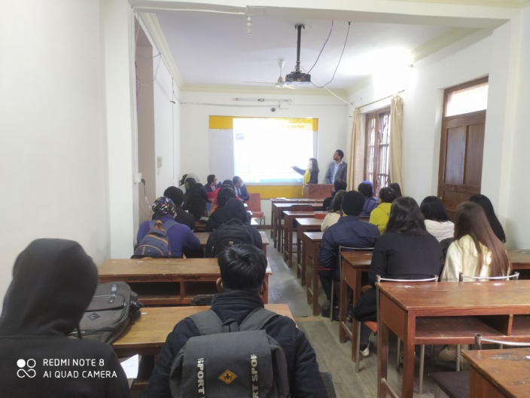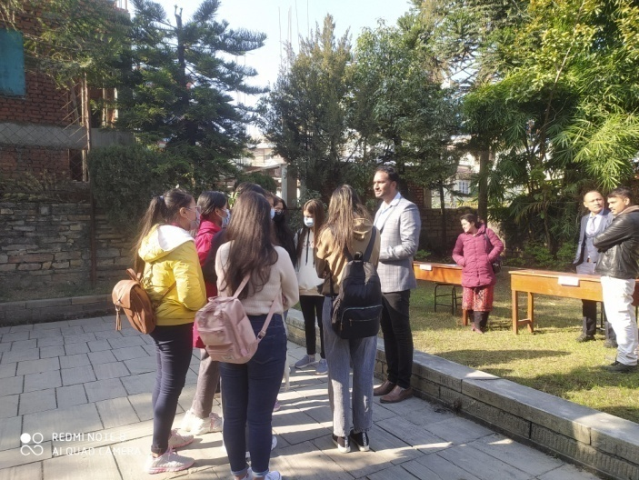
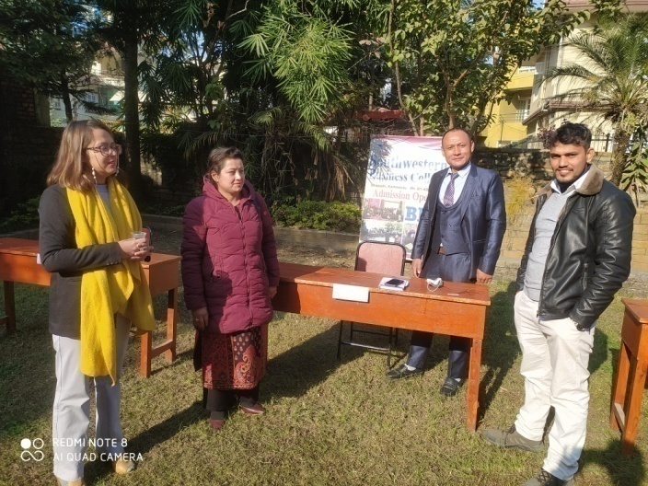
SWBC Scholarship Program: 2078 POUSH
Venue: Classroom 1 Emcee: Mr. Binaya Kattel
AGENDA
- Welcome / about Scholarship Program: Mrs. Prakriti Koirala, VCC
- Speech on ex-student Mr. Subin’s 4 years experiences in SWBC through Scholarship: Mr. Subin Tamang
- General Knowledge Test on Attitude : Ms. Anisha Shrestha
- Individual Counseling from our Experts (Career after BBA)
- More and many others with a cup of Tea
BRIEF INFORMATION:
- The program was organized jointly with Sky Vision Foundation for 22 ‘Plus Two pass’ students. The main aim of the program was to give information on SWBC’s many types of scholarships to the BBA aspiring students.
- Experience sharing by one of the pass-out students enjoying SWBC scholarship scheme made the participants knowledgeable on the precision of the system.
- Attitude Test, exclusively designed by Southwestern Research Center for Leadership Seminars, provided the participants a new awakening on outlooks. The winners, crossing certain marks, received exclusive gifts!
- Free counseling on management subjects by three Faculty members- who were there for the same purpose- was one specific feature.
- The following table shows the marks of ‘ATTITUDE TEST’ :

S.N. | NAME | DENOMINATION | PERCENTAGE | REMARKS
1. | Anita Gurung | 20 | 87%
2. | Anjan Pariyar | 14 | 68.7%
3. | Anurag Mishra | 15 | 65.2%
4. | Boby Tamang | 18 | 78.3%
5. | Debendra Shrestha | 14 | 68.7%
6. | Dipesh Pandey | 18 | 78.3%
7. | Gyanuka Gurung | 21 | 91.3% | Recipient of a Prize! Congratulations!
8. | Ishwor Shrestha | 17 | 73.9%
9. | Liza Gomja | 16 | 69.6%
10. | MD. Dilkash Reza | 21 | 91.3% | Recipient of a Prize! Congratulations!
11. | Om Khadka | 20 | 87%
12. | Pratikshya Aryal | 18 | 78.3%
13. | Puja Gurung | 21 | 91.3% | Recipient of a Prize! Congratulations!
14. | Salina Sigdel | 21 | 91.3% | Recipient of a Prize! Congratulations!
15. | Sarita Pathak | 18 | 78.3%
16. | Saroj Shrestha | 17 | 73.9%
17. | Sheela Pathak | 16 | 69.6%
18. | Shristi Gaihre | 18 | 78.3%
19. | Sneha Shrestha | 14 | 68.7%
20. | Subekshya Sigdel | 16 | 69.6%
21. | Suchitra Thapa Magar | 21 | 91.3% | Recipient of a Prize! Congratulations!
22. | Sujan Khadka | 16 | 69.6%

SCHOLARSHIP PROGRAM WINNER
- Gyanuka Gurung,
- MD. Dilkash Reza,
- Puja Gurung,
- Salina Sigdel, and
- Suchitra Thapa Magar were the Prize winners!
We want to say Huge Congratulations to all our winners, and wish them the very best of luck for their next step in their career-related higher education journey!
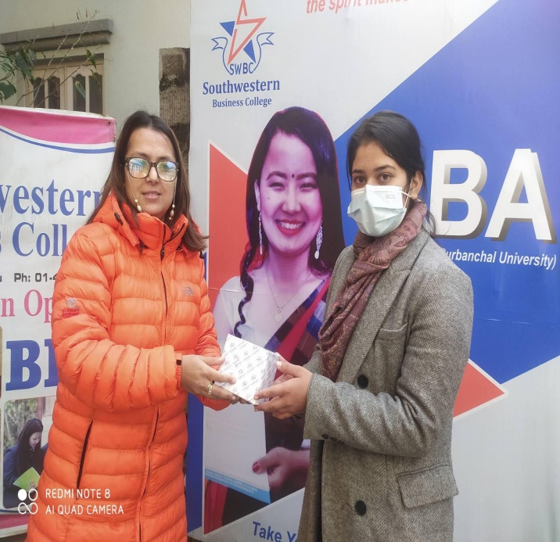Pic: Ms. Salina Sigdel been awarded by the VCC.
CENTER RELATED
Our College was selected and served as the exam center for the exams relating to first/third/fifth/seventh semesters of BCA/PGDCA under Engineering Faculty from 2078.0823 to 2078.09.15.

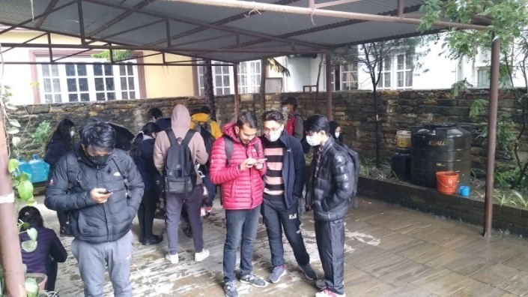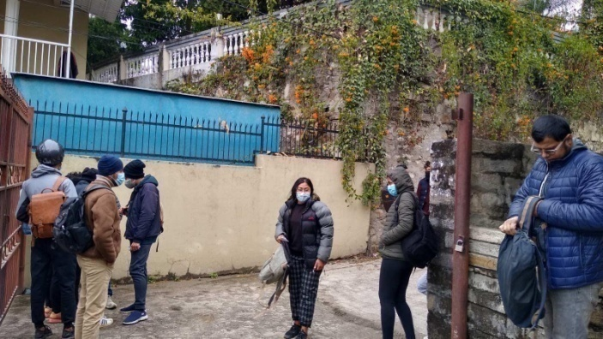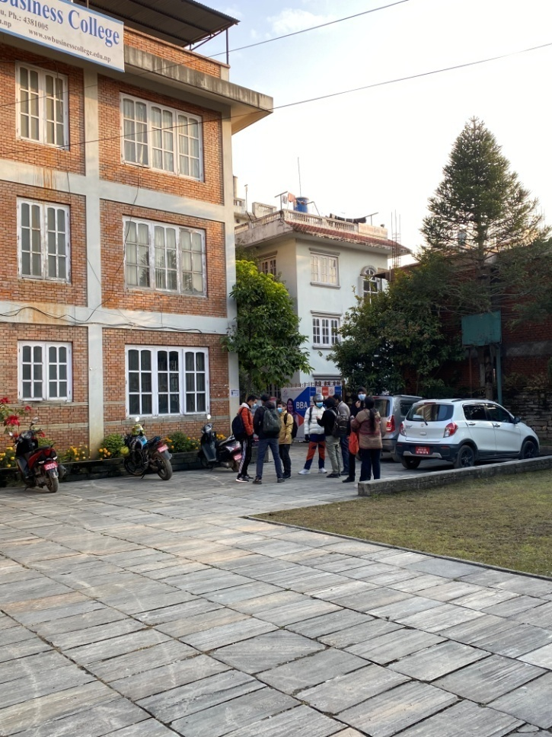

START OF NEW SEMESTERS
Classes of 2nd, 4th, 6th and 8th semesters were commenced from 5th January 2022 (21st Poush 2078). They followed the SWBC custom since beginning: 5 classes of 45 minutes each of five subjects every day (Sunday to Friday).
- Regular Faculties: Aaswin Neupane, Baburam Sharma, Dolraj Dhakal, Prakriti Koirala, Raj Kumar Uprety, Nani Maya Dangol, Sagar Upadhyaya, Sajani Nepal, and Sushma Shrestha.

- New Faculties: Bholanath Khatiwada, Krishna Bahadur Uchai, Rijuta maharjan, Rudra Gyawali, and Sunil Nepali.

ANNUAL GENERAL MEETING
>L ;Dk'0f{ ;b:o dxfg'efjx?
साउथवेस्टन lahg]z कलेज
ljifoM ;fwf/0f ;ef ;+aGwdf
dxf]bo,
यस साउथवेस्टन lahg]z कलेजको संचालक समितिको बैठकको निर्णय अनुसार यस कलेज को ;ftf}+ बार्षिक साधारण सभा मिति @)&* kf}if @$ गते शनिवार xf]6n ofs P08 Plt ;ef xn df संचालन गर्ने निर्णय भए अनुसार उक्त मिति र समयमा उपस्थित भईदिनु हुन अनुरोध गर्दछु ।
सभामा छलफल हुने विषयहरु
!. अध्यक्ष बाट कलेजको बार्षिक प्रतिवेदन प्रस्तुत
@. प्राचार्य द्वारा कलेजको बार्षिक प्रतिवेदन प्रस्तुत
#. प्राचार्य द्वारा कलेजको आ व २०७*÷०७( को बार्षिक कार्यक्रम तथा बजेट प्रस्तुत
$. लेखा परिक्षकको प्रतिवेदन
%. लेखा परिक्षक नियुक्ति र पारिश्रमिक निर्धारण
^. प्रस्तुत प्रतिवेदनहरु माथि छलफल र पारित गर्ने
&. विविध

8f = hoxl/ /fh kf08]
SofDk; k|d'v
साउथवेस्टन lahg]z कलेज

Aff]wfy{ M >L cWoIfHo', साउथवेस्टन lahg]z कलेज

