Southwestern Business College
NEWSLETTER MAGHA 2078
INDIVIDUAL FOCUS SERIES—35
Dr. Jayahari Raj Pandey
In the last issue, we had ended the conversation on the need to be knowledgeable on the aspects related with one’s profession, occupation, involvement, engagement, or association. We had taken one example which had stressed on the need to know swimming when one is on the water. On the one hand, it directly asks you to be well-informed and familiar of your profession or work which is another way of saying: ‘be responsible!’ More explicitly, it is self-realization or accomplishment by oneself of the potentials of one’s nature or individuality.
At the center of your being you have the answer; you know who you are and you know what you want. - Lao Tzu
The above quotation tries to give answers to multiple of questions. If we know ourselves, then we know our plus points, our weaknesses in terms of what we want, and our scale of determination to overcome the weaknesses. Here, for our easy grasp, the term ‘weaknesses’ has been taken as the hurdles towards our goal. Another part is our willingness to develop our skills to match it with the demand of the challenge. We all know that once the skill meets such demand then the flow of the occurrence at the right or precise level happens. That is the level to achieve success. Naturally, the skill needed for one type of success in one case is always different – person-wise as well as case-wise. It is, in a way, same as a medical doctor communicating information differently to different patients. Here, we are trying to connect it with the fact that it is the individual itself who, after self-realization, can take the right course for himself. Let us take one example. In today’s world, there are many persons who get linked with old friends through Facebook etc, and come to find out that certain person who was way behind in intelligence during the study period was now very successful- making lots of money or higher in post comparatively. Self-realized people will not get disturbed by such news and vice versa. Similarly, self-realized people are always able to see the needed changes in the ways they are about to face.
We all know that time changes, and the ways to move forward changes accordingly. Many of the times, changes come through mass understanding at different level than the existing one – either through someone’s inspiration or in a gradual and non-track-able way. I would like to take one example here. Few years back (May 9 – 17, 2019), I was in China at Changsa. It was Global High-End Manufacturing Summit. During the inauguration ceremony, I had a long conversation with a minister of Netherlands who was also involved in Education. We also shared common practices being followed and used for the BBA students. She talked about Brain Writing. After return, I talked about it with colleagues here. Now, we also are using Brain Writing as an effective tool. First of all, by chance I had a meeting with another

person of another country where I got to know about some system which was working there properly, and we followed the system. The change occurred. Secondly, at the broader level, Brain Writing seemed to be able to find wider application in the place of Brain Storming. We, locally, have one proverb which translates more or less like “He who can talk (smoothly) can sell his/her flour, while the one who can’t talk can’t even sell the rice”. The proverb seemed to be representing the working style of Brain Storming. The talk prevailed in Brain Storming due to which many good ideas get or got sidelined. It seems now the selling of wheat or flour instead of rice only on the strength of talking is gone. Change has come through the realization of people’s fading impression on talking only. In a way, they have learnt to filter the truth within the length of the talking. Naturally, marketing has now started laying more emphasis on Quality. Hence, Brain Writing has started to produce more qualitative ideas. Individuals, who don’t want to decorate something more than its true worth with eloquent words, have started to prevail through worthy ideas. We all know that human beings are psychologically regulated lots for whom emotions mean too much. Let us take one example. You are just going out of the home for college when suddenly your mom remarks with pinching words on your last night’s late home coming. You are red faced, you feel hurt, and you want to hit back with some words. But then you calm down and chose to regulate your emotions. Some can and some can’t; similarly in some cases we can and in other we can’t. In the same way, motivation, self-esteem and anxiety are regarded as the factors affecting oral performance. If we connect it to our Brain Storming alternative, people wanting to excel in brain storming need to regulate the one or more of the emotions linking with the above-mentioned three issues. On the other side, brain writing will not need any kind of such regulation of the factors affecting the emotion. Hence, Self-regulated people seem to be able to choose the right course suitable for them as well as devise some appropriate way. There is one story of King Akbar and his main advisor/ one of nine jewels Raja Birbal. One evening, they were relaxing in the garden. King Akbar was very happy with the news of friendship offer accepted by the neighboring King, and he was sharing the good sides of this friendship. Unexpectedly, Akbar Badshah asked: “E Birbal! Can you tell me some words which can make one happy person immediately sad and a sad person immediately happy?” (King Akbar had the habit of asking strange questions to his courtiers regularly, and most of the time Birbal could produce the solution or answer). In this case also, Witty Birbal, as always, replied: I know Oh King the Great! But, do you really want to hear the words? “Yes!” was the King’s reply! Then Birbal said: “This time will not remain as it is; it will change!” Hearing this, King’s mood changed instantly! All the same, we all know that change is natural, but still our emotion comes on the way of understanding the mechanism of regulation.
Thus, the realization of individuality makes one comfortable through the acceptance that we all are unique, we all have different distinct quality, and we all can be uniquely successful as well as satisfied by being different. Many of times, we take the result as the starting point. For example, we are taking a lot about positivity. We try to be positive from the start of its practice not realizing that positivity is actually the result. Similarly, there is another catchy word around: you have to be different to be successful! And many try to be different by copying or imitating others! Interestingly, we are already unique, each one of us. There is just need on the part of us to realize our uniqueness which is also our individuality. Simply, we are already different!
Lastly, "If you get the inside right, the outside will fall into place." -- Eckhart Tolle

EXCEL - PLUS : Prakriti Koirala, Vice Campus Chief
During the encounters with hundreds of students throughout the time of admission, I find some similarities. They are confused on what they want. All of them want success in life. They have mixed version on ‘which course might lead them to success?’ Many of them forget to see that it is not the courses rather the student himself/herself on whom the ‘Success’ depends!
Hence, once they join us, they will go through the activities which are designed on multi-facets! I am going to take few examples on the specific aims of the activities, as follows:
- Activities to connect on multiple aspects of management: Management Tug of War (to make them aware of various roles of management team, board, and committee), Management Bingo (to keep on reminding the key words under management in an environment of Fun), Risk Free Games (to make them aware of Effective Listening Part and Right Communication Part) etc.

- Personality related activities: Speech Competition (delivery part with preparation), Story- telling (ability to make the narration interesting), Presentation Competition (Body Language, Composure and Voice) etc.

- Ideas Related activities: Brain Writing (replacement of brain storming), Business Proposal Competition (practice of going through many existing ideas and thinking hard to bring out some new), Business Photography Competition (Self-realization of many business success stories while searching for good photos) etc. "Ideas are like rabbits. You get a couple and learn how to handle them, and pretty soon you have a dozen.": - John Steinbeck

- Social Connection: Blood Donation, Waste Materials Management, Cleaning Program, Awareness Programs on various relevant aspects through pamphlets distribution/ messages on uniforms/announcements/circulation of same messages by all on social media etc.

(More will follow in next issue)

NOTICE TO THE STUDENTS REGARDING ECA

Dear Students,
Good morning!
We are again online learning! We feel satisfied that you have adapted to the new situation quite well! It proves that human beings have the tremendous capacity and endurance to adapt to new things, to change behaviors, to adhere to the new rules and systems, and adjust to fresh living styles.
Looking at the graph of your class attendance, it is comparatively on the high side slightly- which might be due the same habit factor. That is very satisfactory. However, we are concerned regarding your participation rate in the over-all cases of extracurricular activities.
Extra-curricular activities are closely associated with the modern education. They become an integral part for the students of the degree like BBA and MBA which aim to shape the students with smartness. Extracurricular activities are recognized for the ability to make the students knowing and having the sense of ‘rivalry and its use’, ‘multiplicity in the real world’, ‘teamwork utility and its advantage’, individual capacity and its dimensions’, ‘ group responsibility and its applicability’, ‘ physical strength and its effective use’, ‘ forbearance’, ‘cultural sense’, ‘community belonging’, and ‘practical application of theories’.
In many and different ways, extracurricular activities provide a channeling way or linking thoroughfare for many of the lessons learnt under the syllabus. In such cases, performing in real scenario will have the impact of learning for always – we seldom forget our direct involvements. In other ways, they make the students smarter in varied ways as per the erudition provided and tendency made by the respective activities.
Apart from the above, extracurricular activities will have three VALUES, as under:
- Internal marks
- Immediate Recognition
- Monetary benefit
We urge you all to give your best participations in all the schedules and prescribed activities!
We wish you ALL THE BEST!

ACTIVITIES OF THE MONTH
S.N. | Name of the Activity | Sem | Date | Participants | Proceedings | Remarks
1. | Story Narration Program | 4th | 3rd  Magha | Usha Chhantyal, Sun Maya Magar, Usha Thapa, Dambar Biswokarma, Samkshya Tamang, Rejina Dahal, Manisha Timilsina, Nabin Poudel, Sujita Baniya, Pooja Biswokarma, Rachana Pokharel | Story on Family, Relations, Business, Journey, Visits etc. | Competition; Result based on: level of voice, subject matter dealing, time management, presence/ease/charm, and choice of words
2. | Story Narration Program | 8th | 4th  Magha | Rijan Shrestha, Srijan Adhikari, Suzan Tamang, Manish Gurung, Apil Lamichhane, Sulav Khadka, Sagar Dangol, Sabina Ghale, Nitesh Baniya, Manoj Kumal, Varsha Shahi, Sushmita Kunwar | Story on Family, Relations, Business, Journey, Visits etc. | Competition; Result based on: level of voice, subject matter dealing, time management, presence/ease/charm, and choice of words
3. | Story Narration Program | 2nd | 7th  Magha | Aayush Shrestha, Pooja Lama, Nirmala Khadka, Anjila Rai, Astha Karki, Puja Thapa Magar, Ashok Gurung, Astha Subedi, Sarita Dangol, Manashi Adhikari, Rubina Subba, Binaya Thapa, Santosh Magar, Suvani, Anuska Chand Thakuri, Dikshya Tamang, Ichchya Tamang, Baivab Bista, Rojin Lama, Abhas Lamichhane, Shristi Maharjan | Story on Family, Relations, Business, Journey, Visits etc. | Competition; Result based on: level of voice, subject matter dealing, time management, presence/ease/charm, and choice of words
4. | Story Narration Program | 6th | 9th  Magha | Sunil Nepali, Ronisha Shrestha, Deepak Lamichhane, Sobit Pant, Sangam Acharya, Anupa Biswakarma, Nabina Ghale, Devina Thapa, Sushmita Shahi, Laxmi Sherma, Sujata Thapa, Aasma Rai, Sushmita Panjiyar | Story on Family, Relations, Business, Journey, Visits etc. | Competition; Result based on: level of voice, subject matter dealing, time management, presence/ease/charm, and choice of words
5. | Group Debate on ‘External vs Internal Job’; Final Debate on ‘ Job Creator vs Job Holder’ | 8th | 11th  Magha | Winners  First: Suzan Tamang  Second: Manish Gurung  Third: Binod Karki | Total- 4 Groups  First debate- A & B  Second- D &C  Final Debate- D & A | Presence of Adjudicator and Audience  The audience judge the quality of the facts and arguments stated
6. | Business Photography | 2nd | 12th Magha | Sushma Lama, Prakriti Bhatta, Ghanendra Kr. Panjiyar, Aayush Shrestha, Abhash Lamichhane, Ashok Gurung, Baibhav Bista, Nirmala Khadka, Nisha Chhantyal | Photography on: business ideas, industry, company, successful business person  Time: 3-4 minutes | Competition; Result based on: uniqueness of the idea, understanding of the subject, connection between the theme and description, analysis on some aspects, and provided suggestion
7. | Ad Mad Collage Making | 4th | 14th Magha | --Anju Ghale and Seema Bhurtel ( Group One)  --Rejina Dahal, Usha Chhantyal, Dinesh Bhandari ( Group Two)  --Jharna Gurung, Sunmaya Gharti Magar ( Group Three) | Collage on Business, Environment, current issues with mentions of advantages/ disadvantages | Advertisement creation: bewilderment and comprehension
8. | Business Photography | 6th | 16th Magha | Ronisha Shrestha, Sunil Nepali, Anupa Biswokarma, Sagar Khadgi, Sobit Pant, Aashma Rai, Aayush Kharel, Sushmita Shahi, Nabina Ghale | Photography on: business ideas, industry, company, successful business person  Time: 3-4 minutes | Competition; Result based on: uniqueness of the idea, understanding of the subject, connection between the theme and description, analysis on some aspects, and provided suggestion
9. | Product Dumb Charade | 4th | 17th Magha | Usha Chhantyal, Salina, Usha Thapa, Sunmaya, Anju Ghale, Sujita, Shrijal, Samikshya, Pooja B.K., Rachana Pokharel | Gestures:  -Thumb up: Nepali product  -Thumb Down: Indian Product  -Thumb right: Chinese Product  -Thumb Left; Third country Product  -Eye Right: Inside Part  -Eye Left: Upper Part  -Eye Up- Lower Part  -Eye Down: Outside Part

LET THE PHOTOES SPEAK
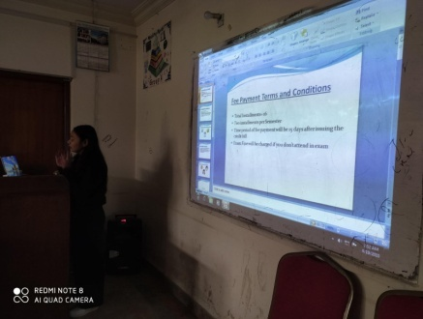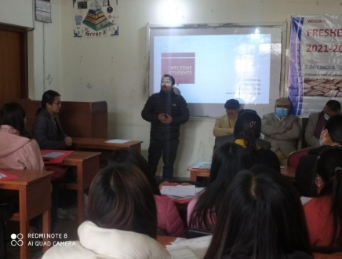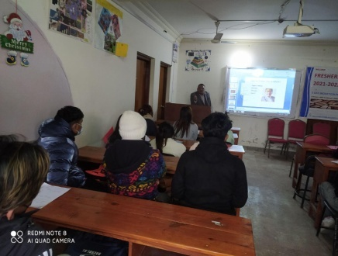
Anisha Shrestha with Financial Terms Faculty Baburam Sir on First Day Board Director Bijaya Sir on Second Day
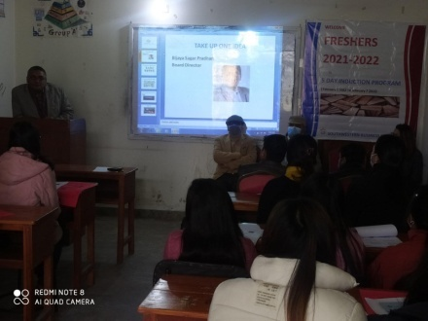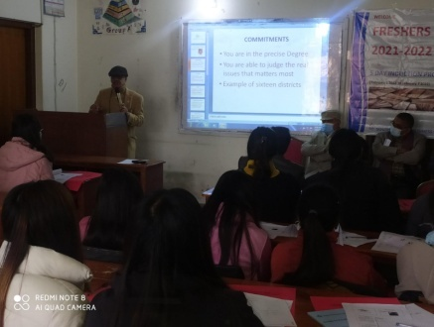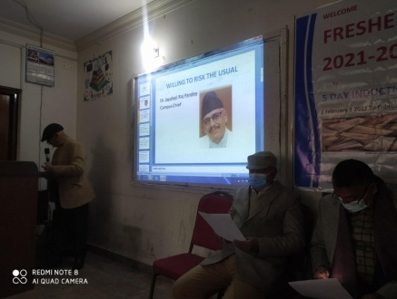
Board Director Bijaya Sir on First Day Campus Chief’s address Campus Chief: Willing to Risk the Usual
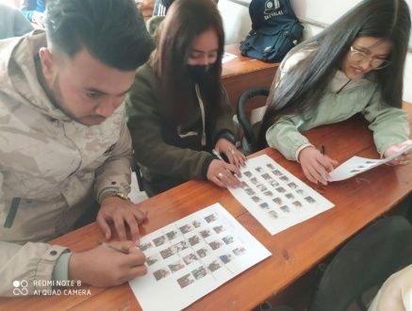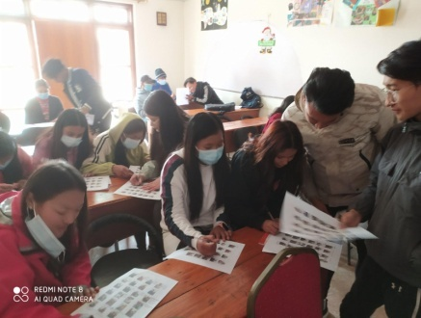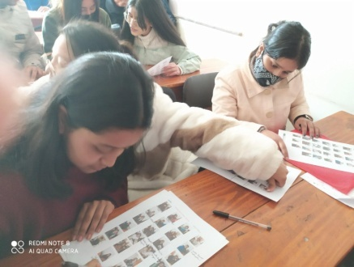
Group 3 on Panel Game on Brand Group 1 on Panel Game on Brand Group 2 on Panel Game on Brand
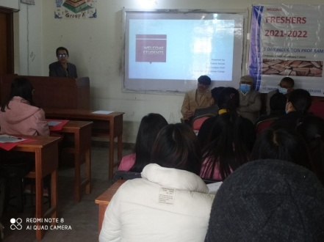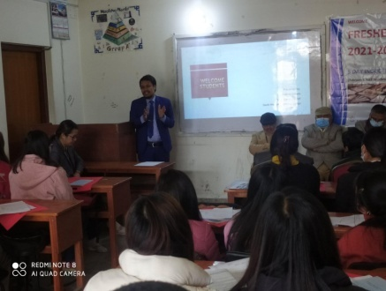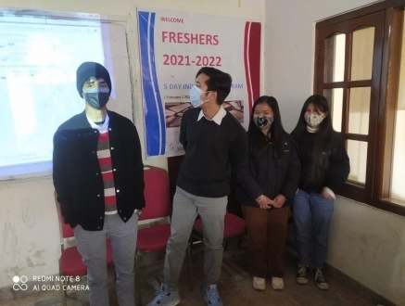
VCC Prakriti Koirala: Welcome Speech Faculty Rajkumar Uprety: First Day Students in front of the Banner
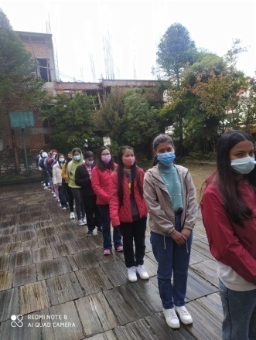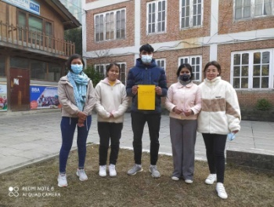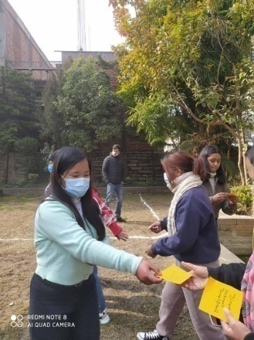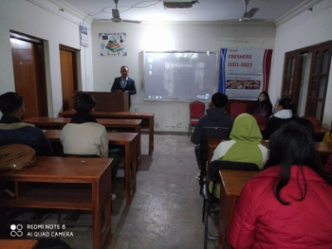
Lining up for RISK FREE GAME Winner Group of TUG of WAR Cards of Tug of War Subin Tamang: Ex-Student
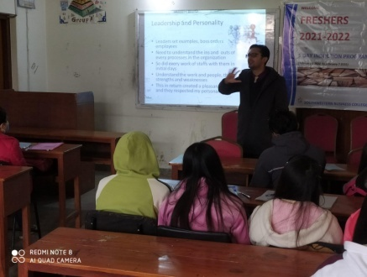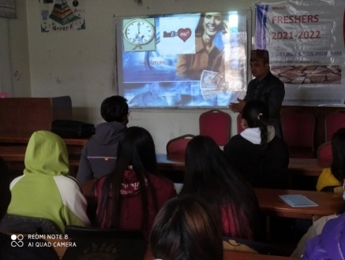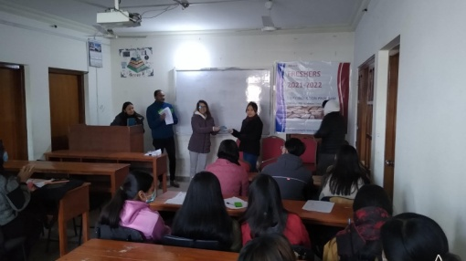
Expert Sulav Neupane on Third Day Expert Tulsi Niraula on Fourth Day One of the winners of Mgmt BINGO
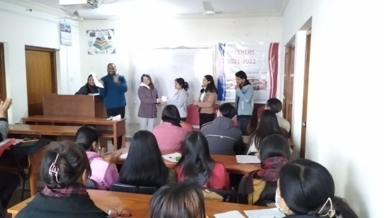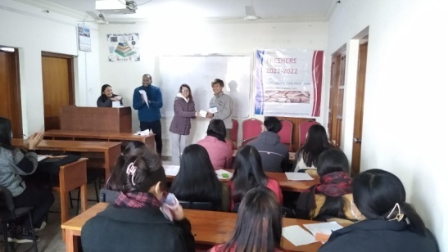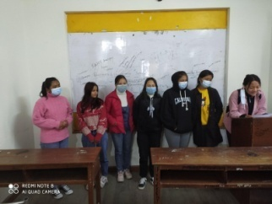
Other winners of Bingo Program Brain Writing: 1st Sem
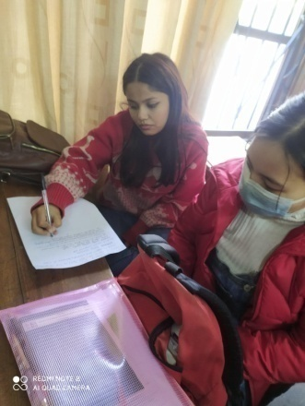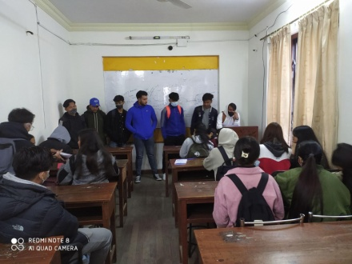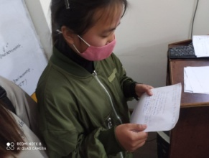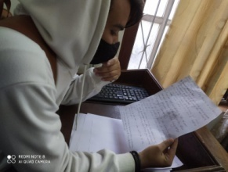
Brain Writing: 1st Sem

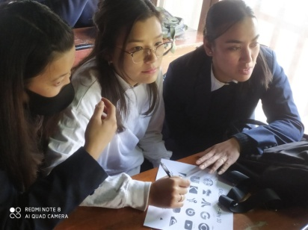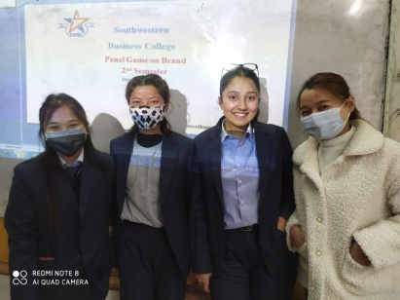

Story of Dipak Lamichhane- 6 Sem Panel Game – 6th Sem Panel Game – 2nd Sem
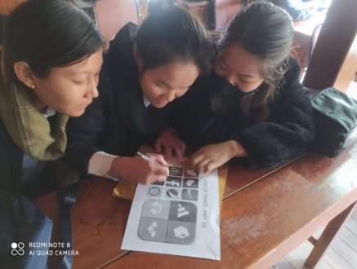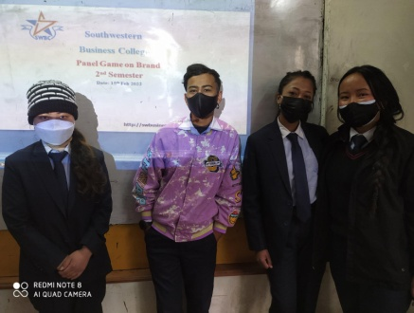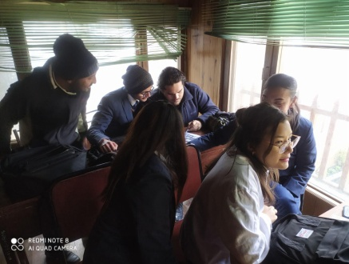

Panel Game on Brand – 6th Sem Panel Game on Brand – 2nd Sem Panel Game on Brand – 6th Sem
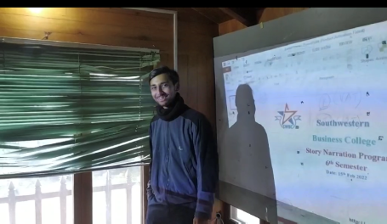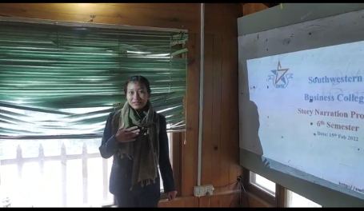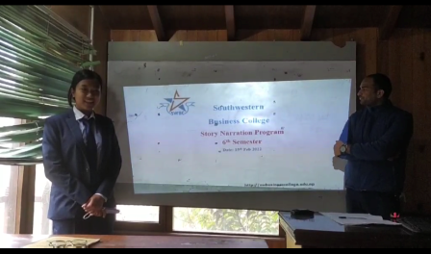
Story of Sangam Acharya- 6th Sem Story of Sushmita Panjiyar- 6th Sem Story of Sushmita Shahi- 6th Sem

Story Narration of 6th and 8th Semesters
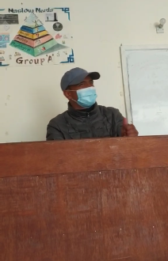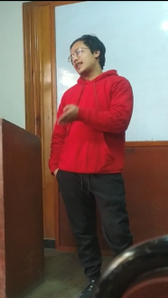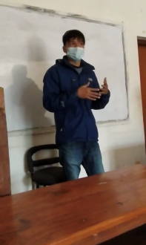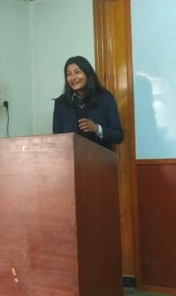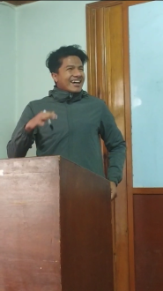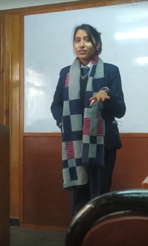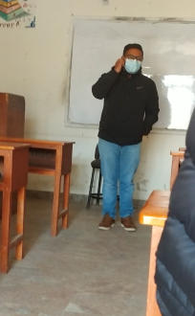
Apil Lamichhane: 8th Damber: 4th Manish Gurung: 8th Manisha : 4th Nabin Pauel: 4th Rejina Dahal: 4th Rijan Shrestha: 8th
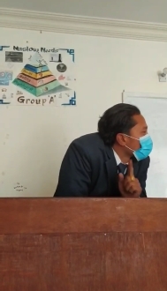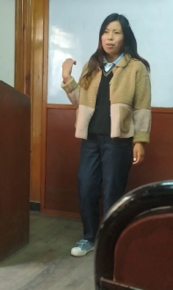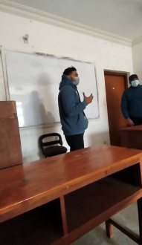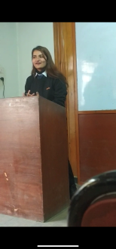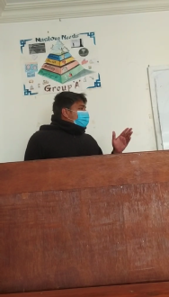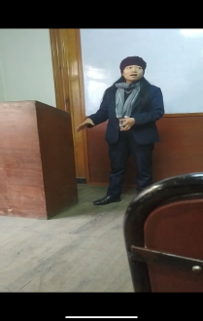
Sabina Ghale: 8th Sagar dangol: 8th Samikshya: 4th Srijan Adhikari: 8th Sujita Banya: 4th Sulav Khadka:8th Sunmaya Magar: 4th
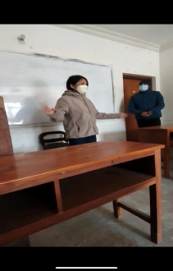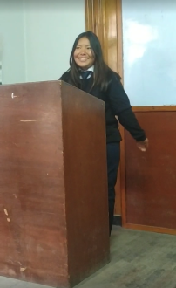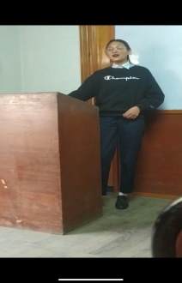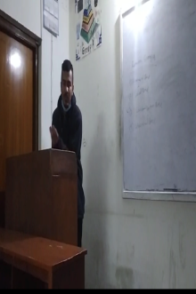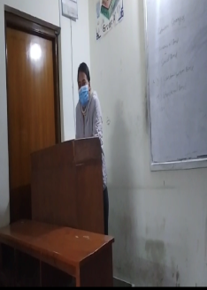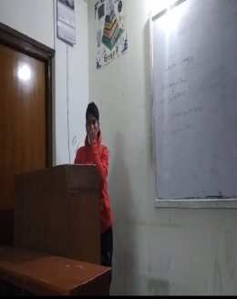
SuzyanTamang: 8th Usha Chhantyal: 4th Usha Thapa: 4th Nitesh Baniya : 8th Sushmita Kunwar: 8th Manoj Kumal: 8th
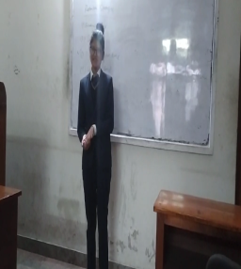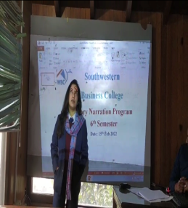
Varsha Shahi: 8th Anupa Biswokarma: 8th

SARASWATI PUJA Magha 23, 2078
Medium: Physical and Online (only a few Faculty members, a few students and non-teaching staffs were present physically).
Participation: 13 students from 2nd Sem, 10 students from 4th Sem, 8 students from 6th Sem, 10 students from 8th Sem, and 13 students from 1st Sem
Proceedings: Puja, Bhajan, Poem recite by 1st Semester student Ms. Sajana Khadka and Prasad distribution
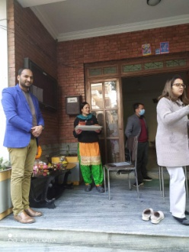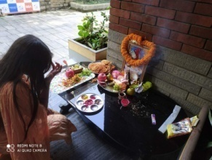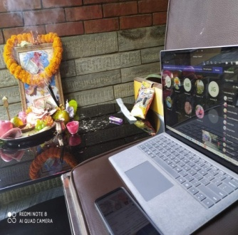
FIRST SESSIONAL EXAM
S. N | Date | 2nd Semester | 4th Semester | 6th Semester | 8th Semester | Time
1 | 2078-10-24 | Business Statistics | Taxation and Auditing | Management Information System | Sales and Distribution | 7:00 AM-9:00 AM (Extra 1 hr. for s ending answer sheet)
2 | 2078-10-25 | Macro Economics analysis and Policy Making | Business Law | Tourism Management | Marketing of Services
3 | 2078-10-26 | Business Communication | Financial Management | Public Finance | Brand Management
4 | 2078-10-27 | Financial Accounting- II | Human Resource Management | Total Quality Management | International Business
5 | 2078-10-28 | Principles of | Quantitative Techniques of Business | Entrepreneurship Development | Strategic Management
 |  | Marketing

Procedures to follow for the 1st Sessional Examination
(The 1st online internal examination will also be the sources of your internal mark’s evaluation).
- Exam is based on online system.
- In this examination, you all will be receiving your question paper at 6:45 AM at your official email address provided by the College.
- Exam will be of 2 hrs. (7AM - 9AM). You will additionally be given 1-hour time to make an arrangement for sending us your PDF copy of your answer sheet (using Cam Scanner). So, answer sheet should be submitted to us by 10 AM.

Answer sheet received thereafter will not be accepted at all.
While sending your answer sheet in an email- on the "Subject " Section, you need to follow the following way:
(Semester name _ Subject name _ Name of the Student)

e.g.: 2nd semester_ Human Resource Management _ Shreya Adhikari

The Answer Sheet should be submitted simply by clicking “Reply” at the same email address (officialswbc@gmail.com) where you receive your question.

Note:
- Sending email of your answer sheet to the Faculties or to any personal email address of the Management Team will not be accepted as it is the procedure of the Examination Committee to submit your answer sheet to the faculties collectively.
- While sending an email of your answer sheet, if you “Reply All” your email, your answer sheet will be disqualified assuming as a process of transferring your answer sheet/ teaching to others.
Once we receive your question, kindly acknowledge as “Received” so that we could update that you have received your questions.

You will also receive an acknowledgement email from the Examination Committee as “Received” when received your answer sheet. Those, students who do not receive the acknowledgement email after 10 minutes of your answer sheet submission, he/she should:

2nd and 4th semester students- make an enquiry call to Ms. Prakriti Koirala Mam- Contact: 01-4981005.
- 6th and 8th semester students- make an enquiry call to Mr. Binaya Kattel Sir- Contact: 9851243953.
Instructions to follow while writing your paper
- You need to use either Full scape paper or A4 size paper for writing your examination. One side of the paper should be used to write your answer as it might make the other side of the paper unclear.
- Leave 1.5 inch on the left, right, up and downside of each paper and write your answer within the margin.
- Mention your Name, Subject name, Date, Page number of your answer sheet on each page of your RIGHT-HAND SIDE OF YOUR answer sheet.

Please feel free to contact the Management Team, if any queries from your side.
Thank You and Stay Safe
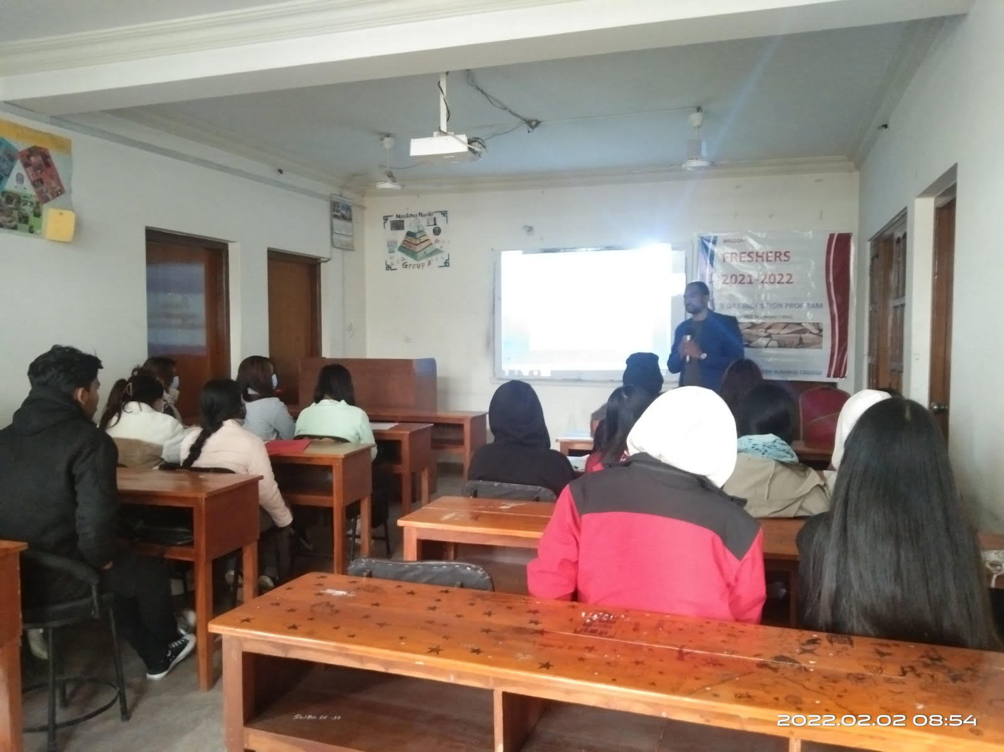 Southwestern Business College
--------------------------------------------------------------------------------------------------------------------------------------------------------
BBA INDUCTION PROGRAMME of 2021 BATCH (5 Days)
Days/  Time/ Title | Day 1: Feb 1 2022 | Day 2: Feb 2 2022 | Day 3: Feb 3 2022 | Day 4: Feb 4 2022 | Day 5: Feb 7 2022
6.30 am-7.30 am  Involve | PANEL GAME ON BRAND
6.30 am-7.15 am |  | About Course:  Mr. Baburam Sir
7.15 am- 8.15 am |  | Are not you the Winner?: Expert
7.30am- 8.15 am |  |  | About Course:  Mr. Dolraj Sir | RISK FREE: Game | Management BINGO: Game
7.30 am- 8.30 am  You all are most Welcome | 1. Initial - 05 minutes: Program Coordinator/Host – Mr. Kattel  2. Willing to risk the usual- 20 min: Campus Chief Dr. J R P  3. Take up one idea-20 min: Board Director B Sagar Pradhan  4. Welcome Speech- 15 min: Chairperson Dr. Krishna B Karki
8.15 am- 9 am |  | SWBC Rules: Mr. Kattel |  | About Course:  Mr. Rajkumar Sir
8.15 am- 9.15 am |  |  | Better Role Model: Expert |  | Tongue VS Patience: Expert
8.30 am- 9.30 am  (Know us) | 1. Program Details – VCC Prakriti Koirala  2. Introduction of Faculty- VCC
9 am- 10 am |  | Mgmt TUG of WAR : Game |  | The FUTURE: Expert
9.15 am- 9.30 am |  |  | Accounts, Library, Computer Lab: Ms. Anisha Shrestha
9.15 am- 10 am |  |  |  |  | About Course:  Mr. Sagar Sir
9.30am- 10.30 a |  |  | Know Each Other: Game
10 am- 10.30 |  |  |  | A brief session with Pass-outs | A brief session with Seniors

Experts: Day One

Experts : Other Days
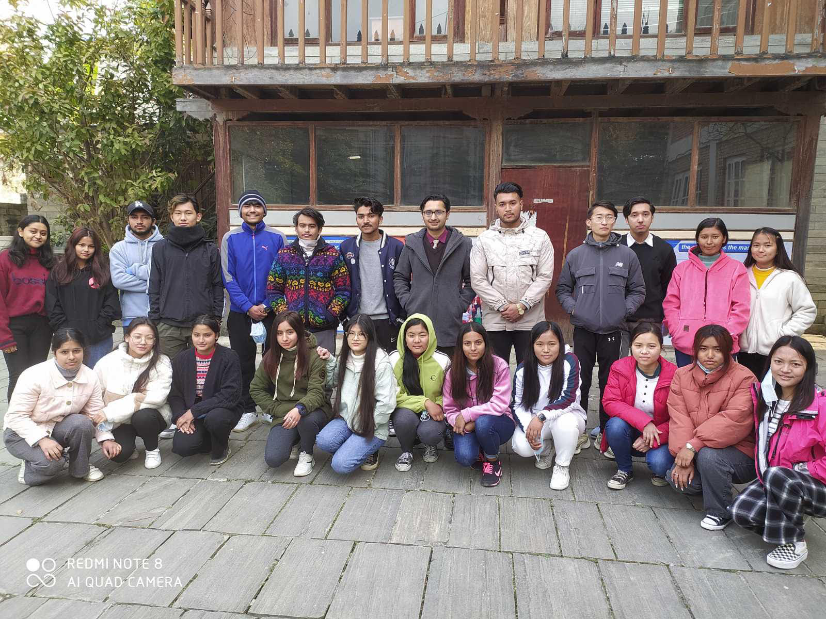
SWBC: Know Each Other Game: FEB 3,2022
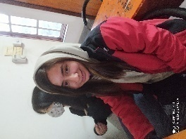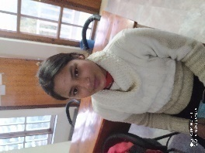
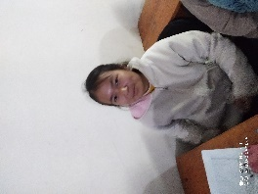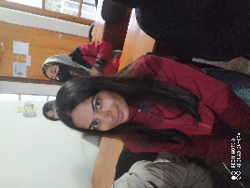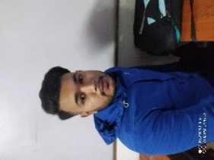
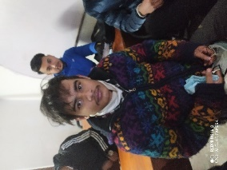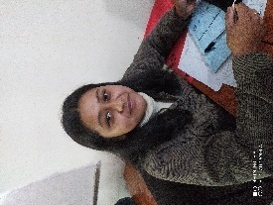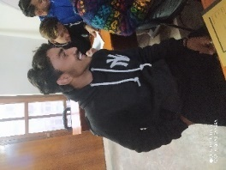
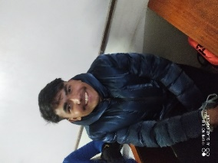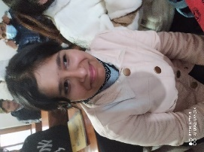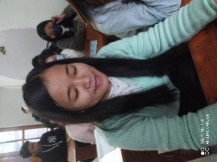
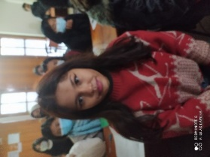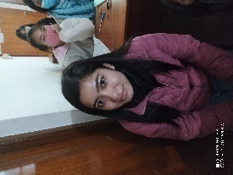
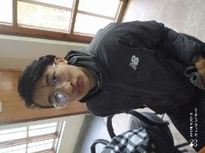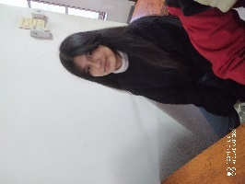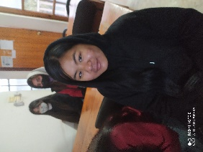
PANEL GAME ON BRAND
Management Tug of War
Definition: It is a Game played between two Teams consisting of equal number players in two sides. The game proceeds forward through both the team members pulling the rope from the two sides with an aim to drag another team across the center line. The center is best described by a red rope or with some white powder on the ground.
Message:
(a) We, generally, do have competitions everywhere. It should be natural and obeying the rules completely. There should be no cheating. We should forget about it after the result is announced since tomorrow we might be in other side.

(b) The game reflects the significance of a CHAIN. It is only as strong as its weakest link. Participants will learn cooperation and team spirit in this ‘NON CONTACT GAME’.
Relevance: Generally, there are two sides of governance in the companies. They get differentiated through their angles. They are:
(a) Management angle; (b) Leadership angle
Many of the times, management and leadership roles are played by the same team, while there is a policy body playing the role of another body which is cooperating, monitoring and checking. In such cases, the angles become:
(a) Performing angle; (b) Policy angle
Hence, as per the requirement, the name of the Team can be:
(a) Management Team (b) Leadership Team (c) Executive Team (d) Policy Team
Photos
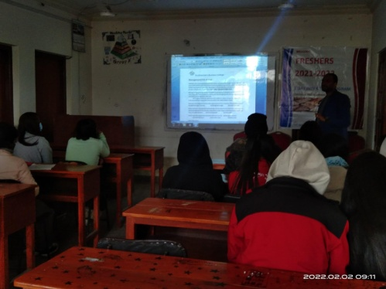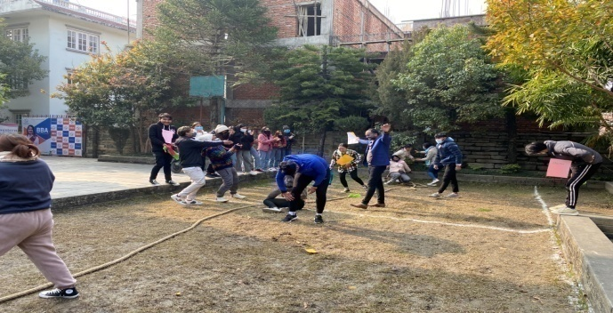
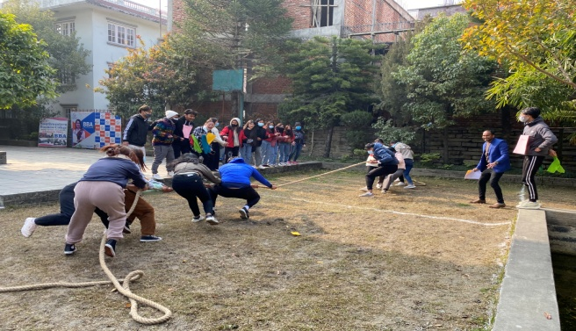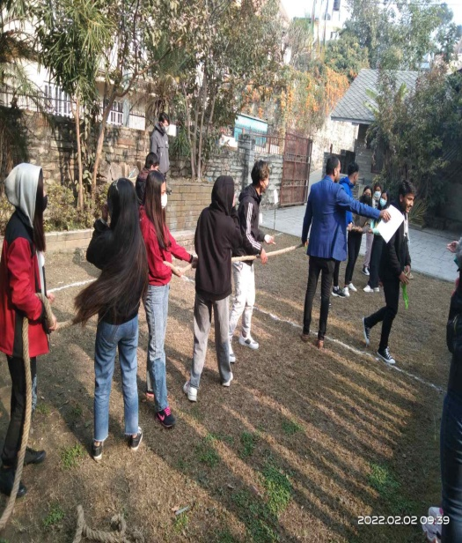

RISK FREE GAME Photos
- Trend of miscommunication when it passes through various hands: Example is the demonstration of simple message conveyed through few body moves by one person to another followed by the imitation of same moves to next by the first receiver and so on. Towards the last, the moves become different.

- 
 