**Southwestern Business College**

**NEWSLETTER BAISAKH 2079**

**INDIVIDUAL FOCUS SERIES—38**

**Dr. Jayahari Raj Pandey**

"Life is 10% of what happens to me and 90% of how I react to it." --- John Maxwell

Reaction is an added concern of the Individual Focus Program. I have taken the help of the above quotation just to have an outside connection to what the theme of the Individual Focus Program believes in. We should not be, however, confused that all quotations are always true or applicable to all. There are several depending factors. Further, we can find two or more contradicting quotations. Let me take one example, as follows:  
"Don't prepare. Begin. Our enemy is not lack of preparation. The enemy is resistance, our chattering brain producing excuses. Start before you are ready."   
-- Steven Pressfield

We have options at every step. When we become able to control ourselves in all situations (even in extreme ones), our capacity of non-reaction is measured at higher level. Naturally, we become able to find more options of solutions. We, as creature of substance – in an ordinary concept of philosophy, find our existence in generic form and are surrounded within perception, knowledge, causation, mind, and thinking. They are the controllers of our behaviors. So, the aim of Individual Focus is to make aware to the students the benefits of responding rather than reacting. Thanks to the wide circulation of individual ideas and experiences via social networks that many useful subjects are spread and exchanged extensively. The two phenomenons: React or Respond fall in the same category. One is instance outcome of emotions, while another is the use of intelligence over the emotions towards producing the desired outcome. Emotion controls you, when you control emotions it is intelligence. Take a case in which there is a family gathering of around 25 including children. They are in happy mood: the shouting coming from here and there, laughter at different corners, background music, and continuous murmurs verified it. Suddenly, there was a shrill scream followed by many more. What exactly had happened was a strange looking insect had landed on the shoulder of a five-year old boy which made him cry in panic that attracted looks from his mother and other aunties. All of them began to shout in diverse styles. IT WAS REACTION! Now, the father of the boy (who was on the other side of the room), understanding the situation came forward, put his hand on another shoulder of the boy, told him not to worry and stop yelling, took out a handkerchief from his pant-pocket, put the handkerchief on top of the insect, grabbed the insect from within, went to the window, and threw away the handkerchief outside from the window. IT WAS RESPONSE!

“Every sensation shares the same characteristic: it arises and passes away, arises and passes away. It is this arising and passing that we have to experience through practice, not just accept as truth because Buddha said so, not just accept because intellectually it seems logical enough to us. We must experience sensation’s nature, understand its flux, and learn not to react to it.” – **S.N. Goenka**

Personally, I am fond of this quotation from Goenka. The reason is simple. It does not ask us to blindly follow the lines told by some famous personality. Rather, good suggestion is to use one’s own individualism, i.e. to understand the consciousness by self, to realize the fluctuation, and thus decide the best course of action through practice.

Individual Focus Program recognizes 7 steps in the direction of such practice. We have already discussed about the three of them.

**Know your individualism**: How you feel in general and overall circumstances? What types of powerful emotions you have? How you perceive things? Take a case: You are in a Café with your friends. One of them you are meeting after so many years. He had arrived just yesterday from USA after a gap of 7 years for a month. The talks covered everything: their university days, their struggles, other friends and their current status, families, movies, and jobs. The friend from USA said to you: You have aged a lot! Your gray hair and softness around the face has made you look like our elder brother! Suddenly, you are red-faced! Your instant impulse is to hit him back with piercing words like ‘look at yourself, you are looking worse or why are you showing your USA drama or are you trying to insult me?’ But, the new situation demands to have a look at your past reactions! Whenever somebody makes a comment relating to you, you don’t like it, you get instantly angry, and you can’t control yourself from making an immediate hit-back. That has been your individualism.

**Analyze without biasness**: It applies in all cases. It is more so, when you are dealing in the aspects of self correction. While you are exploring your past characteristics and trying to know your inner self, you have to be free from prejudice. It is often said that bad comments on us, uncertainties, anxieties etc. are parts of life, and they are like birds – they fly near us and we cannot stop them from doing so, but it is in our capacity not to let the birds make nests within us. Such truths help us in scrutinizing our in general aspects without bothering to hide certain part/s of them, or without discrimination. We become aware that all humans have some flaws and it is quite normal. Smartness demands to know one’s flaw/s, to be brave, and to work towards correcting or minimizing the impact.

**Realization of flaws by self and finding room for correction**: Going inside individualism also reveals which action of self was responsible for such and such bad results in the past. That naturally was the flaws. And such realization was considered as excellent for self-awareness. In the above case, when your friend from USA made such comment, you should go inside yourself and try to remember such incidents in the past when personal comments were made against you. You will comprehend that they made you feel bad, and that feeling was the root-cause of your retort back. Remembering the whole episode, it worked like a cycle of bad feeling creating another bad feeling. It made you feel bad, and later you made him feel bad. In total, it made the environment bad. Room for correction demanded that if someone tried to create a feeling of bad, you should try to convert that feeling into good.

## Adjustment of your emotions: After knowing your individualism and thorough analysis, you need to know some basics. "Insults are like angry bulls... they can only do damage if you let them in. You can't control what people say, but you can control if you let it bother you. No one's opinion of you is more important than your own." -- Doe Zantamata. This quotation tries to touch on the possible damage if one has not control over their emotions and let it go inside to form the anger. Hence, now you know that you get angry when someone makes a comment about you, and that such anger has been producing bad results only as well as further provoking you to be angry in some cases. Thus, you need to be able to adjust your sensation. In the above case, when your friend from USA makes a comment about you having aged more, you take it lightly and give a good smile.

## Stimulus for improved Communication: The conversion of bad feeling created by someone into good one demands some good communication. In the above case, goal is to convert the bad feeling created by others into good feeling. Now is the time to have the ability to put the goal front and center, and have inclination for finding out good words of communication.

## Bring Compassion in Communication – To have that kind of good words (as mentioned above), you should have the understanding of good or bad feelings, and what causes them. The start of an example (given above) had shown that bad comment on self had provoked one’s self, and anger was developed. If it had been the contrary case, i.e. had the words from the friend from USA been like: “You are still the same! You have not aged. Your gray hair and softness around the face has made you look like an adult teenager”, you would have liked it a lot. Same happens to everybody. So, understanding this is called empathy.

## Development of Social Skills – We all are familiar about this. The new technology has made it easier for us, and we have been able to harness the benefits of remaining in contact in easy and interesting formats: be it in social media or emails. They have taught us the nurturing of good inter-personal skills to get progress in communication. A crow does not steal peoples’ money still it is not well-liked. On the other hand, a cuckoo does not give money to anyone, but it is liked by all. The difference is the communication: ‘sweet words’. Here, it will be relevant to remember that social skills will flourish more through human touch and personal interactions, and we should never restrict ourselves to the devices only ( as many of our tasks are being possible through on-line in a growing degree).

**SPORTS WEEK 2079 (5th – 9th Baisakh)**

This is our Annual Event! This time, one new Game was introduced!

**Chess Game:**

**2079/01/05**

Two groups were made: Group A and Group B

**Group A Group B**

* Juju Gurung - AbhashLamichhane
* NabinPoudel - DipakLamichhane
* Sunil Nepali - ManojKumal
* Manish Gurung - Supraj Shrestha

Game1- Juju Gurung VS Abhas Lamichhane:

Game2 – Nabin Poudel VS Dipak Lamichhane:

Game3 –Sunil VS Manoj Kumal

Game4 – Manish Gurung Vs Supraj Shrestha

**Semi Final: Game2 VS Game3, Game1 VS Game4**

* Dipak Lamichhane VS Manoj Kumal
* Juju Gurung VS Manish Gurung

**Final:**

* ManojKumal VS Manish Gurung

**Winner:**

* Manoj Kumal, 8th Semester

**Ludo Game:**

**2079/01/05**

Group A- 1. Supraj Shrestha 2. Juju Gurung 3. Nabin Basnet 4. Rajani Gurung

Group B- 1. Lalit Gotame 2. Chime Dorje Lama 3. Sajana Khadka 4. Shruti Gurung

Group C- 1. Ashish Giri 2. Manisha Khatri 3. Barsha Gurung 4. Nabin Shrestha

Group D- 1. Sushmita Pyakurel 2. Nirmala Khadka 3. Astha Karki 4. AsthaSubedi

Group E- 1. Santosh Magar 2. Bibidh Khatri 3. Avash Lamichhane 4. Reeyaz Manandar

Group F- 1. Ashok Gurung 2. Nabin Poudel 3. Sobit Pant 4. Sunil Nepali

Group G- Sangam Acharya 2. Aayush Kharel 3. Dipak Lamichhane 4. Manoj Kumal

Group H- Nitesh Baniya 2. Sulav Khadka 3. Rabin Shrestha 4. Apil Lamichhane

8 Winners of 8 Groups

Winner of Group A,C,E,G one Game (Game X) : Nabin, Ashish, Reeyaz, Ayush (First and Second)

Winner of Group B,D,F,H one Game(Game Y): Shruti, Nirmala, Sobit, Sulabh (First and Second)

**Final**

Winner of Game X : Reeyaz and Aayush VS

Winner of Game Y: Nirmala and Sobit

**Winner –Sobit Pant**

**Second – Nirmala Khadka**

**Third – Reeyaz Manandhar**

**Badminton Game: Boys**

**2079/01/08**

Game1 –Nitesh Baniya VS Juju Gurung

Game 2- Apil Lamichhane VS Dipak Lamichhane

Game 3- Aayush Kharel VS Sobit Pant

Game 4- SrijanAdhikari VS Sagar Dongol

Game 5- Santosh Magar VS ManojKumal

Game 6- Sangam Acharya VS Sulav Khadka

**Quarter Final**

Game 7- Winner of Game 1 VS Game 6: Nitesh and Sangam

Game 8- Winner of Game 2 VS Game 5: Apil and Manoj

Game 9- Winner of Game 3 VS Game 4: Sobit and Sagar

**Semi Final**

Sangam – Bye and moved to the Third Place

Game10- Winner of Game 8 ( Apil Lamichhane VS Manoj Kumal)

Game11- Winner of Game 9 ( Sobit Pant VS Sagar Dongol)

**Final :** Manoj and Sagar

* 1st – ManojKumal
* 2nd – Sagar Dongol
* 3rd- Sangam Acharya

**Badminton Game: Girls**

Game1- Samarpana Raut VS Sajgata Shrestha

Game2- Ronisha Shrestha VS Nirmala Khadka

Game3- Barsha Gurung VS Sushma Lama

Game 4– Shruti Gurung VS Astha Subedi

Game 5- Laxmi Sherma VS UshaThapa

**Quarter Final**

Game6 – Winner of Game 1 VS Winner of Game5

Game7- Winner of Game2 VS Winner of Game4

Bye to move to the Third Place - Winner of Game 3

**Semi Final**

Sajgata Shrestha VS UshaThapa

Nirmala Khadka VS Shruti Gurung

**Final**

Sajgakta Shrestha VS Shruti Gurung

* 1st- ShrutiGurung
* 2nd – Sajgata Shrestha

**Table Tennis Game: Girls**

**2079/01/06**

**Group A Group B**

1. UshaThapa 1- Shruti Gurung ( Game 1)
2. Sushma Lama 2- Swastika Baral ( Game 2)

**Final**

Game 1 VS Game 2

* 1st- Swastika Baral
* 2nd- Shruti Gurung

**Table Tennis Game:Boys** Tie Sheet

**Pre-Game**

PG1- Juju Gurung VS Nabin Basnet

PG2- Ashish Giri VS Supraj Shrestha

PG3- Ghanendra VS AvashLamichhane

PG4- Bibidh Khatri VS NabinPoudel

PG5- AayushKharel VS Sunil Nepali

PG6- Sangam Acharya Bye

PG7- NiteshBaniya Bye

PG8- Sagar Dongol Bye

**Quarter Final Game**

Game 9 – Winner of PG1 VS PG8: Juju and Sagar

Game 10- Winner of PG2-VS PG7: Supraj and Nitesh

Game 11- Winner of PG3 VS PG6: Abhash and Sangam

Game 12- Winner of PG4 Vs PG5: Bibidh and Aayush

Semi Final Game

Game 13- Winner of Game 9 VS Game 12: Juju vs Aayush

Game 14- Winner of Game 10 VS Game 11: Nitesh vs Sangam:

Game 15- Winner of Game 13 VS Game 14 :

Game 16- for Third Place: Loser of Game 13 vs Game 14

**Final**

* 1st- Juju Gurung
* 2nd – NiteshBaniya
* 3rd- Aayush Kharel

**Management Tug of War**

**2079/01/06**

**Group A GroupB GroupC Group D**

1. Juju Gurung 1. Supraj Shrestha 1. Nabin Basnet 1. ShrutiGurung
2. Anuska KC 2. Dawa Lama 2. Santosh magar 2. Chime Dorje Lama
3. Manisha Khatri 3. BarshaGurung 3. Sajana Khadka 3. Ashish Giri
4. Pooja Lama 4. AsthaSubedi 4. Sushma Lama 4. LalitGotame
5. ReeyazManandar 5. Bibidh Khatri 5. NabinPoudel 5. AbhasLamichhane
6. UshaThapa 6. UshaPokheral 6. Sangam Acharya 6. JuhiGiri
7. ApilLamichhane 7. Sagar Dongol 7. DipakLamichhane 7. Sobit Pant
8. ManojKumal 8. Manish Gurung 8. Sulav Khadka 8. AayushKherel
9. Ronisha Shrestha 9. ShritiGurung 9. Rabin Shrestha 9. NiteshBaniya

Game 1- Group A VS Group B

Game2- Group C VS Group D

Final

Game 3- Winner of Game 1 Vs Winner of Game 2

Winner Group C

* Nabin Basnet Santosh Magar Sajana Khadka
* Sushma Lama Dinesh Bhandari Sangam Acharya
* DipakLamichhane Sulav Khadka Rabin Shrestha

**Basket Ball Game**

**2079/01/07 Tuesday**

**Team A Team B Team C**

1. Sobit Pant 1) ApilLamichhane 1) NiteshBaniya
2. Sunil Nepali 2) Sagar Dongol 2) Manish Gurung
3. SoloniThapa 3) Rizan Shrestha 3) Bijaya Gupta
4. DipakLamichhane 4) Rabin Shrestha 4) Sushant Magar
5. NabinaGhale 5) Sulav Khadka 5) PoojaGurung
6. Ronisha Shrestha 6) Manish Gurung 6) Sajana Khadka

**Team D Team E**

1. Sulav Khadka 1) Chime Dorje Lama
2. Rizan Shrestha 2) ShrutiGurung
3. Santosh Magar 3) Anish Bogati
4. Bibidh Khatri 4) Juju Gurung
5. SaritaDongol 5) Nabin Basnet

**Pre-Game**

Game1- Team B VS Team E

Semi Final

Game 2- Team C VS Team D

Game 3- Team A VS Team C

Game 4 – Team A VS Team B

Game 3- Winnner of Game 1 VS Team A = Team A vs Team B = Winner Team B  
Game 4- Winnner of Game 2 VS Game 3 = Team E vs Team B = Winner Team B

**Final Game: Winner**

* Sagar Dongol Apil Lamichhane Rabin Shrestha
* Sulav Khadka Manish Gurung Rizan Shrestha

**Second**

* Sobit Pant Ronisha Shrestha NabinaGhale
* Sunil Nepali Soloni Thapa Dipak Lamichhane

**Futsal Game: Boys**

**2079/01/9**

There are four teams:

|  |  |  |  |
| --- | --- | --- | --- |
| **Team A** | **Team B** | **Team C** | **Team D** |
| Juju Gurung | Riyaz Manandhar | Sobit Pant | Apil Lamichhane |
| Bijaya Singh Karki | Ashok Gurung | Bijaya Teli | RewazManandar |
| Supraj Shrestha | Aayush Shrestha | Sunil Nepali | Sagar Dongol |
| Nabin Shrestha | Abhash Lamichhane | Sangam Acharya | Rabin Shrestha |
| Chime Dorje Lama | Dambar Bk | Dinesh Bhandari | Shrijan Adhikari |
| Anish Bogati | Nabin Poudel | Deepak Lamichhane | Sulav Khadka |
|  |  |  | Manish Gurung |
|  |  |  | Rijan Shrestha |

**Quarter Final**

Game1 – Team A VS Team C

Game2- Team B VS Team D

Team A and Team D Winner

**Final**

Game3 - Team A and Team D

**Team D Winner**

* ApilLamichhane RewazManandhar Sagar Dongol
* Rabin Shrestha ShrijanAdhikari Sulab Khadka
* Manish Gurung Rijan Shrestha

**Second**

* Juju Gurung Bijaya Singh Karki Supraj Shrestha
* Nabin Shrestha Chime Dorje Lama Anish Bogati

**Futsal Game: Girls : 2079/01/09**

There are 3 Teams

|  |  |  |
| --- | --- | --- |
| **Team A** | **Team B** | **Team C** |
| BarshaGurung | Pooja Lama | Swastika Baral |
| Manisha Khatri | LaxmiSherma | SaloniThapa |
| ShrutiGurung | Ronisha Shrestha | NishaThapa |
| Dawa Lama | NabinaGhale | PoojaGurung |
| SamarpanaRaut | Sushma Lama | SirjanaChaudary |
| RaginiGurung | SaritaDongol | Sajana Khadka |

Team B Bye by Tossing Coin

Game 1- Team A VS Team C

Team A Winner

Game2 Team A VS Team B(Bye)

**Team B Winner**

* Pooja Lama LaxmiSherma Ronisha Shrestha
* NabinaGhale Sushma Lama SaritaDongol

**Second**

* BarshaGurung Manisha Khatri Shruti Gurung
* Dawa Lama Samarpana Raut Ragini Gurung

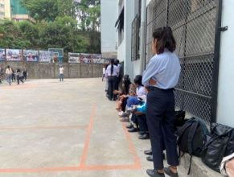 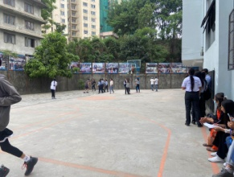 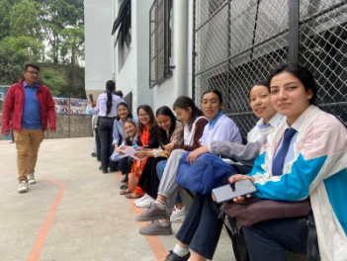 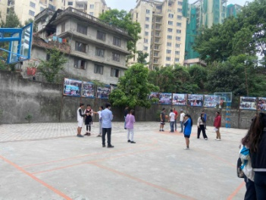

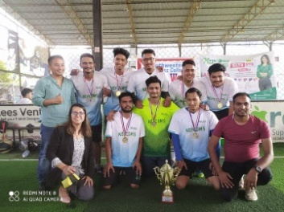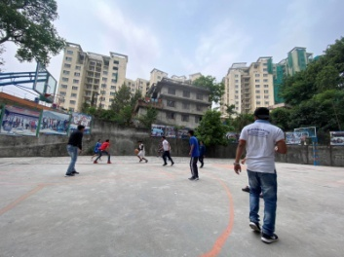 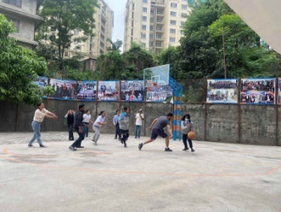 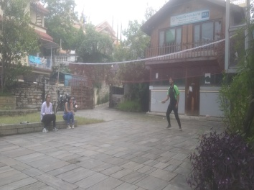

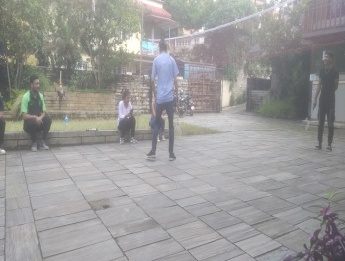 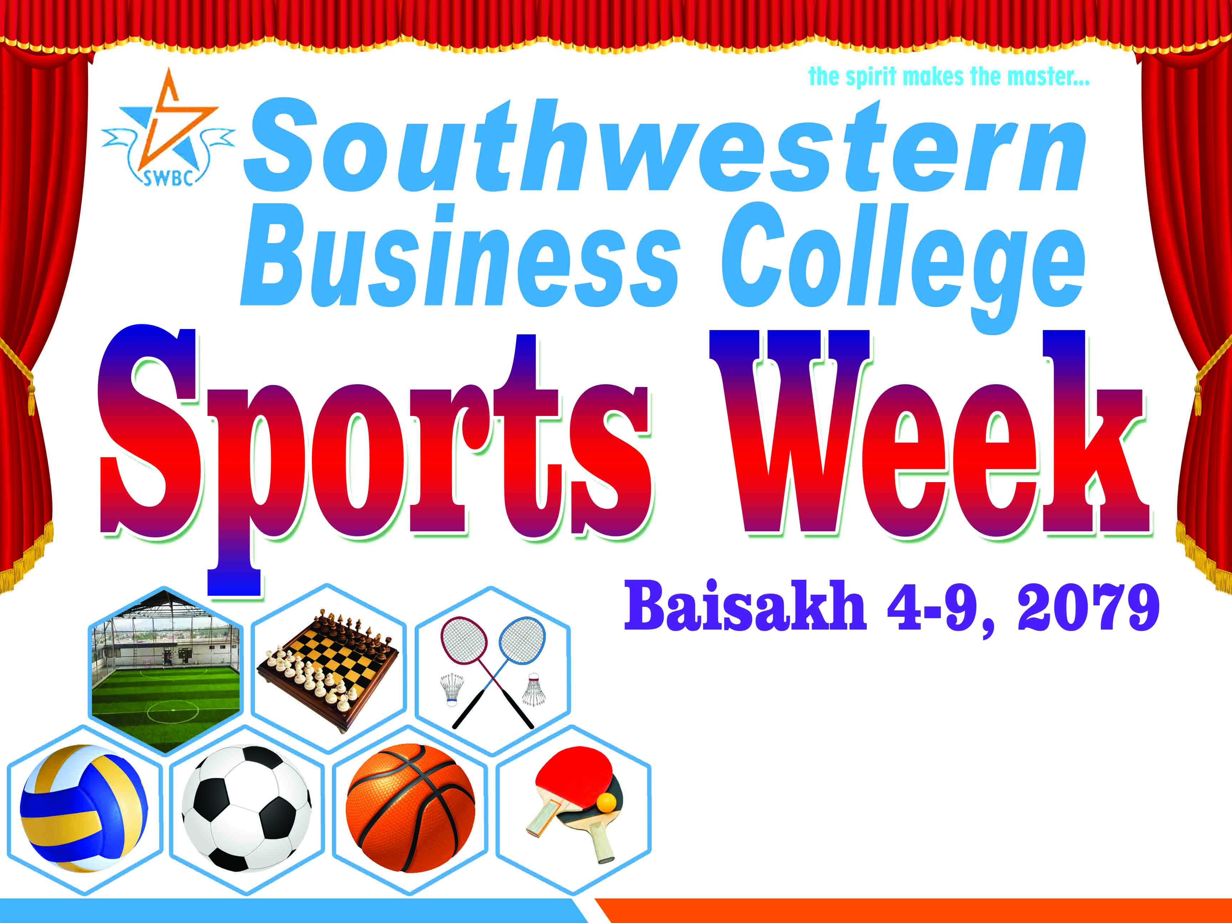 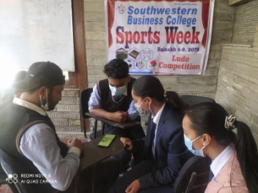 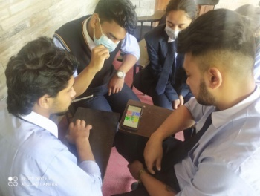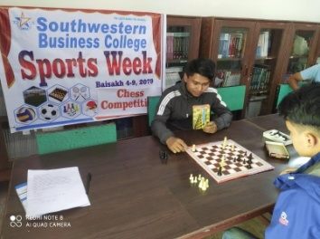 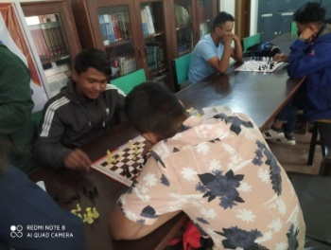 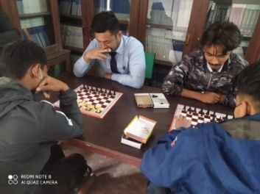 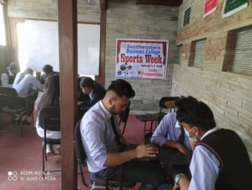

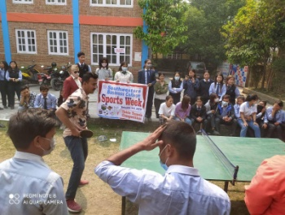 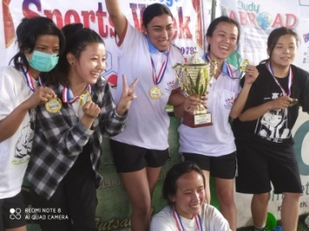 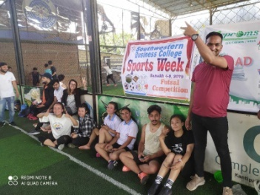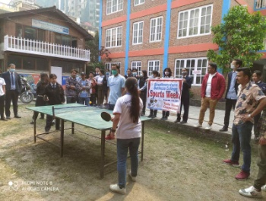

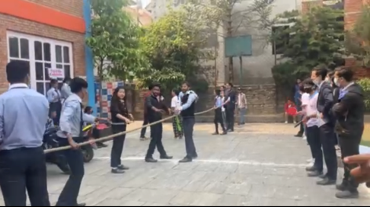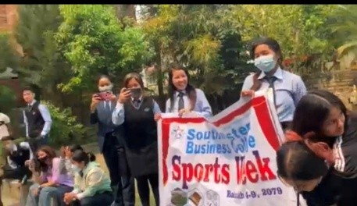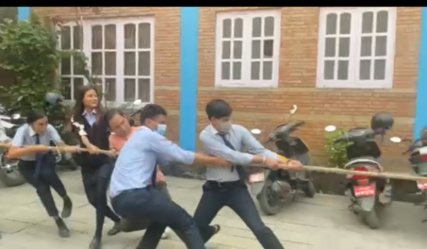

**WELCOME/FAREWELL/AWARD CEREMONY: Baisakh 17th 2079; April 30th 2022**

**Agenda of the Program**

**First Part- Introductory Emcee- Mr. Binaya Kattel, PC**

1. Call On Dias (Chairman, Chief Guest, Guest, BOD, V.C.C).
2. Garlanding the CHIEF GUEST and the Guests.
3. National Anthem.
4. Inauguration by the Chief Guest.
5. Welcome Speech by the Campus Chief.

**Second Part- Welcome**

**Emcee by Second Semester (Ms. Nirmala Khadka, Mr. Ghanendra Kumar Panjiyar)**

1. Name Calling of the New Students.
2. Badge Distribution to the Freshers.
3. Welcome Speech by Mr. Aayush Shrestha and Ms. Nisha Chhantyal.
4. Welcome Dance by Ms. Pooja Lama, Ms. Sushma Lama (2nd Semester). “NEPALI MIX SONG”
5. Welcome Dance by Ms. Sajana Khadka (1st Semester). “AKHAMA GAJAL LAGAYERA”

**Third Part- Farewell**

**Emcee: (Mr.Suzan Tamang, Mr. Nitesh Baniya)**

1. Name Calling of the Students ( the passouts).
2. Badge Distribution to the Students (the passouts).
3. Farewell Speech by Mr. Amit Khanal.
4. Farewell Song by Ms. Suzan Tamang and Mr. Riyaz Manandhar. “MAYA”
5. Farewell Dance by Ms. Nabina Ghale “KAILE PHOOL BANI”

**Fourth Part –Awards Distribution Program**

**Emcee- Prakriti Koirala, VCC**

1. Attendance Focus Awards
2. Dance by Ms. Ragini Gurung (1st Semester). “ CHOLI RAMRO PALPALI DHAKAKO”
3. Academic Excellence Awards
4. Dance by Ms. Laxmi Sherma. “TAMANG SELO”
5. Appreciation Awards
6. Song by Mr. Sobit Pant (6th Semester). “HAWA CHALYO SARARA”

**Fifth Part- Major Awards Distribution Program for Year 2021**

**Emcee: Prakriti Koirala, VCC**

1. Students of the year
2. Prize Distribution
3. Teacher of the year
4. Prize Distribution
5. Hydro visual and Prize Distribution
6. Cultural Program Group Dance by Ms. Manisha Khatri, Mr. Juju Gurung, Ms. Shruti Gurung, Ms. Barsha Gurung, Mr. Yaran Gurung and Mr. Bijay Singh Karki (1st Semester). “ DADHA GHARE SAILI”

**Sixth Part- Addresses Emcee: Binaya Kattel, PC**

* Chief Guest Prof. Dr. Yadav Raj Koirala, VC, PU
* Chair Person Dr. Krishna Bahadur Karki
* Memento to the Chief Guest

**Emcee- Prakriti Koirala, VCC**

**Seventh Part- Mr. /Ms Fresher Show**

Judge Panel- (Ms. Rijuta Maharjan, Mr. Krishna Bahadur Uchai)

* 2020 Batch (Name Calling of the Participants)

1. Ms. Sushma Lama
2. Ms. Astha Subedi

* 2021 Batch ( Name Calling of the Participants)

1. Ms. Ragini Gurung 1) Mr. Nabin Basnet
2. Ms. Sajana Khadka 2) Mr. Chime Dorje Lama

3) Mr. Supraj Shrestha

4) Mr. Anish Bogati

*English Song by Mr. Pawan Neupane*

Round 1: Ramp Walk

Round 2: Introduction Round

Round 3: Talent Round

Distribution Sheet For Audience Marks

Round 4: Question Answer Round

*Song by Mr. Dipak Lamichhane: “NANI KO KAHA PARYO GHARA”*

Mr. /Ms. Fresher announcement by the Judge panel.

Congratulation and Prize Distribution to Mr. /Ms Freshers.

**END OF THE PROGRAM**

**DOING THE SAME PHENOMENON DIFFERENTLY**

The Welcome/Farewell/Award Ceremony Program, this time, had some unique features, as follows:

1. **Place Selection**: This time the venue was selected 25 kms away from our place. Previously, it was organized in nearby places like Godhuli Foodland etc. Beautiful natural place speaks in its own way. Travel to famous place Dhulikhel was the first time for most of the students, and also for many other participants.
2. **4 hours travel through Bus for all:** 3 Buses of our other organizations (School and State College) were used for the whole day (they made two trips for going and coming and stationed there for the entire period of time). The longer you are together with many friends in a journey, in a free mood, the closer you become with each other. The entertaining episodes including songs and poems etc. open up many sensational tissues within the bodies of all.
3. **Exceedingly high attendance**: The number of participants this year was far more in comparison to previous programs – totaling more than 140.
4. **High Level Program**: A program’s level is determined by the dignity of the Chief Guest and other Guests. For the first time, Vice Chancellor of our University Prof Dr. Yadav Raj Koirala was the Chief Guest, and Examination Controller Prof. Mohan Bahadur Basnet was the Special Guest. PU Service Commission Chairperson Badri Nath Shrestha, PU Management Faculty Dean Khagendra Acharya, reputed educationist Prof Dr. Badri Nath Chalise, and current Management Faculty Dean Prof Dr. Biju Thapaliya were the previous Chief Guests respectively.
5. **Good catering**: Similarly, in consideration of the distance to be covered and the duration of the program, two heavy meals – Breakfast and Lunch – were provided to all.
6. **Enlarged Emcees:** In this category of the program, we used to cover the entire agenda through two groups of emcees from the student side (one group of students from the previous batch for the Welcome Program, another group of students from the outgoing batch for the Farewell Program, and one from the Management side for the rest of the sessions). This time, we used two emcees from the Management side (one exclusively for Award Distribution).
7. **Amplified and diversified number of sessions**: Many of the times in the past, the total numbers of the sessions within the Program were seven- as was also this time. However, the address part used to be in the last session. This time, the last session was segregated for FRESHERS ROUND, and the address part was completed in the Sixth Session.

बैशाख २१, २०७९

[](https://artharojgar.com/)

### स्वागत र बिदाई कार्यक्रम सम्पन्न

काठमाडौँ, २१, वैशाख । काठमाडौँ साउथ वेस्टर्न बिजनेश कलेजले धुलिखेल स्थित एक रिसोर्टमा आफ्ना नयाँ विद्यार्थीहरूहरुलाई स्वागत अनि पास आउट भएका विद्यार्थीहरूहरुलाई बिदाई कार्यक्रम सम्पन्न गरेको छ। पुर्वाञ्चल बिश्वबिद्यालय उपकुलपति डा. यादव राज कोइराला प्रमुख अतिथि रहनु भएका उक्त कार्यक्रमा उतकृष्ट हुने विद्यार्थीहरूहरु र कलेजका कर्मचारीहरुलाई बिभिन्न खाले पुरस्कार र सम्मान पत्र बितरण गरिएको थियो।  
कार्यक्रममा पुर्वाञ्चल बिश्वबिद्यालयका परीक्षा नियन्त्रक डा. मोहन बस्नेत CAFIN का निर्देशक गोपाल तिवारी बिशेष अतिथि रहनु उक्त कार्यक्रम डा. कृष्णा बहादुर कार्की को सभापतित्व मा समपन्न भएको थियो। कार्यक्रमलाई सम्बोधन गर्दै उपकुलपति कोइरालाले भन्नु भयो "साउथ वेस्टर्न बिजनेश कलेजले यस्ता खालका कार्यक्रम गरेर विद्याथीहरुलाई मनोबल बढाउने काम गरेकोमा सबैलाई धन्यबाद दिनुभयो।  
कार्यक्रमको बारेमा जानकारी दिदै कोडीनेटर बिनय कट्टेलले भन्नुभयो " यो बर्ष हामीले STUDENT OF YEAR रचना पोखरेल र TEACHER OF YEAR रुपमा अशिविन न्यौपाने लाई समान र मायाको चिनो प्रदान गरिएको र आगामी बर्षहरुमा पनि निरन्तरता दिइने बताउनु भयो।

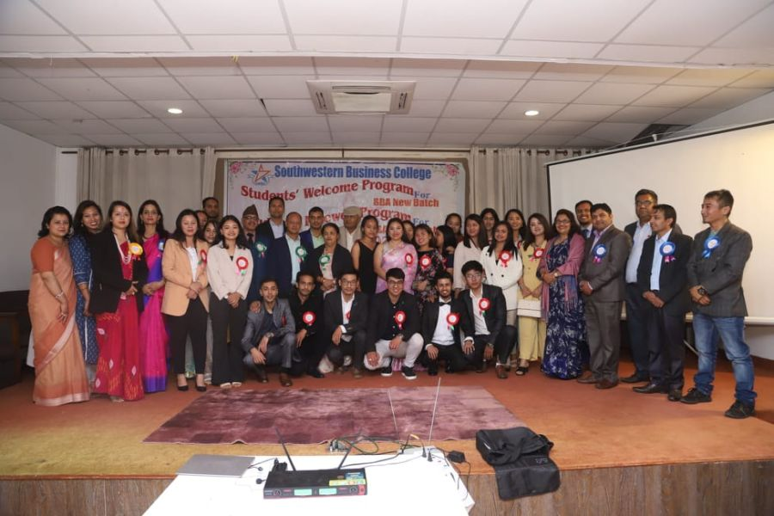



Prof. Dr. Yadav Raj Koirala, Vice-Chancellor of Purbanchal University was the Chief Guest at the Welcome / Farewell / AwardCeremony - 2022 program organized by Southwestern Business College at Dhulikhel Lodge Resort, Dhulikhel.

Dr. Mohan Basnet, Controller of Examinations, Purbanchal University, and Mr. Gopal Tiwari, Director General, CBFIN were the special guests in the program presided over by Dr. Krishna Bahadur Karki.

The program was attended by about 150 people including board members, teachers, pass-out students, new students, other students, and the guests. The program included a welcome program for new students, a farewell program for pass-out students, Academic Excellence Award and Gift Vouchers, Attendance Focus Award, Teaching Excellence Award, Activities Award, and a variety of dance /songs from the students.

Vice-Chancellor of Purbanchal University Prof. Dr. Yadav Raj Koirala presented certificates, cash prizes, and tokens of appreciation to Rachana Pokhrel and Sovit Pant under **Students of the Year** and Mr. Ashwin Neupane under **Teacher of the Year**.

Vice-Chancellor Prof Dr. Yadav Raj Koirala also welcomed the new students on behalf of the university and wished the ‘pass-out students’ successful career ahead and a very bright future.

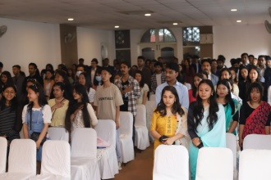 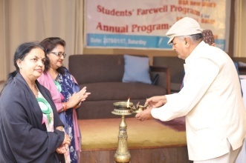 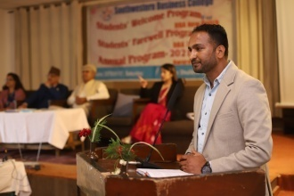 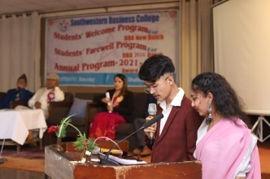

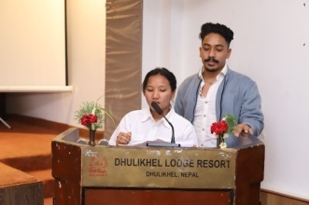 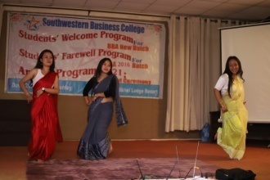 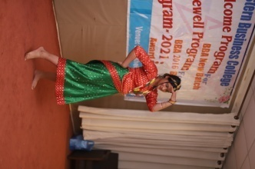 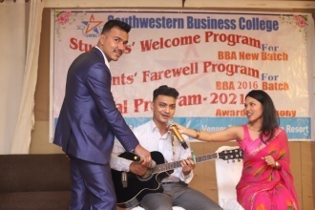

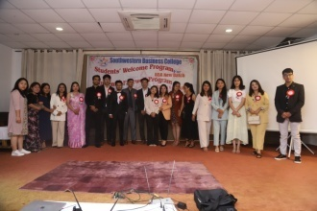 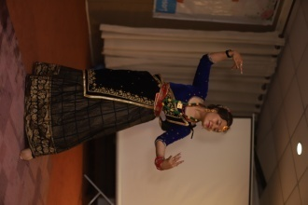 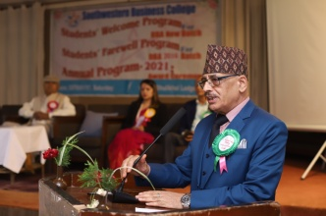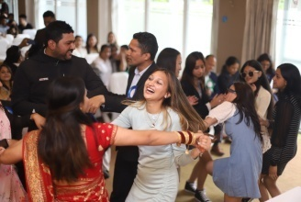

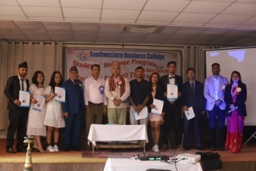 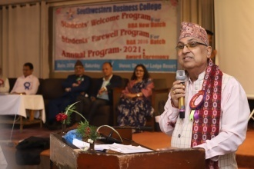 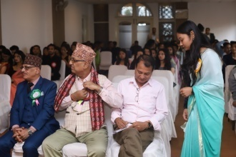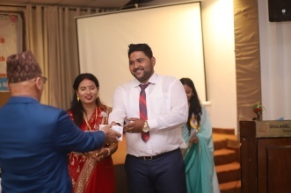

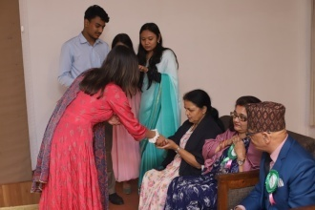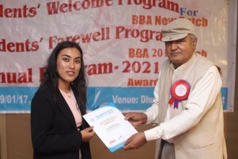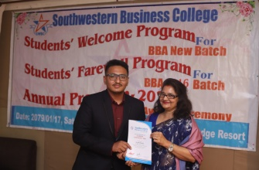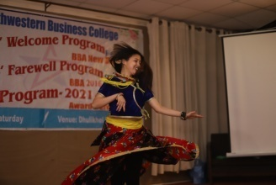

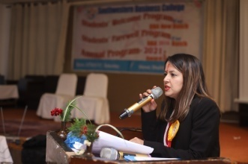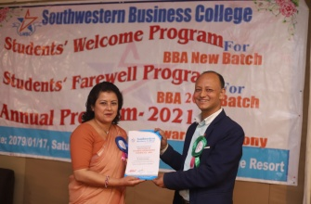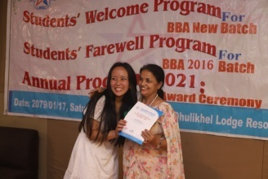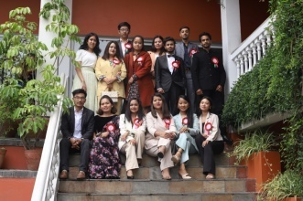

**Awarded persons in the Ceremony**

|  |  |  |  |  |
| --- | --- | --- | --- | --- |
| **S.N.** | **Recipients** | **Criteria** | **Ranking** | **Remarks** |
| 1. | Ashwin Neupane, Faculty | Teacher of the Year | Number One | Cash Prize, Token of Love and Certificate |
| 2. | Rachana Pokharel, 4th Sem | Student of the Year | Number One | Cash Prize, Token of Love and Certificate |
| 3. | Sobit Panta, 6th Sem | Student of the Year | Number One | Cash Prize, Token of Love and Certificate |
| 4. | Pooja Biswokarma, 4th Sem | Academic Excellence Award | 81% in Board Result | Gift Voucher of One Installment of Fee, and Certificate |
| 5. | Sangam Acharya, 6th Sem | Academic Excellence Award | 80% in Board Result | Gift Voucher of One Installment of Fee, and Certificate |
| 6. | Rachana Pokharel, 4th Sem | Academic Excellence Award | 78% in Board Result | Certificate |
| 7. | Sobit Panta, 6th Sem | Academic Excellence Award | 74% in Board Result | Certificate |
| 8. | Sushmita Shahi, 8th Sem | Academic Excellence Award | 70% in Board Result | Certificate |
| 9. | Ajita KC, 8th Sem | Academic Excellence Award | 73% in Board Result | Certificate |
| 10. | Amit Khanal, 8th Sem | Academic Excellence Award | 77% in Board Result | Certificate |
| 11. | Bharat Tamang, 8th Sem | Academic Excellence Award | 74% in Board Result | Certificate |
| 12. | Manish Bahadur Gurung, 8th Sem | Academic Excellence Award | 77% in Board Result | Certificate |
| 13. | Nitesh Baniya, 8th Sem | Academic Excellence Award | 73% in Board Result | Certificate |
| 14. | Rewaz Manandhar, 8th Sem | Academic Excellence Award | 72% in Board Result | Certificate |
| 15. | Rijan Shrestha, 8th Sem | Academic Excellence Award | 73% in Board Result | Certificate |
| 16. | Satarkata Shrestha, 8th Sem | Academic Excellence Award | 72% in Board Result | Certificate |
| 17. | Sajagata Shrestha, 8th Sem | Academic Excellence Award | 74% in Board Result | Certificate |
| 18. | Suzan Tamang, 8th Sem | Academic Excellence Award | 77% in Board Result | Certificate |
| 19. | Varsha Shahi, 8th Sem | Academic Excellence Award | 74% in Board Result | Certificate |
| 20. | Sumana Shrestha, 8th Sem | Academic Excellence Award | 70% in Board Result | Certificate |
| 21. | Sabina Ghale, 8th Sem | Academic Excellence Award | 70% in Board Result | Certificate |
| 22. | Sushmita Kunwar, 8th Sem | Academic Excellence Award | 75% in Board Result | Certificate |
| 23. | Abhash Lamichhane, 2nd Sem | Table Tennis Competition | 1st Position | Certificate |
| 24. | Nirmala Khadka, 2nd Sem | Product Dumb Charade Competition | 1st Position | Certificate |
| 25. | Prakriti Bhatta, 2nd Sem | Product Dumb Charade Competition | 1st Position | Certificate |
| 26. | Puja Thapa Magar, 2nd Sem | Quiz Competition | 1st Position | Certificate |
| 27. | Puja Thapa Magar, 2nd Sem | Ad Mad Collage Competition | 1st Position | Certificate |
| 28. | Sandesh Thapa, 2nd Sem | Badminton Competition | 1st Position | Certificate |
| 29. | Anju Ghale, 4th Sem | Quiz Competition | 1st Position | Certificate |
| 30. | Dinesh Bhandari, 4th Sem | Quiz Competition | 1st Position | Certificate |
| 31. | Rejina Dahal, 4th Sem | Proposal Writing Competition | 1st Position | Certificate |
| 32. | Sunil Nepali, 6th Sem | Ludo Competition | 1st Position | Certificate |
| 33. | Reeyaz Manandhar, 2nd Sem | Quiz Competition | 1st Position | Certificate |
| 34. | Anju Ghale, 4th Sem | Attendance Focus | 4th with 70% | Certificate |
| 35. | Usha Chhantyal, 4th Sem | Attendance Focus | 3rd with 75% | Certificate |
| 36. | Manisha Timilsina, 4th Sem | Attendance Focus | 2nd with 82% | Certificate |
| 37. | Rachana Pokharel, 4th Sem | Attendance Focus | 1st with 94% | Certificate |
| 38. | Aashma Rai, 6th Sem | Attendance Focus | 4th with 85% | Certificate |
| 39. | Laxmi Sherma, 6th Sem | Attendance Focus | 1st with 89% | Certificate |
| 40. | Nabina Ghale, 6th Sem | Attendance Focus | 6th with 78% | Certificate |
| 41. | Ronisha Shrestha, 6th Sem | Attendance Focus | 3rd with 87% | Certificate |
| 42. | Sangam Acharya, 6th Sem | Attendance Focus | 5th with 82% | Certificate |
| 43. | Sobit Panta, 6th Sem | Attendance Focus | 7th with 77% | Certificate |
| 44. | Sushmita Kumari Panjiyar, 6th Sem | Attendance Focus | 2nd with 88% | Certificate |
| 45. | Sushmita Shahi, 8th Sem | Attendance Focus | 7th with 77% | Certificate |
| 46. | Mingbuti Sherpa, 8th Sem | Attendance Focus | 1st with 88% | Certificate |
| 47. | Nitesh Baniya, 8th Sem | Attendance Focus | 2nd with 76% | Certificate |
| 48. | Rewaj Manandhar, 8th Sem | Attendance Focus | 3rd with 72% | Certificate |
| 49. | Anju Ghale, 4th Sem | Activities Participation | 73% | Certificate |
| 50. | Rachana Pokharel, 4th Sem | Activities Participation | 91% | Certificate |
| 51. | Usha Chhantyal, 4th Sem | Activities Participation | 82% | Certificate |
| 52. | Rewaj Manandhar, 8th Sem | Activities Participation | 100% | Certificate |
| 53. | Sabina Ghale, 8th Sem | Activities Participation | 100% | Certificate |
| 54. | Reyaaz Manandhar, 2nd Sem | Activities Participation | 93% | Certificate |
| 55. | Sushma Lama, 2nd Sem | Activities Participation | 73% | Certificate |
| 56. | Baburam Sharma | FACULTY | Good Educator | Certificate |
| 57. | Dolraj Dhakal | FACULTY | Good Educator | Certificate |
| 58. | Prakriti Koirala | FACULTY | Good Educator | Certificate |
| 59. | Sagar Upadhyaya | FACULTY | Good Educator | Certificate |
| 60. | Raj Kumar Upreti | FACULTY | Good Educator | Certificate |
| 61. | Sajani Nepal | FACULTY | Good Educator | Certificate |
| 62. | Sushma Shrestha | FACULTY | Good Educator | Certificate |
| 63. | Nani Maiya Dangol | FACULTY | Good Educator | Certificate |
| 64. | Ashwin Neupane | FACULTY | Good Educator | Certificate |
| 65. | Sangam Acharya, 6th Sem | National Hydro Competition Team Leader | First Prize | Certificate |
| 66. | Pawan Neupane, 6th Sem | Team Member | First Prize | Certificate |
| 67. | Ronisha Shrestha, 6th Sem | Team Member | First Prize | Certificate |
| 68. | Sobit Panta, 6th Sem | Team Member | First Prize | Certificate |
| 69. | Nabina Ghale, 6th Sem | Team Member | First Prize | Certificate |
| 70. | Dinesh Bhandari, 4th Sem | Team Member | First Prize | Certificate |
| 71. | Sushma Lama, 2nd | Team Member | First Prize | Certificate |

MOTIVATIONAL SEMINAR : Better Role Model: By- Sulav Neupane to 2nd Sem

