Southwestern Business College
NEWSLETTER JESTHA 2079
INDIVIDUAL FOCUS SERIES—39
Dr. Jayahari Raj Pandey
''It is not only for what we do that we are held responsible, but also for what we do not do.''
- Moliere
If we don’t realize the limitations of the use of the available facilities, we become responsible for the after-consequences of such over-use.
In the last series, we had ended after having some discussions on social skills development. Technology has tremendous roles in our lives and it has made our lives comfortable in many ways. The rate of our advancement has suddenly gone to new unthinkable levels. However, if we begin to perform all the possible aspects through the use of technology, we might be compromising with many of our internal qualities, personal strength, and aspects related with healthy relationship.
Everything has limitations, and intelligence demands the knowing of such degree of limitation. We are hearing these-days: ‘Study Smarter, not Harder’, and many are taking the good-sounding-suggestion in the wrong way. Being smart is always welcome, but smartness needs the knowledge of the basics and finding ways to cut down on inputs (energy, time, resources etc.) and still be able to have at least the same result. Similarly, we have stopped thinking about the harms we will be inviting by leaving more and more aspects to the technology. The bonding between two people which is regarded as the most natural occurrence and which is the real force behind the desire to live/conquer/exist happens only when there is the physical meeting. We have already heard and read about many incidents in which relationships have developed hatred and hostility. ‘The Overindulgence Of Technology In The Veldt: By Ray Bradbury’ has tried to depict the grave consequences through such over-dependence. I have one personal experience in this regard. Raja Ram Shrestha is the ex-mayor of Kathmandu Metropolitan City of Nepal. Throughout all those I have known him through technology, i.e. newspapers, TV, and other medias, and I have to be true that I have never liked him. In 2019, I was in an International Seminar in China with participants from many European, African, American and Asian Countries.
Raja Ram Shrestha also was one of the hundred plus participants of the Seminar, and we got introduced with each other on the second day. I liked him immediately, or in other words we found ourselves admiring each other instantly, and the boding got so close that we are still in regular contact.
This is the beauty of physical contact, one-to-one meeting and knowing each other.
Smartness is based on the continuous analysis of self, the moving factors around you, and developing the most satisfying environment for you. It will demand your firm grasp on the motivating factors for you. We can take a relatively over-used context applied to all of us and that is the suggestion to avoid negative thoughts. It is easier said than done. There are so many kinds of negative thoughts, and smartness is to know first of all what kinds of negative thoughts you are having. That way, we might be able to instruct our brain to reframe such negative thoughts which can cause problems to us. Many students ask me about the positive thinking, and its scope, its ways, and its peripheries. It is vast area, but still there are summing ups. Many a times and most of them I tell simply: Positivity is the knowing of the universally applied natural law of give and take. It will help to focus on the good in any given circumstance.

"The biggest wall you have to climb is the one you build in your mind: Never let your mind talk you out of your dreams, trick you into giving up. Never let your mind become the greatest obstacle to success. To get your mind on the right track, the rest will follow."
-- Roy T. Bennett

Despite having the capacity to think positively, smartly and wisely, there will be some occasions in which things will not proceed as per the plan and corresponding decision. Here again needs the application of the similar positivity, elegancy, and intelligence. There was one recent personal incident. After a thorough checkup and personal assurance of all the related aspects including the food, amenities, seating arrangement and access, A/C, parking space etc, we had booked a Hall for a family gathering of around 300 persons around 45 days prior to the Event. It so happened that a reputed Social Organization also had booked the Hall for a day earlier. I got the information three days prior to the event of the Social Organization that the registration for the meeting had crossed 600 – as I was also a part of this Organization as its Past Head. That had needed more arrangements for A/C. Back home, after attending this Social Event, I had expressed happiness to my family members with the news of needed coolness within the Hall. Now came the next evening. The invitees began to enter the venue gradually. Everything went as per the plan and expectations till 7.30 p.m. Then, the unexpected began to happen. The light went out. It was natural, and we had guessed rightly that soon it will come when the backup will begin to function. It came, but again the phenomenon was repeated. After the light went out and came again for the fourth time, I enquired with the manager of the place, and came to know that the electrical system could not support the newly fixed additional A/C joints. ‘What you are doing right now?’ was my next question, and he had no idea. I was puzzled. I told him: ‘what don’t you un-install the whole new additions, and leave the entire scenario back to previous setting?’ It was as simple as that, but it should have been the responsibility of the Manager to come out with such solution. My guests were troubled. That was hurting me.
“So whenever something hurts you there are two options: you can either become wounded or you can become wise. This is the choice. The more things hurt you earlier in your life the wiser you should have become. But, unfortunately, most people become wounded. This is simply because they just need an excuse to turn their own intelligence against themselves. Especially, if the world turns against you. Is it not very important that your intelligence stands up for you?”--- Sadguru

PU OFFICIALS VISIT (May 19, 2022) The Visit by Management Dean Prof. Dr. Biju Thapaliya and Director Dr. Uttam Kumar Regmi was in relation to the Feasibility Study of Section Adjustment to 48 from the existing 40. Talks with Chairperson Dr. Krishna Bahadur Karki, Campus Chief Dr. Jayahari Raj Pandey, Director Bijaya Sagar Pradhan, and Teaching and Non-Teaching Faculty members were followed by buildings/classrooms/ facilities inspections, and Lunch.
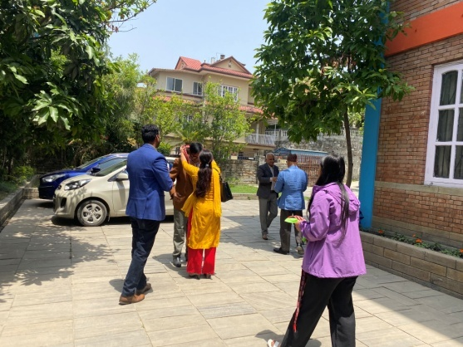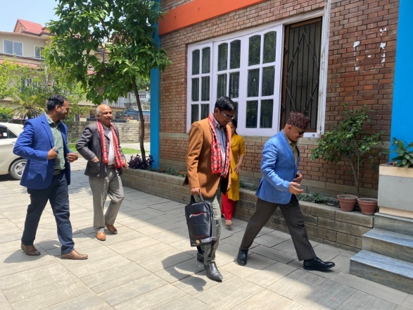

ORIENTATION ON HR CARNIVAL 2079 Jestha 08: FIRST SEMESTER
SWSC Alumni Association SESON, with Chairman Medhabi Dhakal, Pratigya Neupane and one associate, conducted the Orientation to the students of First Semester which centered on the details of the forthcoming HR Carnival. Providing information on the facilitators Mr. Prayas Rajopadhaya ( Director of Jobs Dynamics), Samaya Khadka ( Co-Founder of Sharing Opportunities), Anil Upadhyaya ( Director of MAN), and Elisha D. Kharel (Co-Founder of Skillathon), they elaborated on ‘Two Days Workshop Module’, ‘To Prepare students for Job Market’, ‘Create network with Organization’, ‘ Find your Fit’, ‘ CV/Resume Writing, Group Assignment, and Email Writing.
ANISH Bogati, Anuska KC, Ashish Giri, Barsha Gurung, Binita Malla, Chime Dorje Lama, Juju Gurung, Lalit Gotame, Manisha Khatri, Nabin Basnet,Nabin Shrestha, Nima Chhiring. Nisha Thapa, Puja Gurung, Ragini Gurung, Sajana Khadka, Sajita Shrestha, Shanisha Maharjan, Shruti Gurung, Srijana Chaudhari, Sumana Senchuri, Swostika Baral, Yaran Gurung, and Soniya Thapa were the participants.
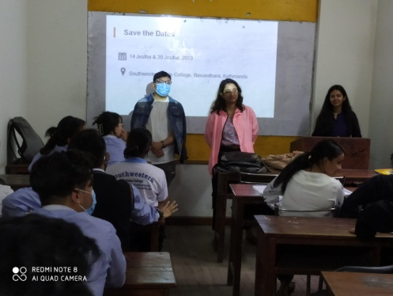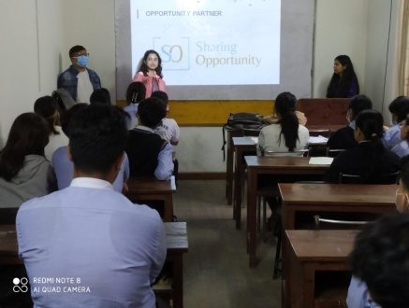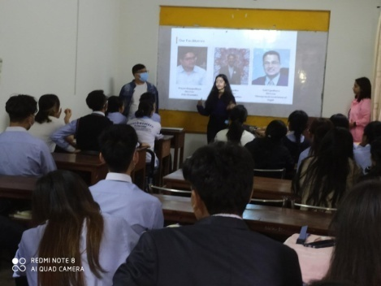

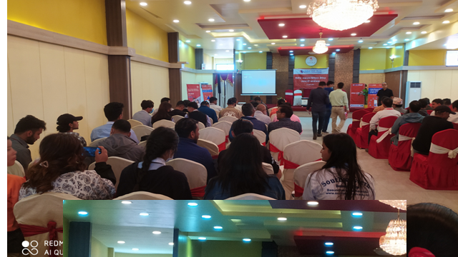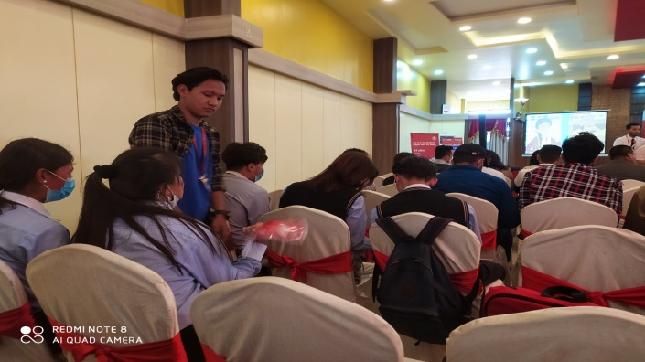
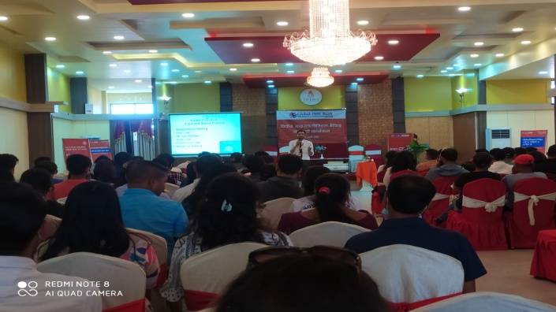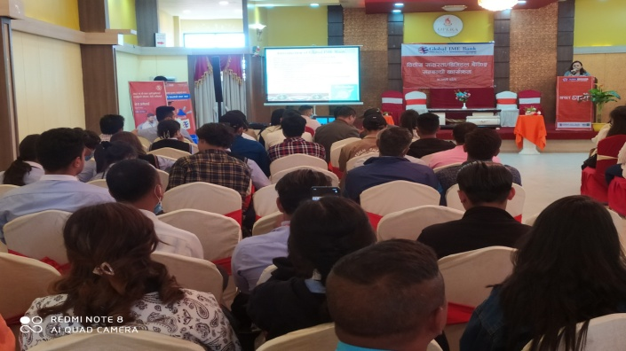
It was organized by Pani Pokhari , Maharajganj Branch. Branch Manager Mr. Basanta Raj Regmi was the Key Speaker. Akriti Rai, ANISH Bogati, Anuska KC, Ashish Giri, Binita Malla, Chime Dorje Lama, Dawa Sangmu Ghale, Juju Gurung, Karina Bhujel, Lalit Gotame, Nabin Basnet, Nisha Thapa, Puja Gurung, Ragini Gurung, Sabira Adhikari, Sajana Khadka, Sajita Shrestha, Shanisha Maharjan, Shruti Gurung, Srijana Chaudhari, Sushmita Pyakurel, Swostika Baral, Yujina Basnet and Soniya Thapa were the participants of the program which was related with the Automation of Traditional Banking Services which enables us to access banking services and products through an electronic / online platform. The program , organized jointly with our long term partner, dealt with introduction of Global IME Bank as one of the largest banks in Nepal with 3200 staffs, 7 lakhs bank accounts and 53 ATM services followed by information and guidance on ‘obtaining bank statements’, ‘ transferring funds’, ‘ mobile banking’, ‘ cash withdrawals’, ‘ bill payments’, ‘Debit Card’, ‘ Missed Call Banking’, ‘QR Code Payment’ etc. Other participants among the total of around 150 were shareholders, clients and staffs.
In the Report Writing Program of the DIGITAL BANKING PROGRAM on Jestha 10, SAJITA SHRESTHA, SONIYA THAPA, SAJANA KHADKA, JUJU GURUNG, RAGINI GURUNG, ASHISH GIRI, AND SHRUTI GURUNG were able to score 90% marks! Many ‘Congratulations’ to all of them!
GUEST LECTURE : Nani Maiya Dangol: Jestha 16, 2079: FIRST SEMESTER

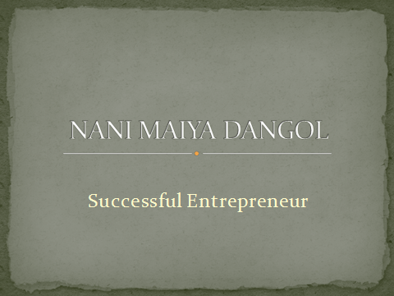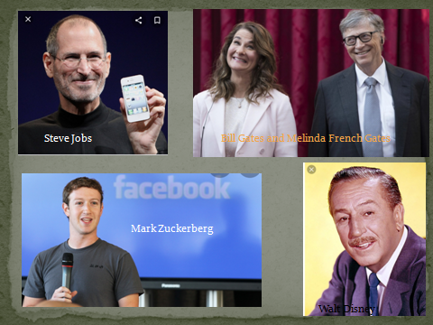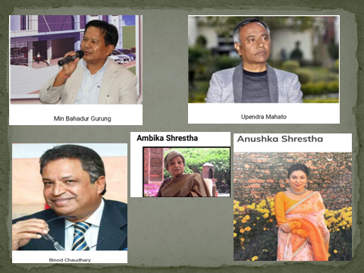
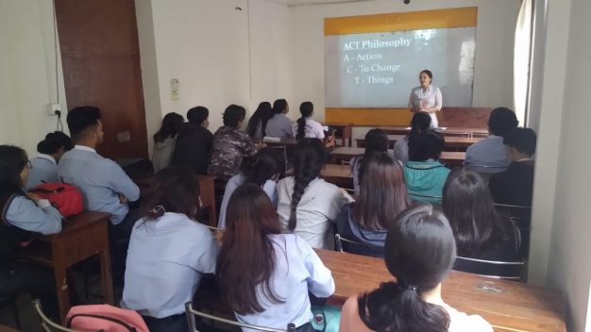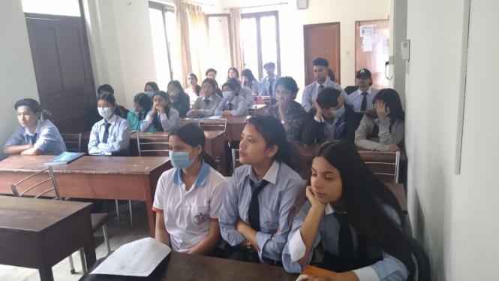

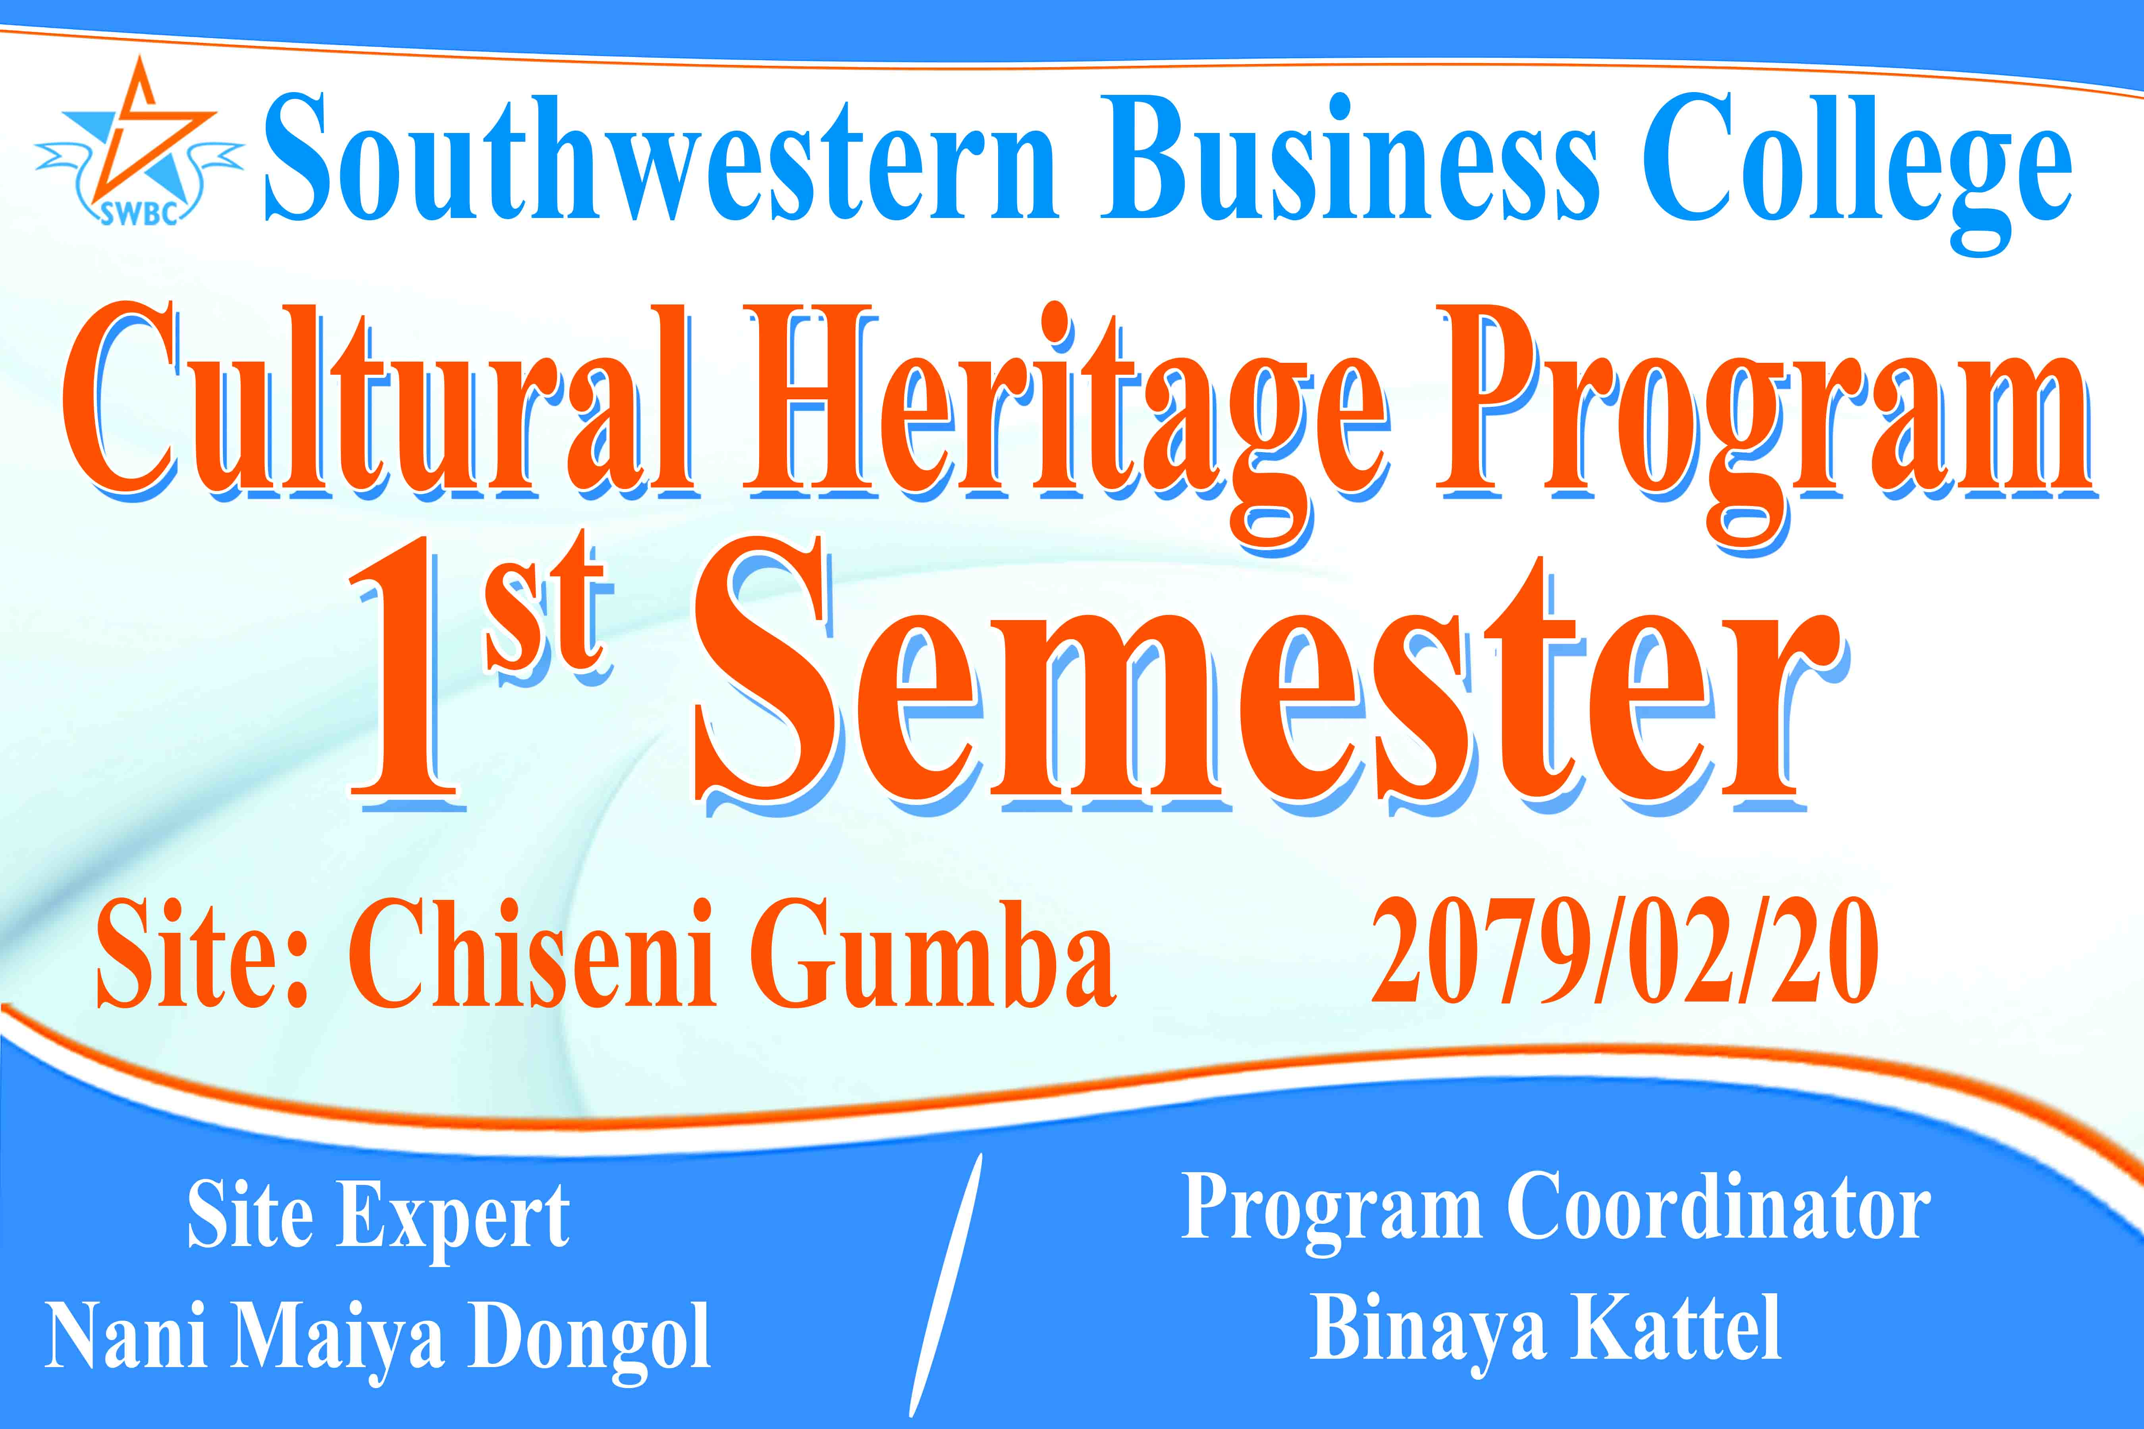
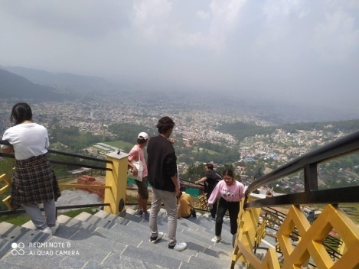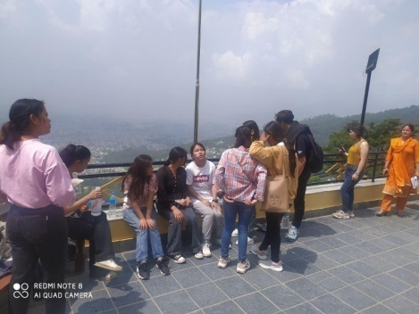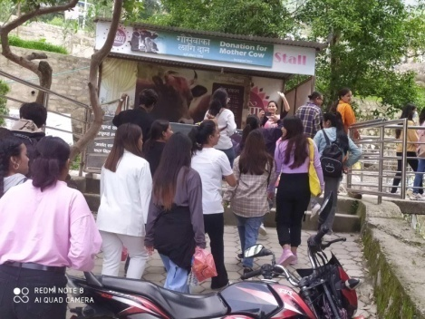
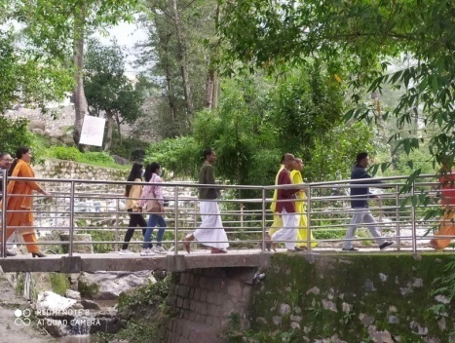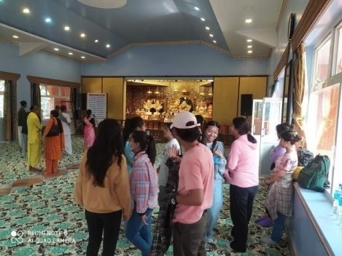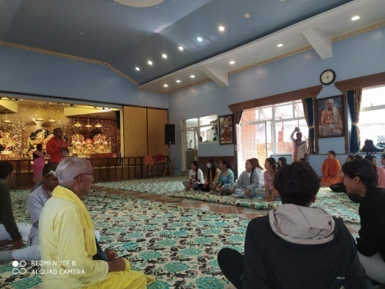
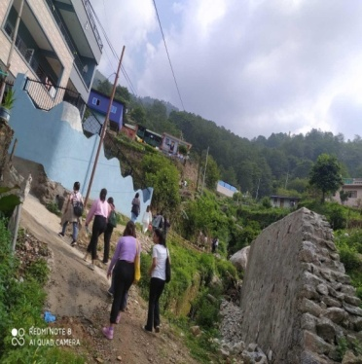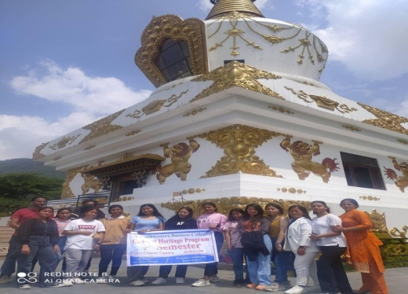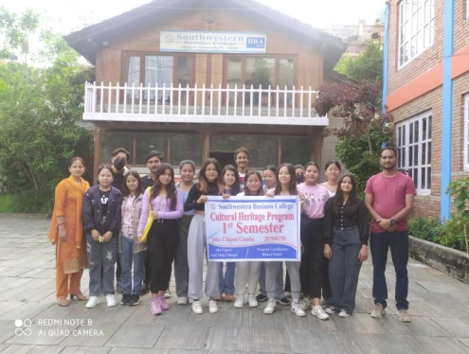
HOME ASSIGNMENT
Introduction: Our Cultural Heritage program consists of three stages:
Feel the Vibes at the site (that was done at Chiseni Gumba),
Know the theory behind the subject and relate yourself (10th June 2022),
Present your own slide, judge and learn (17th June 2022).
The Cultural Heritage Program, designed by SWBC, has a mix of theoretical and practical education consisting of methodological approaches with an objective to make you aware of the reality of the whole gamut on the broader side as well as make you proud of your own heritage which includes cultures, customs, beliefs, rites, rituals, ceremonies etc. thereby preparing a sound ground for ‘emerging new cultures’ which will become the heritage of the future.
Cultural Heritage Home Assignment Judge: Each will present and Each will Judge
Procedure of Judgment
- Judging through team work
- Team: one from management side and one student Judge
- Different judge for each presenter
- Open Marking System
- Opportunity to all
- At the end, marks will be declared here
- Judge will give marks to other’s presentation
- We know about the marks given by your friend and by the management
Time: 2hrs
PRESENTATION DATE: 27 Jestha
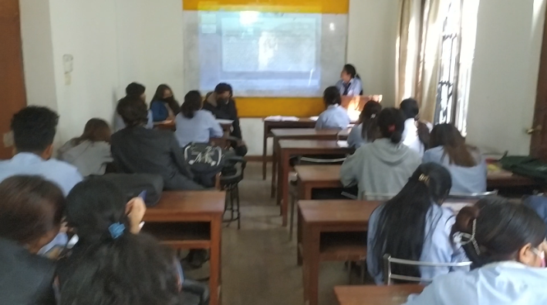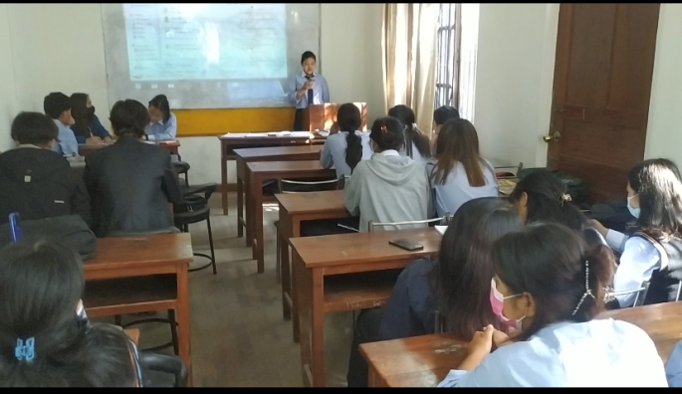
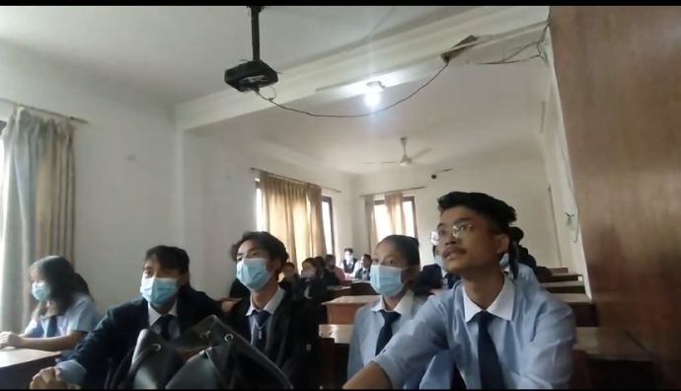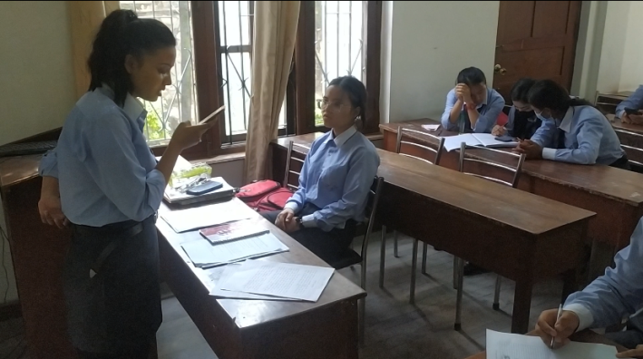

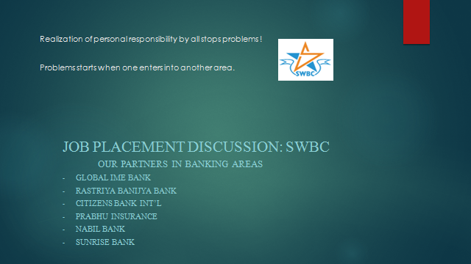 2078 Jestha 11
- Information about our Banking Partners
- Internship Opportunity: Seasonal Job, Permanent Opportunity, Paid Internship ( Rs. 580 per day)
- Benefits: Job experience, network development, confidence building
- 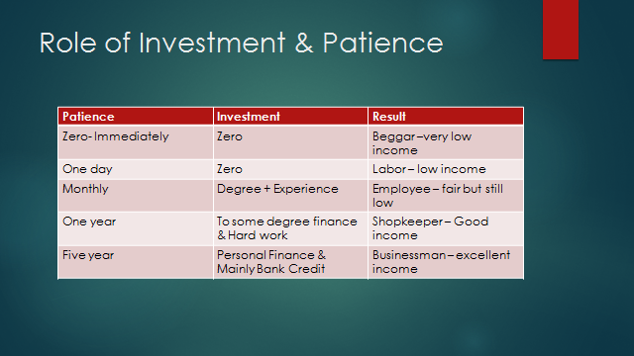
Participation in HR CARNIVAL: 2079 Jestha 14 AND 20-, SWSC
Day 1:
Before you apply for a Job Find your Fit CV writing Group Assignment Email Writing
Day 2:
How to face an Interview Real Time Interview Job Mela
Soniya Thapa, Sushmita Pyakurel, Lalit Gotame, Karina Bhujel, Puja Gurung, Nisha Thapa, Akriti Rai, Nabin B Shrestha, Sajita Shrestha, Shurti Gurung, Yuzena Basnet, Sumana Senchuri were the participants.
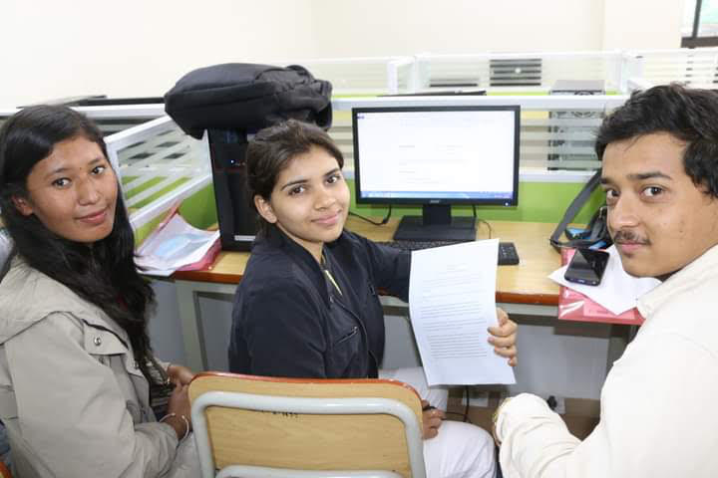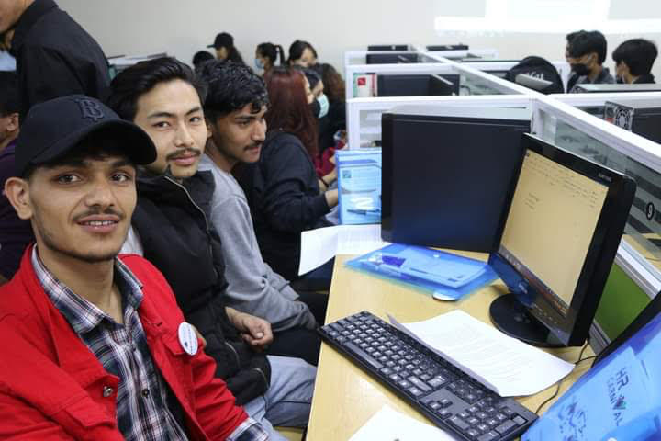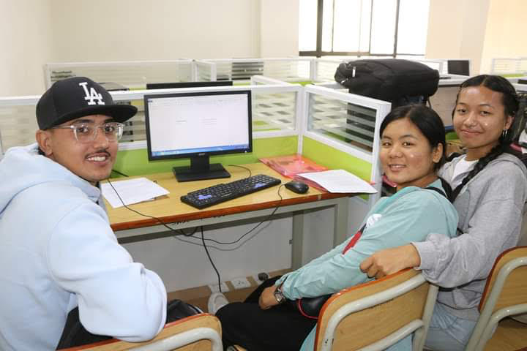
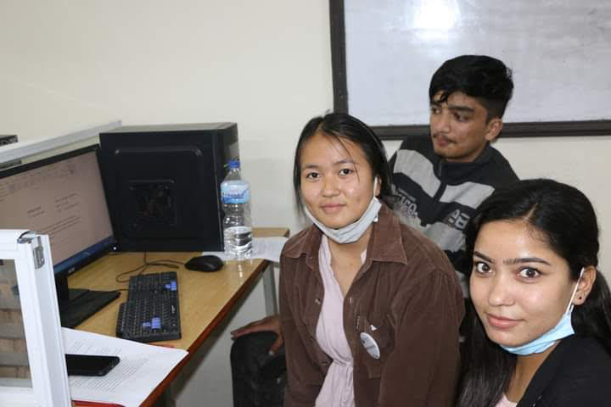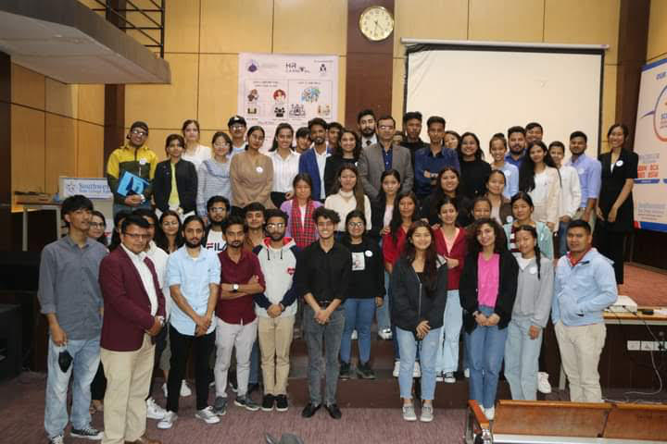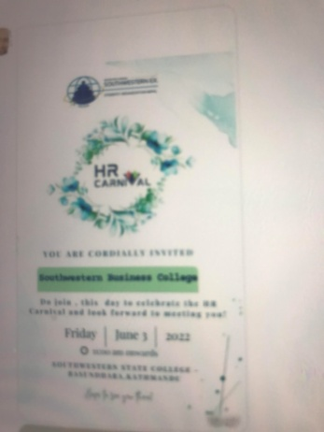

S
S
Result Discussion Samples
