Southwestern Business College
NEWSLETTER KARTIK 2079
INDIVIDUAL FOCUS SERIES—44
Dr. Jayahari Raj Pandey
In the last episode, we were contemplating on the need of Individual Focus as an instrument to sharpen the students through self-realization of their unparalleled uniqueness, and eradication of unnecessary confusions developed/ created due to/ by so many things , happenings and incidents ( intentional or accidental).
"Go and love someone exactly as they are. And then watch how quickly they transform into the greatest, truest version of themselves. When one feels seen and appreciated in their own essence, one is instantly empowered." -- Wes Angelozzi

We are touching upon the base of this Series from time to time so as to bring the whole discussion into the mainstream. In this series too, we will be repeating the same method.

Before that series, we were on the issue of Lie Factor – the easy hook for all of us. The aim of the focus on Lie Factor is to create realization by heart among the students the harms that the lies aimed at affecting others bring to self- only time factor. However, there are white lies. A personal example might be helpful here. There is a system of collecting fresh cow-milk everyday from a shop. The payment method is monthly. For that, the shop has a method of manual entry into a notebook. For reconciliation purpose, the member of the house (a boy) who has been entrusted with this job (of collecting the milk and making payment later) is in the habit of maintaining a record. There was one small but very crucial incident. In one month, the bill sent by the shop showed lesser liters of milk than the record of the boy. Not wanting to cheat the shop, the boy pointed out the ‘matter of less billing’ at the shop where the reaction was that of a shocked one, and made the payment as per the corrected bill. After six months, the same incident was repeated- this time the lessening on the bill was by more amount than it was previously. This time, however, the boy did not mention the ‘matter of less billing’ to the shop. Actually, he had found out, in between the days, that the salesperson had been sacked from the job due to the earlier reporting of less billing by the boy; and now he did not want to jeopardize another salesperson’s job by such reporting of less billing. This is called a ‘white lie’ which is, in general, used to avoid harming another person. This is not for self interest of any kind. Interestingly, in BBA First Semester, the new English Syllabus has a topic on an article named ‘Tell White Lies (Occasionally): by Donald W. McCullough’, which vouches to lie sometimes for good cause or manners. Essentially, Individual Focus focuses on multiple issues which are key elements for our over-all development or evocative existence, and that demands balancing of many factors.

The ancient Chinese Yin-Yang symbol represents the balance of yin (peacefulness, serenity, acceptance, rest, rejuvenation, roots, tradition) with yang (activity, strength, striving, movement, change, wings, invention, progress). A meaningful and joyful life is to be found in balance. (Jonathan Lockwood Huie in ‘Daily Inspiration’ dated 27 November 2022).

Hence, our purpose is also to fill-in the values of natural sides of our lives for the students who have joined in a career-development purpose. Such filling-in will be purposeful when they are instilled in an understanding way or in a kind of conversational approach. Many years ago, I was in New Delhi, India in the course of participating a Leadership Seminar, where the emphasis was on the natural aspects as well - which many of us, generally, forget to take into consideration while taking the responsibility of educating the students. We tend to take the things on the surface level, and forget to analyze the bases which are so much intrinsically connected. Naturally, we wonder about the poor results despite so much preparation, and hard works of very high level experts and professionals. We expect abrupt result or sudden transformation of the students without trying to eradicate many stratums of confusion, misunderstanding, apprehension, awkwardness and hesitation which had deep-rooted within them through various family/ society factors including religious, customs, misconducts, and wrong expectations. So, in New Delhi Seminar, the emphasis was to connect us with the nature first. There were the uses of quotations like the following:
This land, this water, this air, this planet -
this is our legacy to our young.
- Paul Tsongas
All other aspects and issues came after nature. Unknowingly and many times for the sake of comforts of the elders, the young ones are forced to develop unnecessary (and many of them very harmful for the long run) habits and practices which actually are the sources of total personality and behavior. Simply, by nature we mean to put the students in their true selves exterminating all other layers which have distanced them from the reality. There is another factor as well. Such wrong faiths/ beliefs/ practices/ conducts should be eradicated the sooner the better. Student life, and BBA is the prime time of that life since it’s career-oriented, is regarded as the best point in time for corrections in personality and temperament. If we didn’t correct such major feature of life on time, slowly and gradually the element will have a heavy chance of reaching to a stage of conflagration.

Whether it is a health condition, a family feud, or overdue bills, manage small fires before they become uncontrollable blazes. -- Anonymous

There is another side. These are the truths, but still they should not be taken alarmingly. What comes into sight very creepy is in all probability nothing to dread when considerately examined in the light of the possibility of change through correct method. Obviously, the correct method is the internal one, i.e. the self consciousness and resultantly self determination coming through the internal change of habit owing to self-realization.
Your inner knowing is your only true compass.
- Joy Page

Many of the times, I am questioned in a genuine manner: “I get often advised by wise persons and heavy books on building the ability to do as per my inner wish; and when I just do that there are complains of my misconduct/ misbehavior/negligence/apathy.” I tell them that there is always the need to check your inner wish and find out whether they are just fulfilling your ego, whether they are entering into the fields of others’ rights, whether they are against the social and cultural norms, and whether they have the forms of indifference. Consequently, Individual Focus is very much related with compassion.
"The highest form of knowledge is empathy, for it requires us to suspend our egos and live in another's world."
-- Plato

Students Prepare for Laxmi Puja – 21st October 2022 (Kartik4, 2079) Friday
Rangoli (special design) is the favorite custom of TIHAR festival, which is gaining popularity year after year. Rangoli is a faith in terms of prosperity, happiness, positivity and well-being of an entity in the form of household or organization. It is, in true sense, connected with Laxmi (Goddess of Wealth and Good Luck) and is used as a true form to welcome Laxmi. Students of SWBC (especially Laxmi Sherma, Nabina Ghale, Sushma Lama, Sarita Dangol, Sangam Acharya, and Dipak Lamichhane) were remarkable in arranging/ preparing/ drawing Two Rangolis: at the entrance of the building and in front of the Reception.
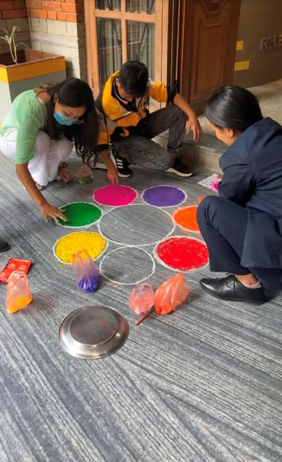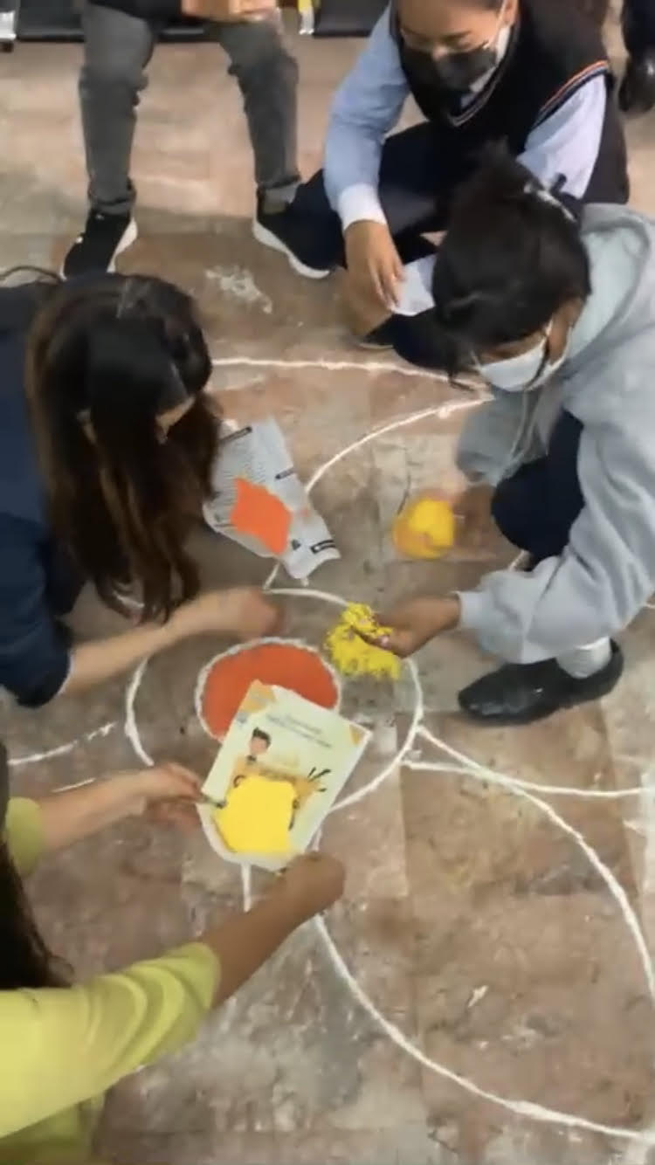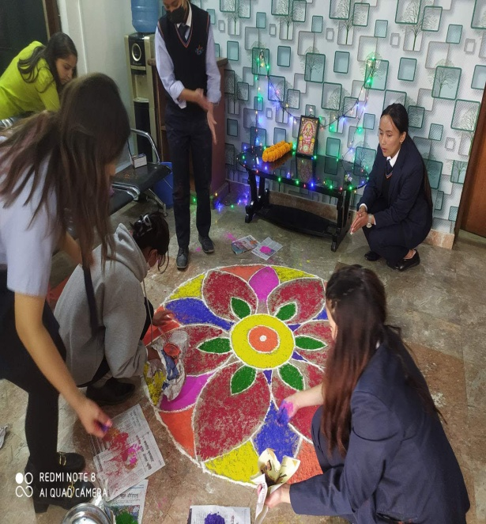

W
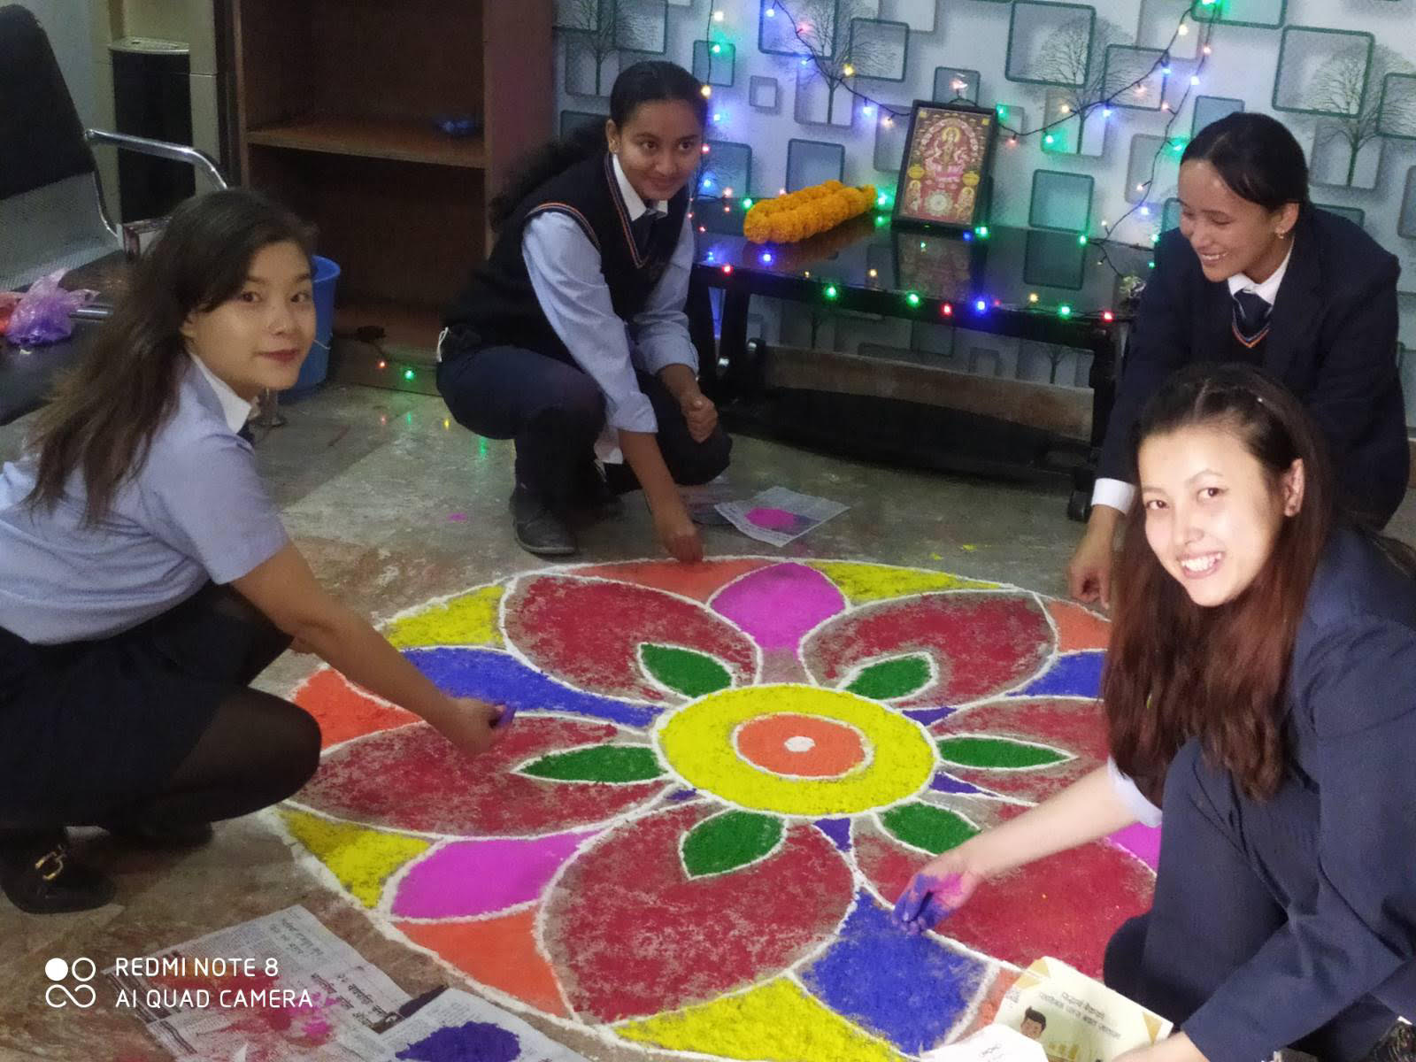

Partnership Meeting: October 21, 2022
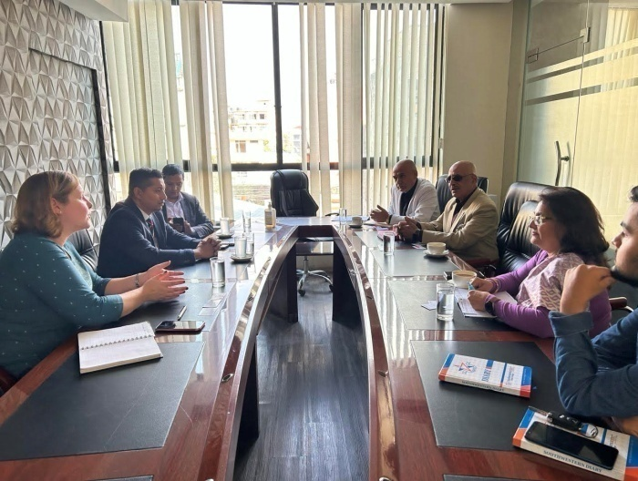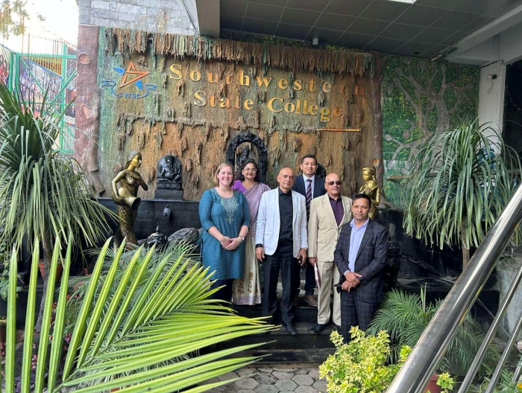

SHORT INTERNSHIP FOR GAINING KNOWLEDGE OF REAL BUSINESS WORLD – 21st October 2022 (Kartik4, 2079) Friday
Four Students were sent to RURU HYDRO AGM for experience gaining.
Reeyaz Manandhar | Astha Subedi
Puja Thapa Magar | Santosh Magar

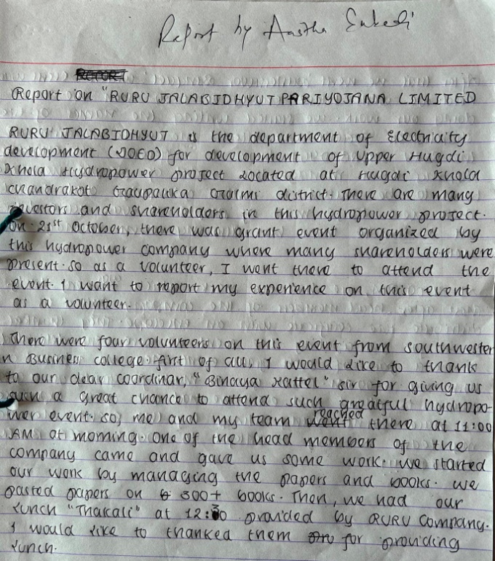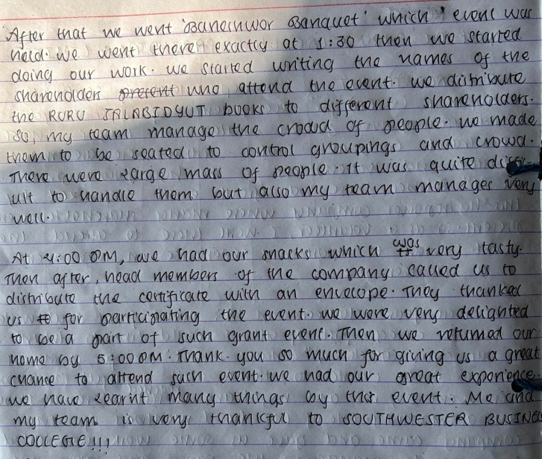
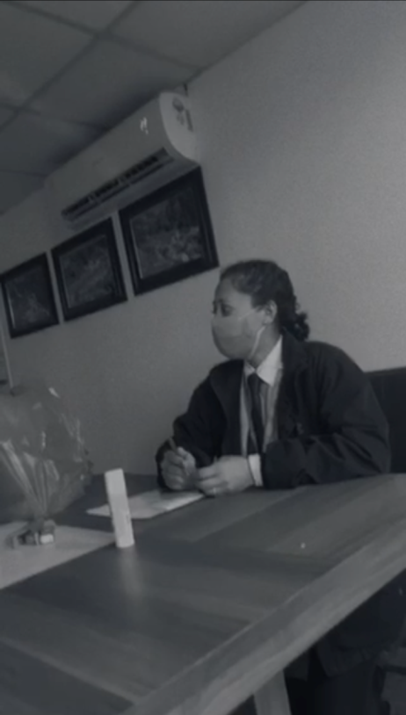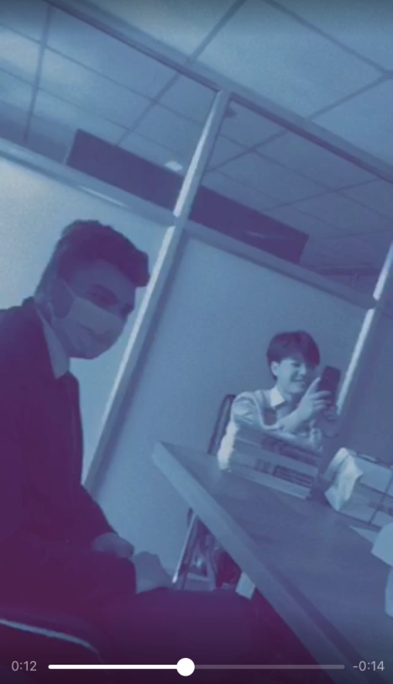
Seminar to BBA Students :Young Entrepreneur ’s Guide under
‘Success Tips on Long Term Goals and Networking ’
– 4th November 2022 (18th Kartik 2079) Friday
Shreeya Giri, Founder of Happy Minds, was in the Campus to induce the students through sharing different clues on making mind happy. The queries from the students were numerous, and so was her tactful as well as convincing response.
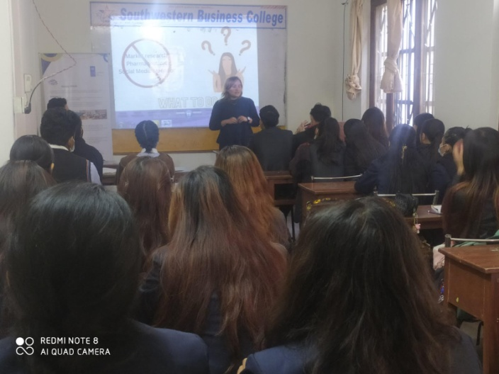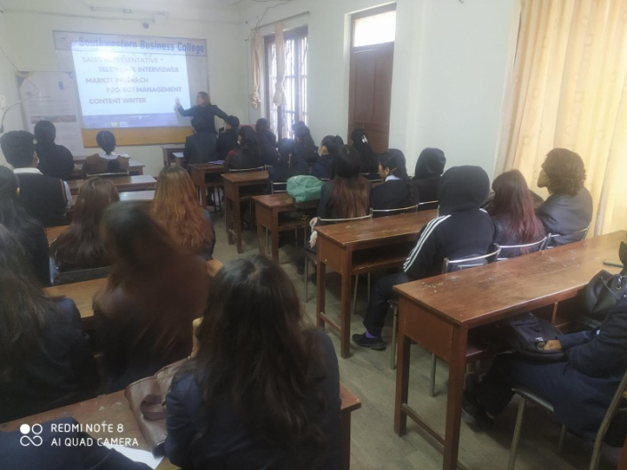
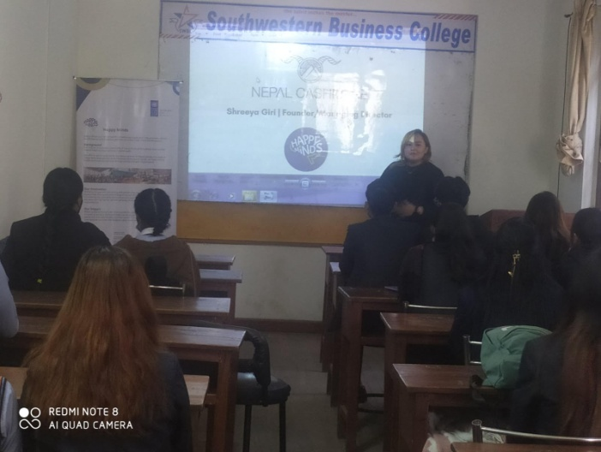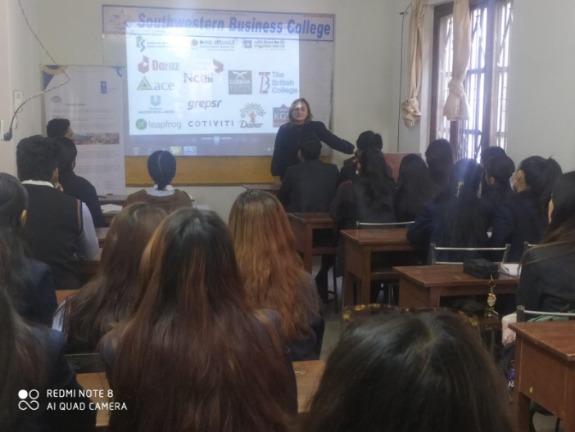
Anuska Thakuri | Shristi Maharjan | Manisa Timalsina | Rejina Dahal | Pooja B K | Anju Ghale | Rachna Pokhrel
Reiyaz Manandar | Sushma Lama | Astha Subedi | Sudip Pun | Chime Dorjee | Anuska KC | Juhi Giri
Shruti Gurung | Sumana Senchuri | Sajita Shrestha | Sunmaya Magar | Usha Chhantyal | Swastika Shresta | Barsha Gurung
Puja Gurung | Yujina Basnet | Lalit Gotame | Susmita Pyakurel | Karina Bhujel | Manasi Adhikari | Nirmala Khadka
Puja Thapa | Aayush Shrestha | Baivab Bista | Melina Magar | Nisha Chhantyal

Pre- Board Examination
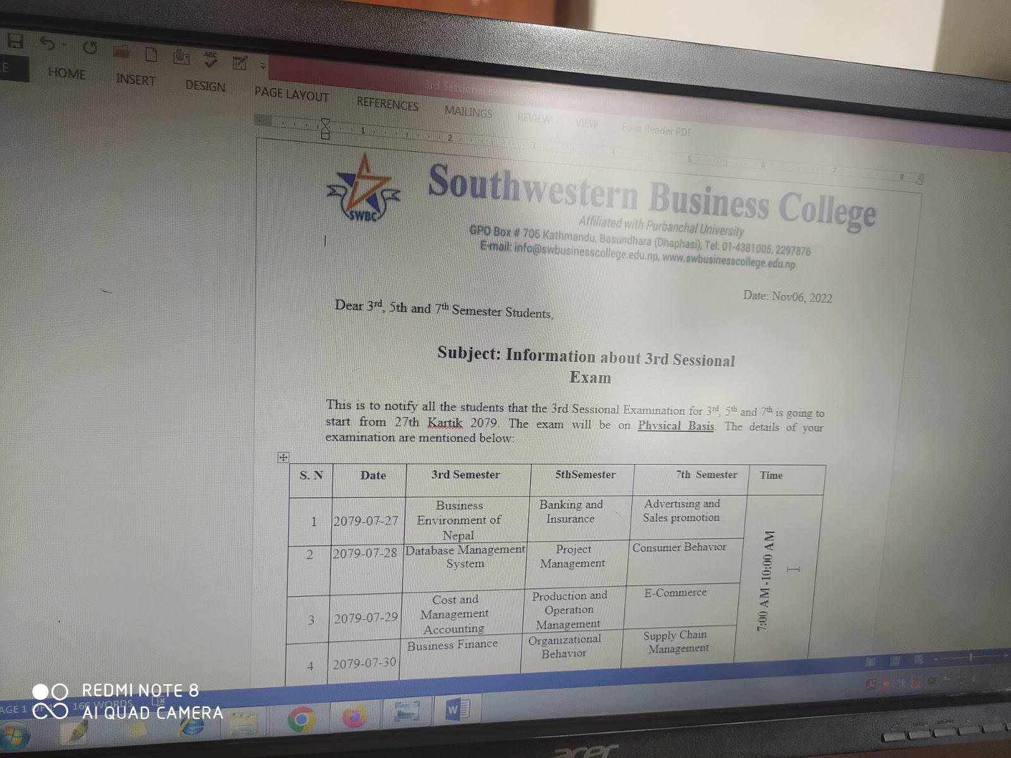

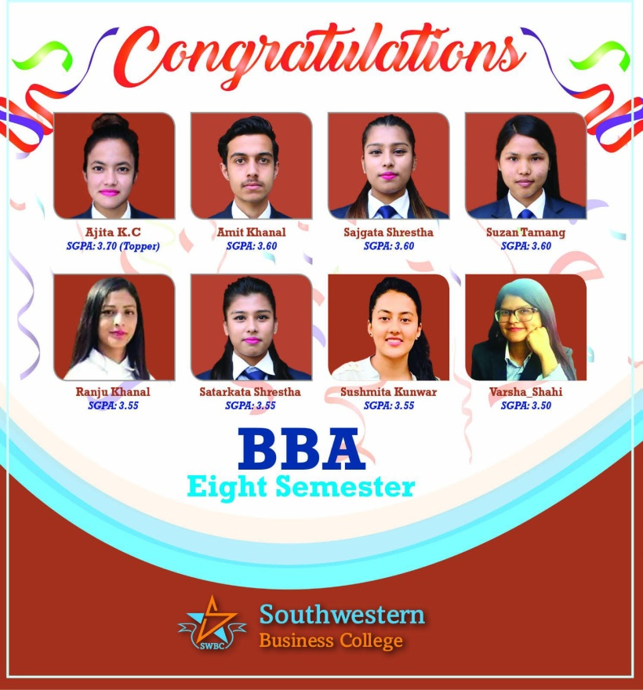
The program, Chaired by Campus Chairperson Dr. Krishna Bahadur Karki had the presence of the Faculties and the students. The program, with Binaya Kattel as the Quiz Master, had been designed in the following way:
OBJECTIVE
The intention behind the organization of Inter-Semester Quiz competition is to get a College level Quiz Team who will represent the College in all such competitions outside the College within a year.
AREAS:
- General Knowledge, 2. Sports,
- Health & Foods 4. Business
The current ‘Inter semester quiz competition Program- 2079’ is for the winners of the 2nd, 3rd, 5th and 7th semesters. The names of the winners are the following:
Names from 2nd Semester Group–(1) Chhime Dorje Lama (2) Juhi Giri (3) Samarpana Raut (4) Nabin Basnet
Names from 3rd Semester Group –(1) Nirmala Khadka (2) Reeyaz Manandhar (3) Shanti Gautam (4) Nisha Chhantyal
Names from 5th Semester Group – (1) Manisha Timilsina (2) Usha Chantyal (3) Rejina Dahal (4) Sunmaya Gharti Magar
Names from 7th Semester Group – (1) Aashma Rai (2) Sushmita Panjiyar (3) Laxmi Sherma (4) Mamata Rai
Rules
- Each category will have 10 questions, and they will be given numbers, eg. 1, 2, 3…10 etc. The students will have the optional power to ask for one of the numbers from each category.
- Right answer for fresh question will get 10 points, and for passed question 5 points.
- For passed questions, first raised hand will get the first chance.
- There will be 10 questions for each group.
- Time limit to answer the Fresh question is 30s, and 15 seconds for passed question.
Chief Guest and the Chair Dr. Krishna Bahadur Karki gave away Gold Medals to all the members of the FIRST TEAM ( 5th Sem Team) securing 45 points, SILVER MEDALS to all the members of the SECOND TEAM ( 3rd Sem Team) securing 35 points, and BRONZE MEDALS to all the members of the THIRD TEAM ( 2nd Sem Team) securing 20 points. The Fourth Team ( 7th Semester) were given Pen prizes. 