Southwestern Business College
NEWSLETTER MANGSIR 2079
INDIVIDUAL FOCUS SERIES—45
Dr. Jayahari Raj Pandey
In the last episode, we had touched upon the term ‘compassion’-which can be better understood
by using the term ‘care’. We are social creatures, and our aspects related with various phases of life, our success, our going-ahead, passions, disappointments, pleasures, measurements of other parameters, and achievements are inter-related with societal dealings and interactions. We will have better results through satisfaction we can produce to others with whom we are in association if we have that empathy. That also is the best method of fruition of being conscious.

"Life will give you whatever experience is most helpful for the evolution of your consciousness. How do you know this is the experience you need? Because this is the experience you are having at this moment."
-- Eckhart Tolle

We can have all the knowledge through many channels and ways. But, when you enter the practical field, your understanding of the knowledge gets change to bitter or sweeter mode. That, exactly, is the result of how you are dealt by various people whom you met/ interacted/ discussed/ mingled during your practical grounds.

Recently, I was in a ‘semi-religious mixed with adventure and fun’ kind of tour to the southern parts of India. After thorough and vigorous home-works through a series of talks with friends, WhatsApp talks/chats with friends of India, and phone calls to relatives who had been to those places earlier, the finalized route was: Flight to Bangalore by Nepal Airlines ( a journey of 3 hours) , pick-up at the airport by a pre-arranged Inovo driver who was booked for next 7 days for the tour, Self-arrangement of a Hotel for the night, start of the journey of second day towards Kanjipuram ( a road trip of 280 Kms and 6 hours), Self-arrangement of the hotel at Kanjipuram, Start of the third day with visits to Ekmbareshwar Mahadev Temple and Kanchi Kamachhi Temple, proceed towards Pondicherry ( a road trip of 114 Kms and 3 hours), spend quality time at the Beach, self-arrangement of the hotel at Pondicherry, start of the fourth day with fun time at the hotel and proceed towards Madurai ( 6 hrs; 340 Kms), self arrangement of Hotel at Madurai, start of the fifth day with visit to Minakchhi Temple, and proceed to Rameswaram ( 173 kms, 3 hrs), visit to the famous Temple, self arrangement of Hotel at Rameswaram, start of the sixth day with fun time at the beach and proceed to Mysore (590 kms, 12 hours), self-arrangement of hotel at Mysore, start of the seventh day with fun time at the hotel pool and visits to Mysore Palace and Mysore Garden, proceed to Bangalore ( 144 kms, 3 hrs), thank the Inovo driver, self-arrangement of hotel at Bangalore, start of the eighth day with some shopping at Bangalore, proceed to Airport, and fly for New Delhi (3 hours). The finalization of the itinerary had taken a total time period of 18 days. We were sure that lots of the upcoming experience would depend upon the exact implementation of the schedule. The first day went smoothly. The flight was on time, the processing at the exciting airport was friendly/ functional, and the driver was available outside the Gate with a cardboard displaying our Surname. The hotel was booked a day earlier, and it was very near the airport. Booked on the basis of comments on the hotel, we had done a good choice. Interestingly, nearby was a very popular and fine place to dine and spend time relaxingly. Next day onwards was the real test of the success or failure of the whole trip. We would be with an unknown person from morning to evening, and the demand was of the chemistry-building or chemistry-happening (which-ever applied). In actual terms, rapport with a person did not happen easily, and chemistry-building is a term which can be faked for a very brief period, or took a long period of time to get established genuinely. We had 7 days, and for those many days it could not be faked, as well as could not be taken as a course of building relationship. In cases like ours, it had to happen or cease.
We were very cautious since the beginning of the second day when the new journey with the driver started. There were the original barriers, and the initial hesitations. Slowly and gradually, the inhibitions began to fade away. We all began to become more natural self, and by the lunch time all of us were totally ourselves. The reason was the concern he showed towards us and our plan- it was so natural. On the opposite side, he also might have wished for and found the same from our side. Once it was established, there was no looking back. We all know that when the relationship gets one pattern, the smoothness breaks only when something unusual happens suddenly. During the total period of the journey, there was never the infringement pattern or realization of being at the discomfort zone. We all felt the lonely emotion of sadness at the end of the journey.

General people are actually so busy thinking about themselves that they forget or don’t think it necessary to enter into the field of general well-being of others. Many of us take life so seriously that we find it very hard and are overly conscious of making it successful and thus easy (in our presumption).

When I hear somebody sigh, "Life is hard," I am always tempted to ask, Compared to what?
- Sydney Harris

29th November 2022 (Mangsir 13, 2079) Tuesday

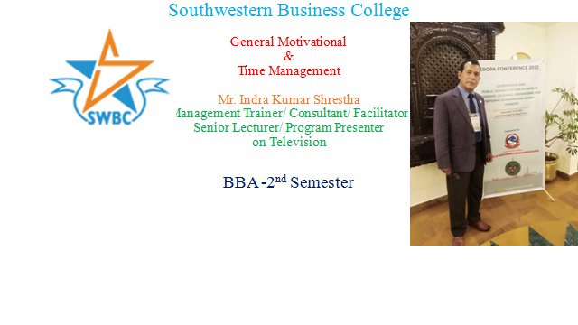
1. | Akriti Rai | 2. | Anish Bogati | 3. | Anuska KC
4. | Ashish Giri | 5. | Barsha Gurung | 6. | Binita Malla
7. | Chime Dorje Lama | 8. | Karina Bhujel | 9. | Juhi Giri
10. | Kriti Waiba Lama | 11. | Lalit Gotame | 12. | Manisha Khatri
13. | Monika Gurung | 14. | Nabin Basnet | 15. | Nabin Shrestha
16. | Nisha Thapa | 17. | Pooja Gurung | 18. | Sajana Khadka
19. | Sajita Shrestha | 20. | Shruti Gurung | 21. | Soniya Thapa
22. | Srijana Chaudhary | 23. | Sudip Pun | 24. | Sushmita Pyakurel
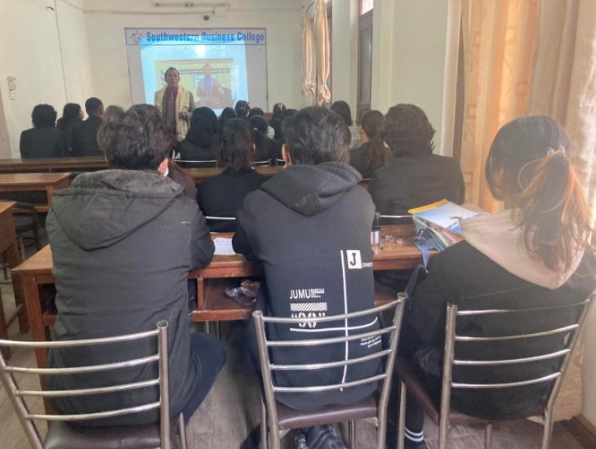The style of the presentation was unique, and everybody liked it!

TWO DAYS TOUR

1. | Akriti Rai | 2. | Anish Bogati | 3. | Anuska KC
4. | Sanisna Maharjan | 5. | Barsha Gurung | 6. | Supraj Shrestha
7. | Chime Dorje Lama | 8. | Swastika Baral | 9. | Juhi Giri
10. | Samarpana Raut | 11. | Lalit Gotame | 12. | Manisha Khatri
13. |  | 14. | Nabin Basnet | 15. | Nabin Shrestha
16. | Nisha Thapa | 17. | Pooja Gurung | 18. | Sajana Khadka
19. |  | 20. | Shruti Gurung | 21.
22. | Srijana Chaudhary | 23. |  | 24. | Sushmita Pyakurel
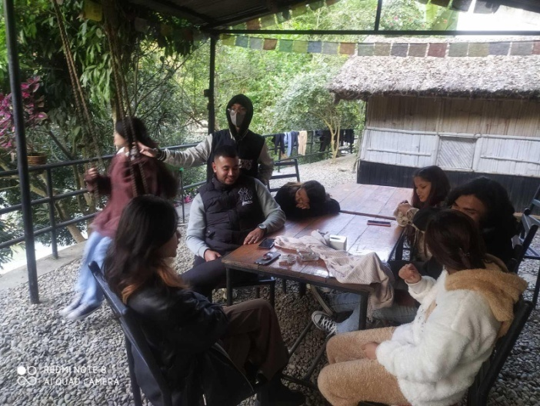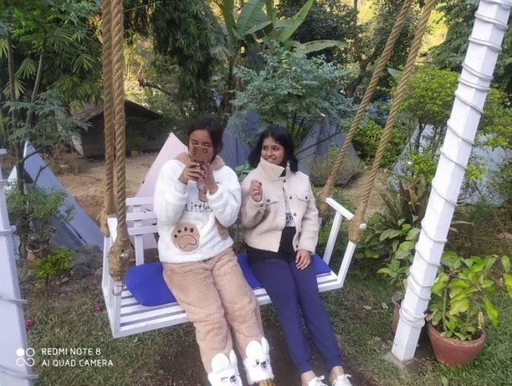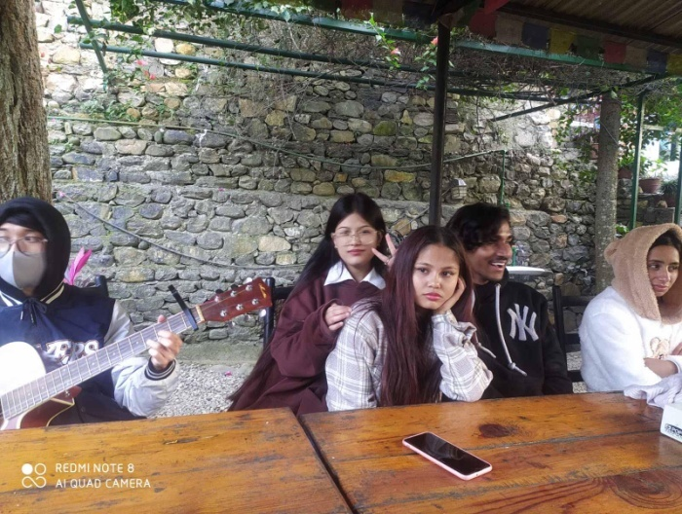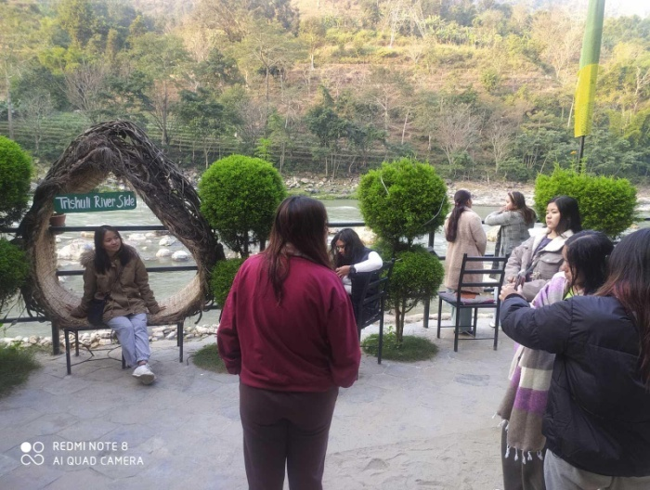
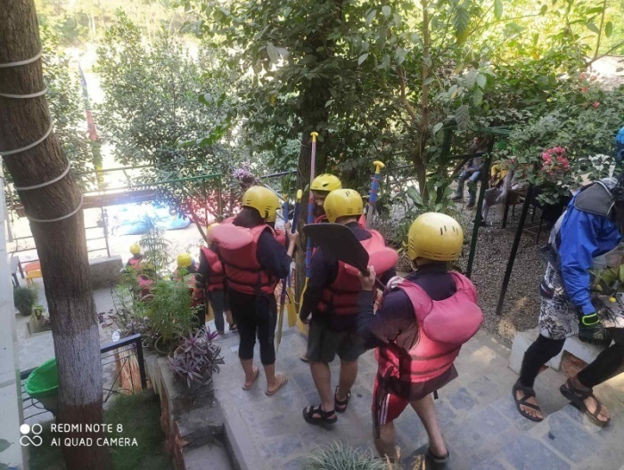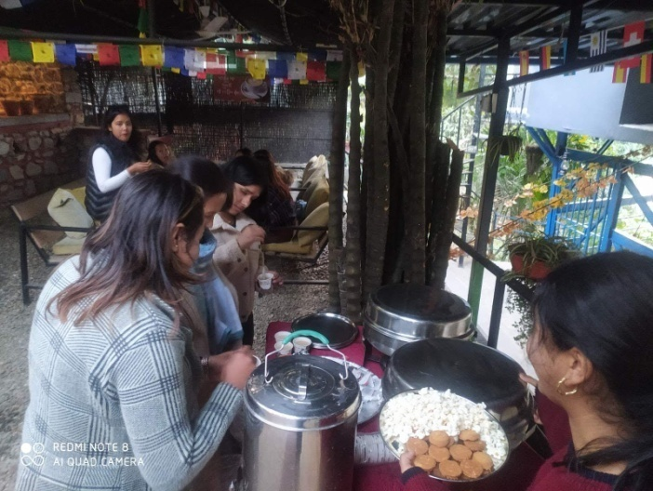
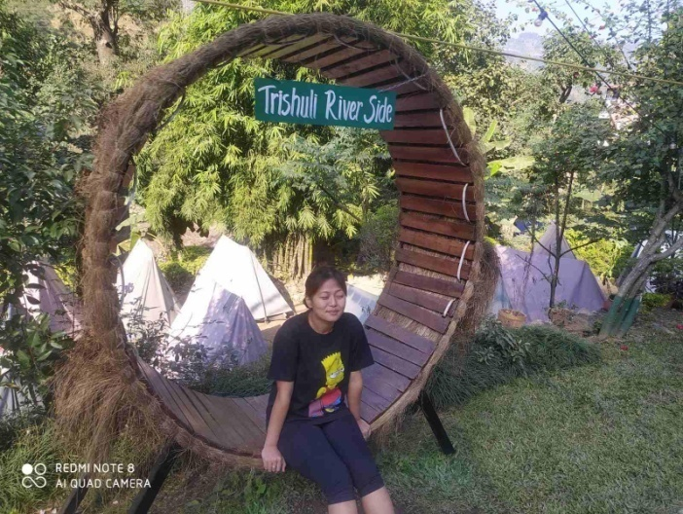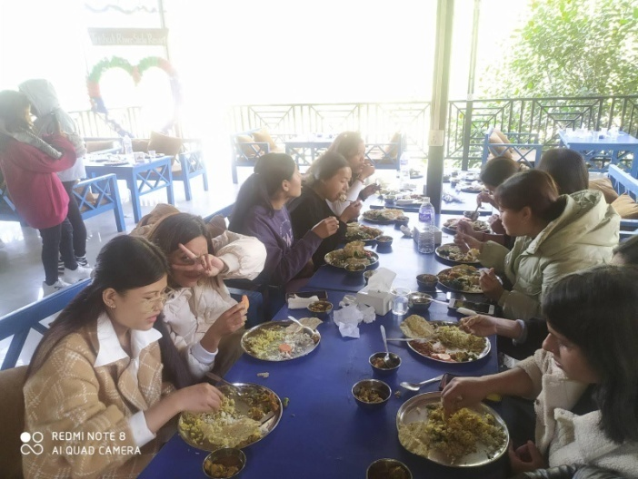
S 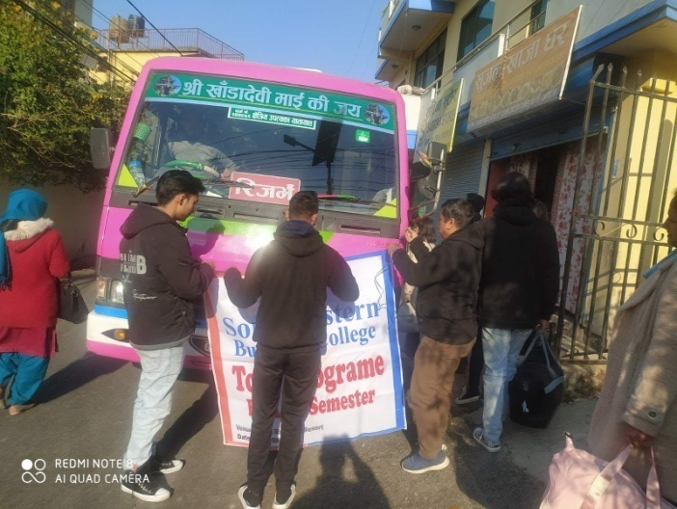 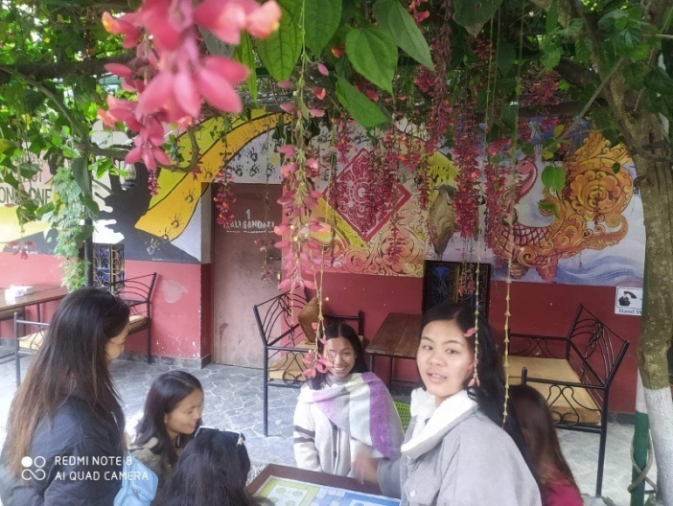
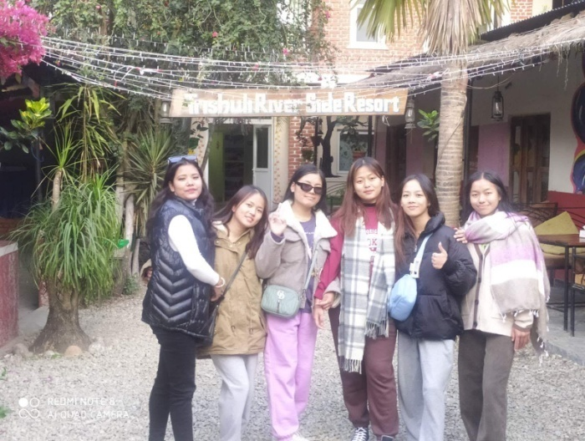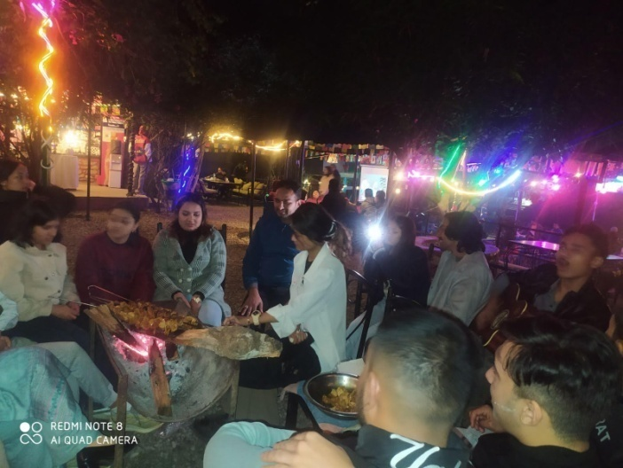
Pr
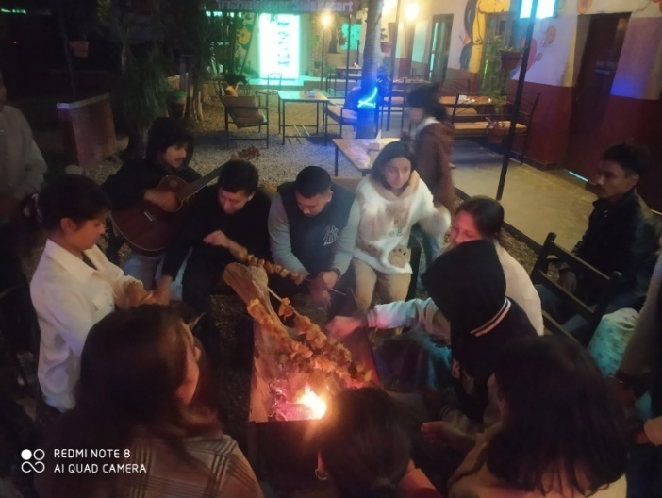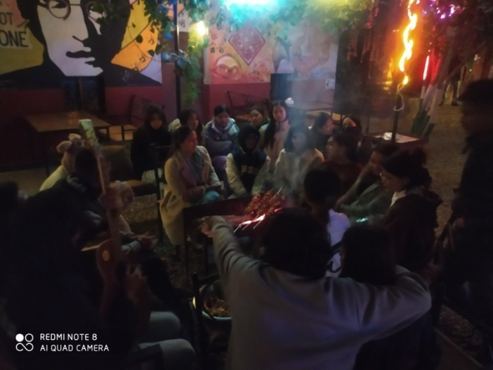

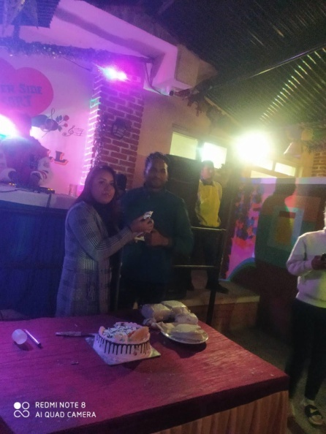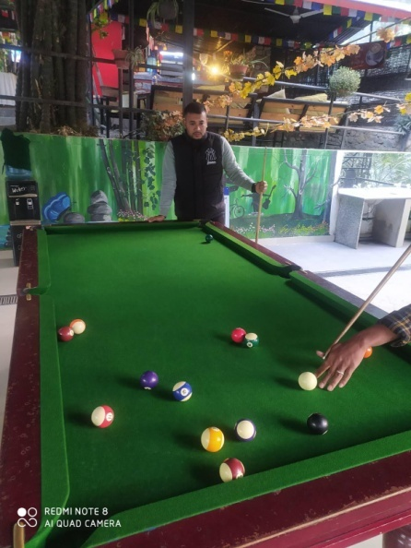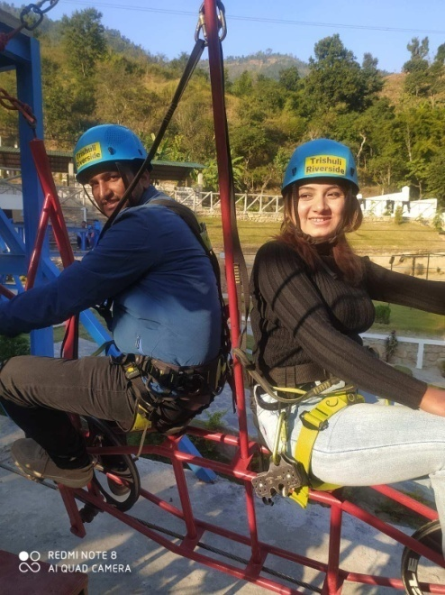
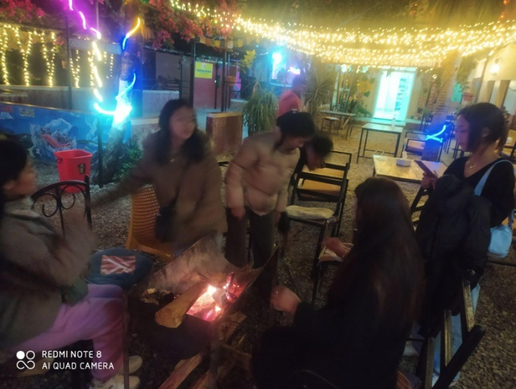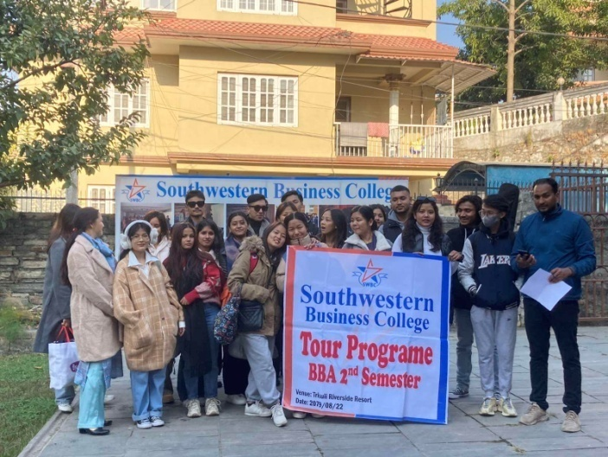
Program Coordinator Binaya Kattel and Faculty Nani Maiya Dangol escorted the students from college to the tour place and next day back to the college.
BBA INDUCTION PROGRAM – 5 DAYS (11th to 15th December 2022 (Mangsir 25th to 29th , 2079) Sunday to Thursday: FOR 2022 BATCH
Southwestern Business College
------------------------------------------------------------------------------------------------------------------------------------------------------- BBA INDUCTION PROGRAMME of 2022 BATCH (5 Days)
Days/  Time/ Title | Day 1: Dec 11 2022 | Day 2: Dec 12 2022 | Day 3: Dec 13 2022 | Day 4: Dec 14 2022 | Day 5: Dec 15 2022
6.30 am-7.30 am  Involve | - PANEL GAME ON BRAND
6.30 am-7.15 am |  | About Course:  RudraGyawali Sir
7.15 am- 8.15 am |  | Are not you the Winner?: Expert SG
7.30am- 8.15 am |  |  | About Course:  Dolraj Sir | RISK FREE: Game | Management BINGO: Game
7.30 am- 8.30 am  You all are most Welcome | - Initial and Badge Distribution- 15 minutes: Program Coordinator/ Host – Mr. Kattel  - Willing to risk the usual- 10 min: Campus Chief Dr. J R P  - Take up one idea-20 min: Board Director B S Pradhan  - Welcome Speech- 15 min: Chairperson Dr. Krishna B Karki  - Lapel Pin Distribution
8.15 am- 9 am |  | SWBC Rules: Mr. Kattel |  | About Course:  Sagar Upadya Sir
8.15 am- 9.15 am |  |  | Better Role Model: Expert TN |  | Tongue vs Patience: Expert:BL
8.30 am- 9.30 am  (Know us) | - Program Details –Sulav Neupane  - Introduction of Faculty- Nani Maiya Mam
9 am- 10 am | About Course: Sajani Nepal Mam | Mgmt TUG of WAR : Game |  | The FUTURE: Expert: IKS
9.15 am- 9.30 am |  |  | Accounts, Library, Computer Lab: Anisha
9.15 am- 10 am |  |  |  |  | About Course:  Dev GyawaliSir
9.30am- 10.30 a |  |  | Know Each Other: Game
10 am- 10.30 |  |  |  | A brief session with Passouts | A brief session with Seniors

Individual File, College Pen, College Lapel Pin, Name Badge, Uniform T’Shirt, and Guide Book were distributed to all on the First Day. Each Day was defined on the Theme of COLORS!
First Day: GREEN DAY: Freshness and Hope: Green is also traditionally associated with money, finances, banking, ambition etc.
Second Day: YELLOW DAY: Happy and Youthful: the color signifies many things including sunshine, glory, optimism, and enlightenment.
Third Day: RED DAY: Vigor and Courage: Red symbolizes life. It asserts itself with boldness and daring and expresses itself with pioneering spirit. Red represents the strength and determination.
Fourth Day: BLUE DAY: Freedom and Imagination: Blue also represents meanings of depth, trust, loyalty, sincerity, wisdom, confidence, stability, faith, and intelligence.
Fifth Day: GRAY DAY: Wisdom and self-respect: It also means dignity, honor, and repentance. It is also the color of humility and acceptability. It is the color of Balance.
----------Student of the Day was selected on all the FIVE DAYS, and the selection was based on the cumulative marks scored by the students in the key events of the Day!
DAYS | GAME SCORE | EVENT NUMBER ONE | EVENT NUMBER TWO | SEMINAR | STUDENT OF THE DAY | Other Ranking of the Day
GREEN | Panel Game on Brand: Highest Mark 17 | Score from Badge Distribution: Highest Mark 20 | Score from Lapel Pin Distribution: Highest Mark 20 | TAKE UP ONE IDEA: Highest Mark 20 | Sushma Shrestha (71 marks) | Heena Shrestha- 2^{nd ( 68} marks)  Swastika Acharya- 3rd (67 marks)  Sneha Tamang-4th (65 marks)
YELLOW | Tug of War: 20/15/10/5 marks | Score from Subject Quiz: Rudra Hari Gyawali: Highest Marks - 25 | Score from SWBC Rules: Binaya Kattel: Highest Marks - 25 | Are not you the Winner? : Shreya Giri: Highest Marks- 25 | Mausam Basnet and Rasmita Gurung ( 95 marks); the winner was decided by the Toss of a Coin: Winner of RED DAY was RASMITA GURUNG | Divya Malla -2nd ( 90 marks)  Bal Kumari Ghale, Heena Shrestha, Subin Ghimire, Sujata Thapa, and Swastika Acharya – 3rd ( 85 marks)
RED | Know Each Other: Highest- 32 marks | Score from Subject Quiz: Dolraj Dhakal: Highest Marks - 25 | Score from SWBC Account Rules QUIZ: Anisha Shrestha: Highest Marks - 25 | Better Role Model QUIZ: Tulsi Niraula: Highest Marks - 25 | Anisha Majhi: 102 marks | Swastika Acharya- 2nd ( 97 marks)  Shital Maharjan- 3rd (93 marks)
BLUE | Risk Free Game: Highest marks- 25 | Score from Subject Quiz: Sagar Upadhyaya Highest Marks - 25 | Score from Our Pass-Outs Quiz: Subin Tamang & Suzan Tamang: Highest Marks - 25 | THE FUTURE QUIZ: Indra Kumar Shrestha: Highest marks - 25 | Swastika Acharya- 90 marks | Rasmita Gurung, Sushma Shrestha and Heena Shrestha- 2nd ( 85 marks)  Bal Kumari Ghale, Shital Maharjan, and Sima Rana – 3rd (80 marks)
GRAY | BINGO: 90/60/40/30 marks | Score from Subject Quiz: Dev Hari Gyawali Highest Marks - 25 | Score from Our Seniors Quiz: Nabina Ghale and Laxmi Serma: Highest Marks - 25 | TOUNGE vs PATIENCE: Binod Luitel: Highest mark- 25 | Divya Malla – 155 marks | Sima Rana – 2nd ( 120 marks)  Shital Maharjan- 3rd ( 110 marks)

