Southwestern Business College
NEWSLETTER POUSH 2079
INDIVIDUAL FOCUS SERIES—46
Dr. Jayahari Raj Pandey
In the last episode, we had touched upon the general attitude of the people towards life. There are various kinds of suggestions from experienced people and great people on this matter. We can’t say that all of them fit in our lives exactly or word by word. Let’s analyze the following two quotations:

"If you look to others for fulfillment, you will never truly be fulfilled. If your happiness depends on money, you will never be happy with yourself. Be content with what you have; rejoice in the way things are. When you realize there is nothing lacking, the whole world belongs to you."
-- Lao Tzu

“Conceit is bragging about yourself ! Confidence means you believe you can get the job done.”
--Anonymous

The first one is very deep in the meaning. It seems it had been used in certain context. If we begin to take it as the general theory for everybody’s lives, many people might not be ambitious in their careers and life targets - with the understanding that we should always be content with whatever we have or with the ongoing condition. However, if the same quotation is connected with the state of mind to be filled with happiness, then it gives another meaning of going ahead with one’s mission without worrying about the consequences and not letting one’s mood of happiness dampen by certain result. If you have such a state of mind, you will find contentment in your manners, in your behavior, and your attitude. It is often said that lots of consequences depend upon the style of dealing. When one deals without the urgency of anticipation, or without the deliberation of negotiation, then automatically an environment of honesty develops. The results coming out of such circumstances are always virtuous or righteous for the long run. On the other hand, we have seen/ heard/sensed that many of the successful results coming out of ill-intention/ false motives/ cunning maneuvers have proved to be either short of the target or gone towards the fail direction in the long run. We don’t have seemingly direct connection of any sort of such cases. However, the vibes coming out of honesty or authenticity goes straight into the minds of other people. It remains there to be a source of happiness, contentment, goodwill, and altruism.
I will relate a personal experience which can be said as having a close resemblance to the situation described above. It was in 2013 July. We ( me and my spouse) had a conference to attend in Hamburg
(north central Germany – near the north sea), and thought about spending some time after the conference around Europe. As soon as we talked about our plan for four weeks in between June and July of that year, family members residing in the USA also showed their interest to join. After home-works of few weeks, the schedule of the travel was finalized. First of all, we would fly for our five-day conference, and next day reach Barcelona by the train. 5 members of the family would reach Barcelona the same morning from a flight from USA. Of the five family members, one was from Chesapeake, Virginia, and four were from Minnesota (they were meeting at New York and flying out from there). Now was the time for the main task of finalizing the destinations of the visit within three weeks, the mediums of transportation, and staying places. It was not like old times. The advanced technology had made possible frequent sessions between us - sometimes talking face to face, some other times quick voice talks, and still many of the times writing few lines. The determination of the places to visit and the required duration in certain place was the hardest aspect among the deciding agenda. Available alternatives, cost factors, information received from previous experiences of other closed ones, and comparison of so many things could make the work-at-hand hectic and time –consuming: only to be saved, however, by the single coincidence that the tastes of all seven of us were almost same – love to walk, swim, and exercise; eat heavy breakfast and variety in dinner; visit more sites in a single day rather than spend unnecessary lengthy time in one place; ignore unknown persons to be saved from unwanted disruptions; and enjoy the most being with the family members. The situation was lively. All the family members would think commonly, and a suggestion or calculation made by one would be received most welcomingly by all others. May be it’s because of the heredity factor: there is an English proverb – “The apple doesn’t fall far from the tree”. However, I would like to connect this situation with what I had said earlier: “the vibes coming out of honesty or authenticity goes straight into the minds of other people. It remains there to be a source of happiness, contentment, goodwill, and altruism.” We never argue because it would be a situation of arguing with self.
Continuing the above scenario, we decided on few things:
- Find a hotel at Barcelona for all for the arriving night.
- Cruise of 7 days from Barcelona covering an area of six destinations falling between three countries: France, Spain and Italy- starting from the second day.
- Spend few days at Madrid: book a flat and vehicle for the duration.
- Spend few days at Rome: book a flat and vehicle for the duration.
- Spend few days at Milan: book a flat and vehicle for the duration.
- Spend few days at Barcelona before departing to our own destinations.
All of us worked as per the planning and the understanding, and the end result was so successful that three weeks of ‘family-gathering’ and ‘quality plus fun time spending together’ have been so far the best ever vacation for all of us. The perfection of the planning, exact implementation, and immediate corrections as and when necessary could be the reasons; however, the honesty was the main factor.
“Honesty is the first chapter in the book of Wisdom”. – Thomas Jefferson

Also, most relevantly, there might have been some or many occasions in one’s past when dealings/ deeds/ actions were based on dishonesty. Even if so, it is highly advised to correct yourself in the future transactions/ conducts/ performances – taking it as your pure right to pardon yourself.
"Just because you've made mistakes doesn't mean your mistakes get to make you. Take notice of your inner critic, forgive yourself, and move on."
-- Robert Tew
Contd….

SWBC ANNUAL GENERAL MEETING: HOTEL SHANKER: 2079 Pouch 30 (Jan 14, 2023) Saturday
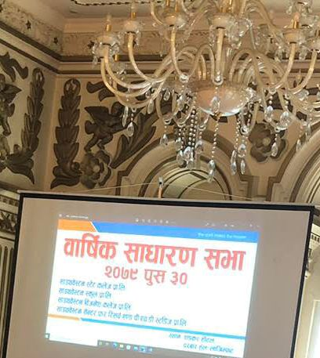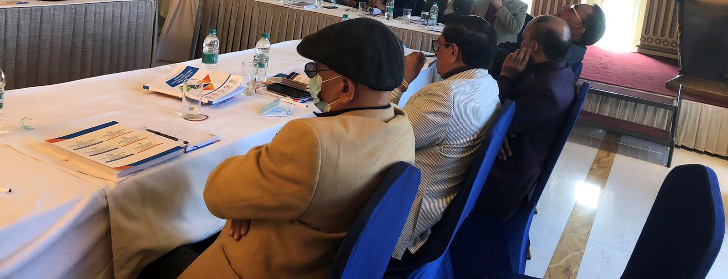
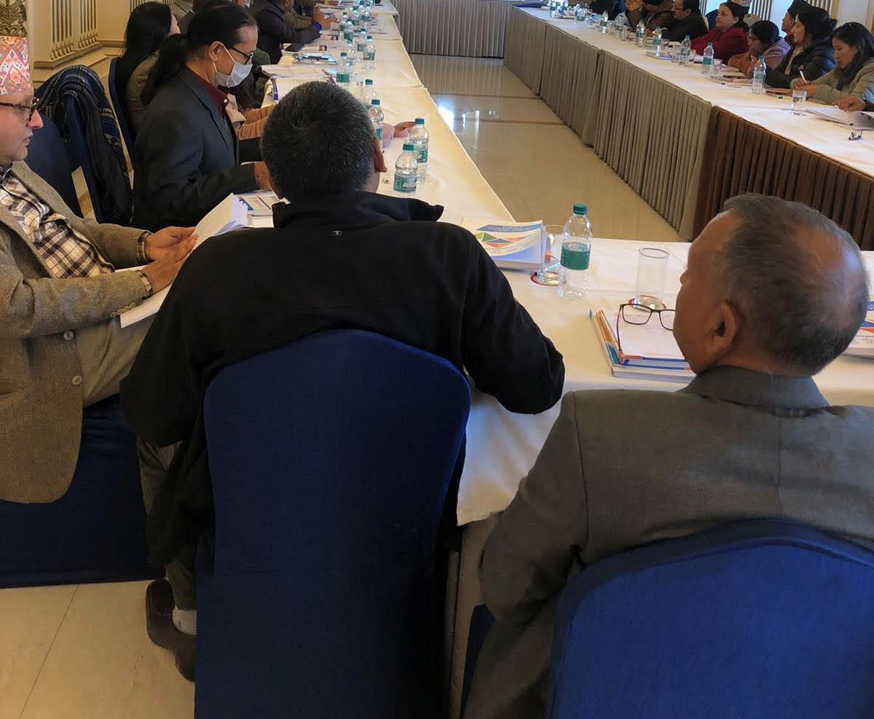

CYBER CRIME SEMINAR: SWSC Seminar Auditorium, 2079 Poush 24
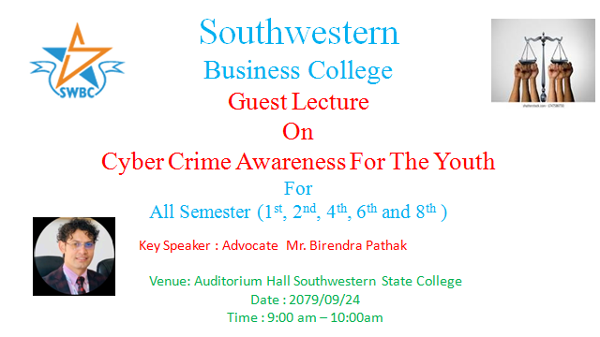
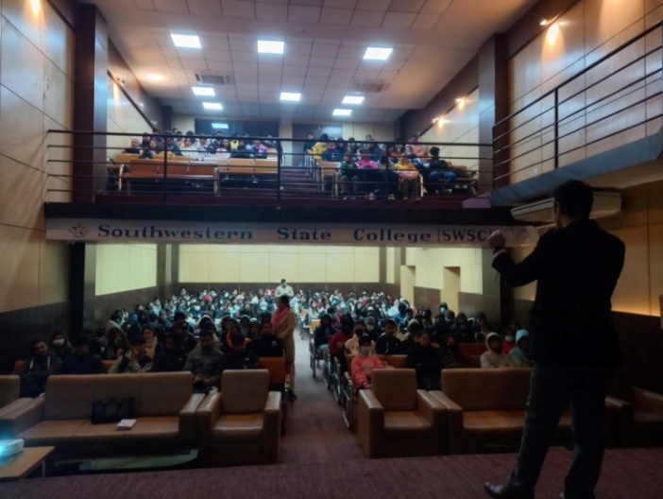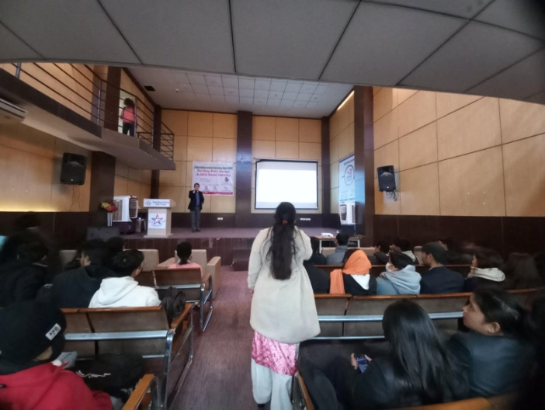
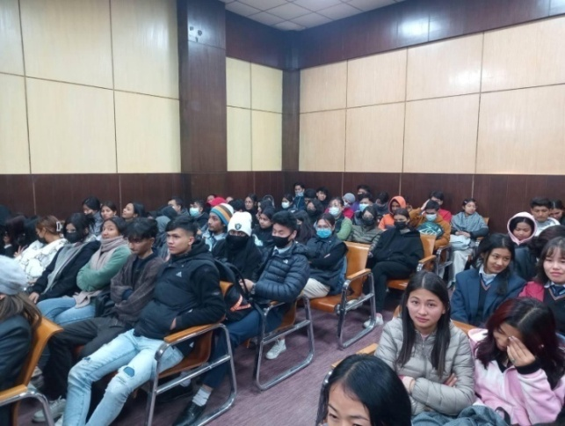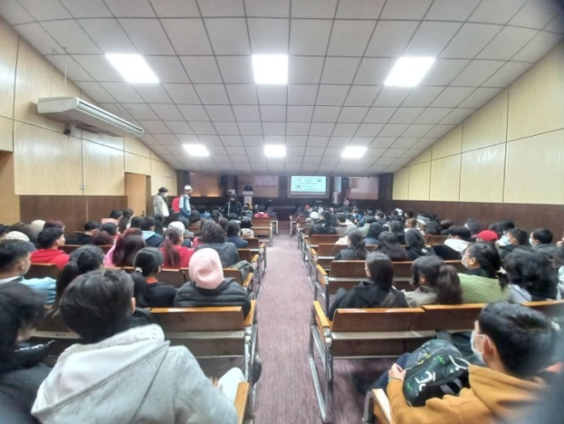
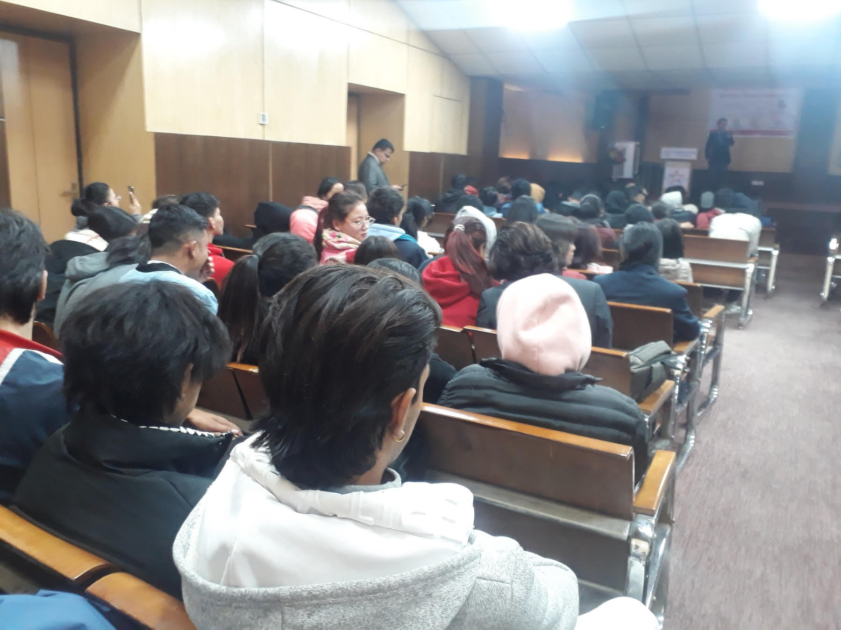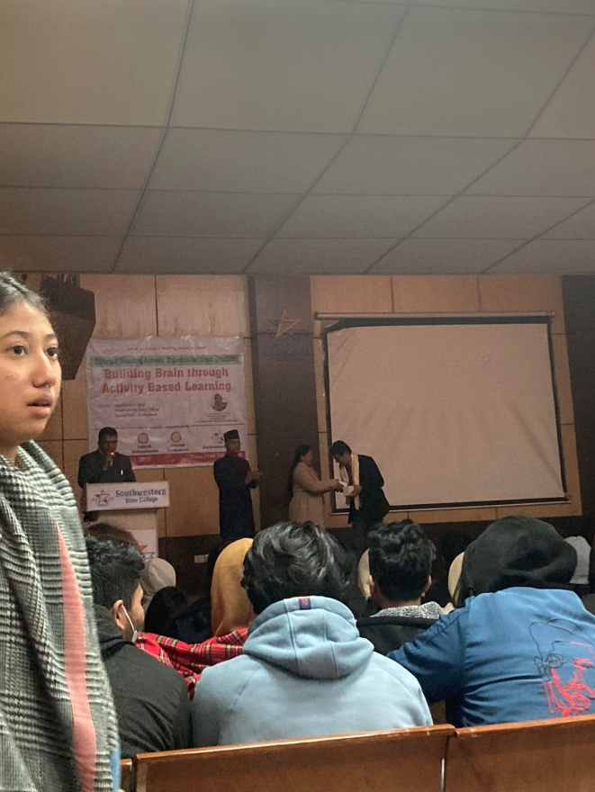

Samrat Shrestha | Arbin Gurung | Mausam Basnet | Ram Chandra | Utkrist Shrestha | Rohit Khadgi
Anju Ghale | Seema Bhurtel | Pooja B K | Rachna Pokhrel | Nisha Thapa | Barsha Gurung
Puja Gurung | Shruti Gurung | Sajita Shrestha | Srijna Choudhry | Sajana Khadka | Suraj B K
Nabin Poudel | Ghanedra Panjar | Riyaz Mandhar | Manisa Timlsna | Rejina Dahal | Usha Thapa
Salina Pakurel | Menuka Tamang | Rojina Dahal | Smriti Moktan | Puja Khatri | Neelam Tamang
Tulasa Poddar | Sneha Khatri | Manisha Rana | Sabin Ghimire | Sudin Dhakal | Chetan Magar
Asbin Shrestha | Susma Shrestha | Bal K Ghale | Rasmita Gurung | Divya Malla | Shanti Gautam
Aasta Karki | Anjila Rai | Nirmala Khadka | Sarita Dangol | Puja T Magar | Baivab Bista
Anuska Thakuri | Shristi Maharjan | Sima Rana | Sita Shrestha | Simran Khadka | Nirjla Soleman
Saharsa R Magar | Karisma Shresta | Bijendra Regmi | Samip Thapa | Milan Baisinju | Sobit Basnet
Swastika Sresta | Usha Chhantyal | Sunmaya Magar | Shital Maharjan | Sneha Tamang | Sujata Thapa
Dinesh Khadka | Subin Ghimire | Mrinal Adikari | Nurbu Tamang | Dipes Syangpa | Mahima Koirala
Suvexya Aryal | Beemala Dangol | Vabisya Pariyar | Asmita Pariyar | Isha Rai | Bitisha Mahrjan
Roshni Regmi | Upama Mahato | Suwana Pandey | Melina KC | Sushma Lama | Pooja Lama
Astha Subedi | Ashok Gurung | Roja Shrestha | Yogita Gurung | Onsika Aryal | Shiwani Karki
Arati Timilsina | Aliza Pradhan | Ichchha Tamang | Amisha Tamang | Dishan Shrestha | Nischal Xetri
Juhi Giri | Chime Dorje L | Anuska KC | Swastika Baral | Soniya Thapa | Karina Bhujel
Sudip Pun | Binita Malla | Susmita Pyakrel | Akriti Rai | Lalit Gotame | Upasana BC
Manika Rai | Nandika Oli | Aaral Mainali | Anusha Thakuri | Prakriti Thakuri | Priti Singh
Bindiya Xetri | Lucky Thapa | Rijan Manandar | Ankit Thakur | Nisseem Limbu | Ashim KC
Rohan Gurung | Aftar Kandel | Puja Karki | Sukriti Ghale | Padam Ghale | Nishan Ghale
Suman Thapa | Asmi KC | Rupa Rai | Sandesh Amgain | Mortal Vee | Briaspati Magar
Saroj Rumba | Nirjara Shresta | Asha K Thakur | Nishan Gurung | Sumit Adikari | Sisir Dhakal
Raj Tamang | Boby Tamang | Amok Hamal | Roshani Shahi | Sandhya Gupta | Prerna Pun
Srijna Chaudary | Alisha Rai | Purnimaya Rai | Syangbo Tamng | Sudipa Regmi | Salina Khatri
Nisha Thapa | Barsha Pathak | Ronisa Adikari | Ays Sing Thakri | Khusbu Magar | Ujana Khatri
Laxmi Vattarai | Kirtan Gurung | Binesh Adikari | Pravas Amgai | Sajina Ghale | Dhan K Gurung
Alsing Thakur | Nikhil Thapa | Dipendra Ghale | Shyra Gurung | Jyoti K Singh | Sneha Shahi
Sandesh Kafle | Nikhil Adikari | Keshab Budha | Pramesh Thapa | Adarsh Karki | Nikesh Lama
Radhan Ghale | Sujal Silpakar | Kusum Purkuti | Aagya Balami | Swyam Hajr KC | Bippal Shrestha
Eminem Gurung | AnupBabu Karki | Nabin Thapa Mg | Aman Lama

Farewell and Welcome Program: for Outgoing and Incoming Program Coordinators
–3rd January 2023 (19th Poush 2079) Tuesday: Venue: College Premises
Joint Program on: (1) FAREWELL to Mr. Binaya Kattel & (2) Welcome to Mrs. Nani Maiya Dangol
Date: 2079 Poush 19 ( 3rd January 2023) Tuesday; Venue: College Premises
AGENDA
PART ONE (Emcee: Sulav Neupane, Vice Campus Chief)
- Call on Dais
- Start of the Program by the Chairperson
- Khadas to the Chairperson and the two Personalities
- Few starting words of parting and warmness from the Campus Chief Dr. Jayahari Raj Pandey

PART TWO (Emcees: Ghanendra Kumar Panjiyar, Nirmala Khadka, and Salina Pyakurel)
- Welcome Dance- medley (Sushma Syangden, Nabina Ghale)
- Experience sharing from a student ( Sangam Acharya)
- Poem: Director Shova Silwal
- Expression of Understanding from a student ( Deepak Lamichhane)
- Dance –hijo rati sapanima ( Sneha Khatri, Manisha Rana)

PART THREE (Emcee: Sulav Neupane, VCC)
- Wise Words from Mr. Binay Kattel
- Formal handover and acceptance articulation from Mrs. Nani Maiya Dangol
- Open to one speaker for some expressions: Faculty Bimal Shrestha
- Key address from the Chairperson Dr. Krishna Bahadur Karki
- Token of Appreciation/ Recognition/ Gifts
- Cake cutting followed by socialization program

Proceedings
- Seat on the Dais: Chairperson, Campus Chief, Bijaya Sagar, Shova, Binaya, Nani Maiya, Sajani, Devhari, Bimal, Gokul
- Khadas distribution
- Dr JRP: this welcome / farewell different from our usual since it’s the deserving one and only twice such farewell happened; rules/regulations/discipline can’t be taken by the students bluntly and Prog coordinator should be able to comply them with students’ cooperation; activities during his tenure was tri-fold and participation two-fold
- Shova Silwal’s poem was unique
- Bimal Shrestha emphasized on healthy tradition
- Token of Appreciation to Binaya, Bouquet of Flower for Nani Maiya, Personal Gift of Pen from Dr. JRP, and a Jacket from Sulav
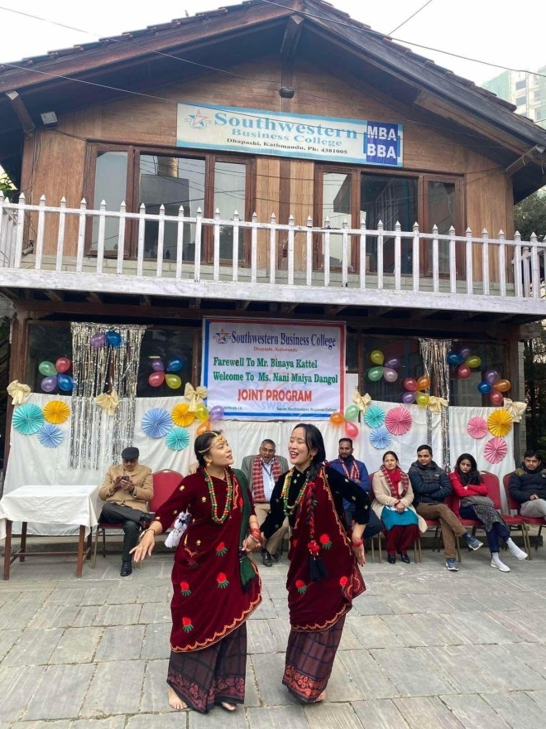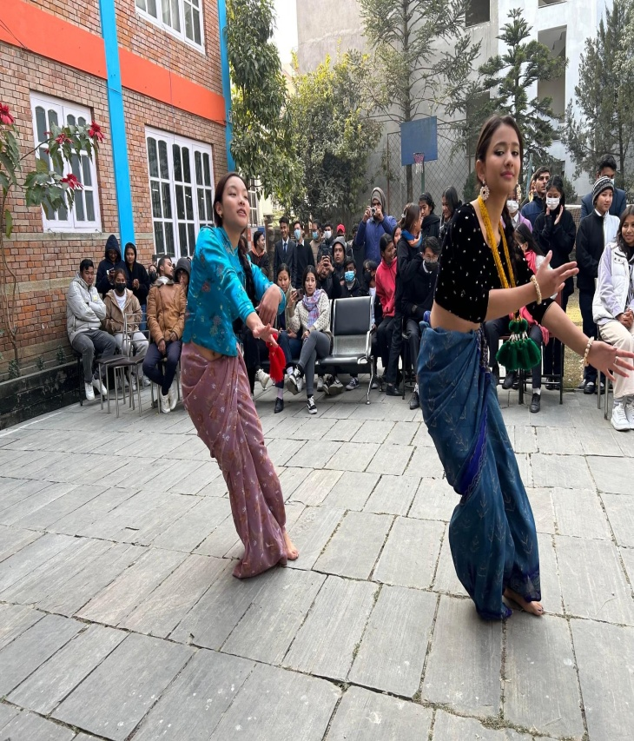
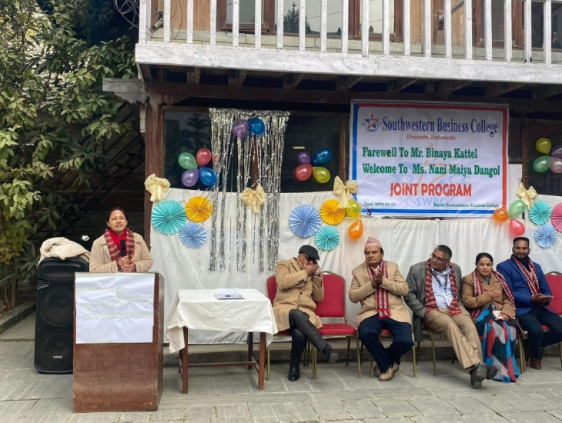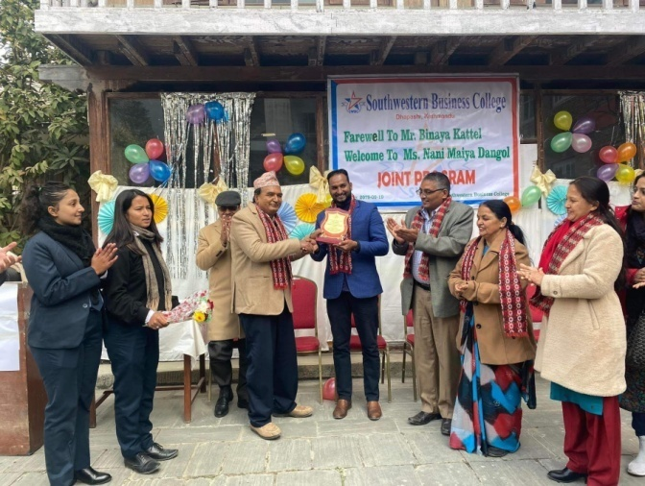
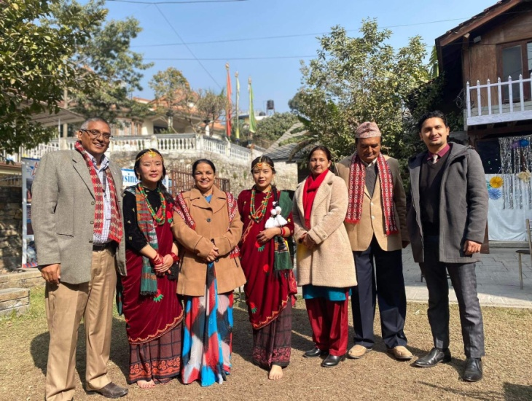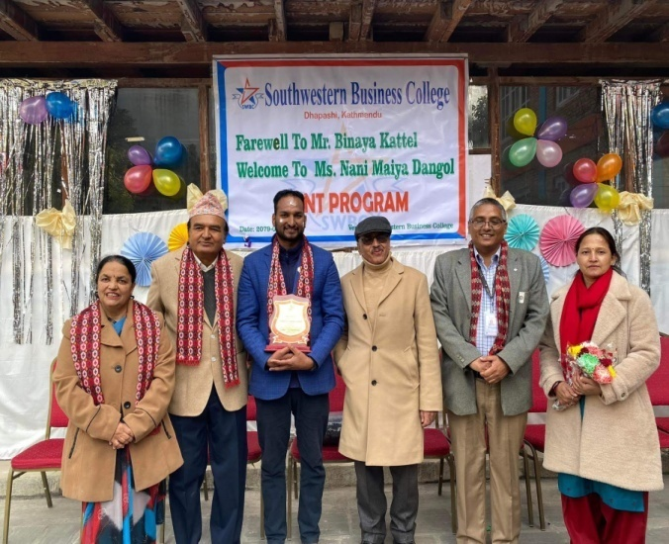
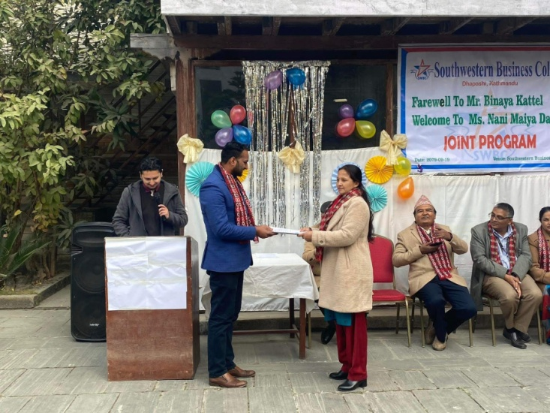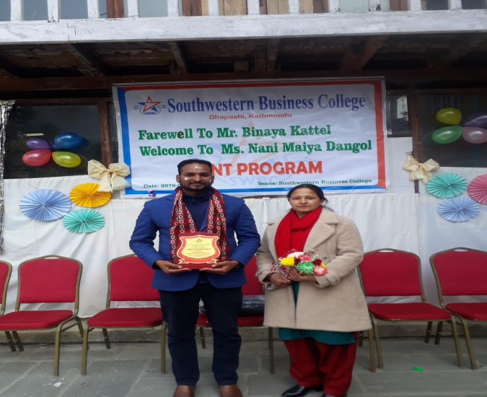

Welcome and farewell program (coordinators’ joint Program)
Students participated in program
Date: 2079 /09/19
S.N. | Name | S.N. | Name | S.N. | Name
 | Ashrika Basnet | 34 | Akriti Rai | 65 | Aayush Shrestha
 | Anisha Lamichhane | 35 | Anuska KC | 66 | Amisha Tamang
 | Anup Mishra | 36 | Barsha Gurung | 67 | Anusha Chand Thakuri
 | Arbin Gurung | 37 | Binita Malla | 68 | Ashok Gurung
 | Asbin Shrestha | 38 | Chime Dorge Lama | 69 | Astha Subedi
 | Bal kumari Ghale | 39 | Juhi Giri | 70 | Baivab Bista
 | Chetan Ghrti Magar | 40 | Karina Bhujel | 71 | Dikshya Tamang
 | Dinesh khadka | 41 | Lalit Gotame | 72 | Ghanendra Kumar Panjiyar
 | Dipesh Tamang | 42 | Manisha Khatri | 73 | Ichhya Tamang
 | Divya Malla | 43 | Pooja Gurung | 74 | Manashi Adhikari
 | Heena Shrestha | 44 | Sabira Adhikari | 75 | Nirmala Khadka
 | Kabita Lama | 45 | Sajana Khadka | 76 | Nisha Chantyal
 | Manisha Rana | 46 | Sajita Shrestha | 77 | Pooja Lama
 | Mausam Basnet | 47 | Shanisha Maharjan | 78 | Puja Thapa Magar
 | Neha Shah | 48 | Shruti Gurung | 79 | Reeyaz Manandhar
 | Nurbu Tamang | 49 | Soniya Thapa | 80 | Sarita Dangol
 | Ram Chandra Shrestha | 50 | Srijana Chaudary | 81 | Shristi Maharjan
 | Rasmita Gurung | 51 | Sudip Pun | 82 | Sushma Lama
 | Rohit Khadgi | 52 | Sumana Senchuri |  | ……………………………………………
 | Sabin Ghimire | 53 | Supraj Shrestha |  | 6th Semester
 | Samrat Shrestha | 54 | Shusmita Pyakurel | 83 | Manisha Timalsina
 | Shital Maharjan | 55 | Swostika Baral | 84 | Nabin Poudel
 | Sima Rana | 56 | Yujina Basnet | 85 | Pooja Bishwokarma
 | Simran Khadka |  | ………………………. | 86 | Rachana Pokharel
 | Sita Shrestha |  | 8th Semester | 87 | Rejina Dhakal
 | Sneha Khatri | 57 | Anupa Bishwokarma | 88 | Salina Pyakurel
 | Sneha Tamang | 58 | Dipak Lamichhane | 89 | Seema Bhurtel
 | Subin Ghimire | 59 | Nabina Ghale | 90 | Sunmaya Gharti Magar
 | Sudin Dhakal | 60 | Ronisha Shrestha | 91 | Swastika Shrestha
 | Sujata Thapa | 61 | Sangam Acharya | 92 | Usha Chantyal
 | Sushma Shrestha | 62 | Sobit Panta | 93 | Usha Thapa
 | Swastika Acharya | 63 | Sushant Magar | 94 | Utkrist Shrestha
 | Tulasa Poddar | 64 | Susmita Kumari Panjiyar

MANAGEMENT TUG OF WAR: 2nd SEM, 18th Dec 2022
TEAMS
S.N. | Team ‘BOARD’ | Team ‘Management’ | Team ‘Leadership’ | Team ‘Promoter’
1. | Nisha Thapa | Manisha Khatri | Sajana Khadka | Karina Bhujel
2. | Juju Gurung | Shruti Gurung | Binita Malla | Lalit Gotame
3. | Supraj Shrestha | Ashish Giri | Akriti Rai | Sajita Shrestha
4. | Anish Bogati | Anuska KC | Nabin Shrestha | Srijana Chaudary
5. | POSITION: FIRST | POSITION: FOURTH | POSITION: SECOND | POSITION: THIRD

SWBC YOUNG GENIUS in ADVERTIZEMENT
Advertising has been getting due and increasing importance because it has the CAPACITY:
- To make the people aware of the product
- To reach the right audience
- To put the product in the minds of the potential customers
- To make it remain in the minds of the potential customers
- To convert the potential customers into paying customers
- To make the paying customers permanent customers, and thus
- To drive business growth
Needed QUALITY of Advertising
- Full and Adequate Information of the Product
- Ability to attract customers
- Build Customer Trust
- Go ahead in competition
Advantages
(a) Introduction of the product in the existing market
(b) Growth of the existing market
(c) Gradual and constant increase in the sales
(d) Edge in Competition
(e) Gradual and constant increase in quality
(e) Easy and full information for all
(f) Feeling of satisfaction for the customers
(g) Reliable support for the salesmanship
(h) Elimination of unnecessary middle channels

Definition: SWBC Young Genius in Advertising is a powerful Game to:
- make our students aware of the power of advertising,
- generate innovative ideas on advertising,
- bring out ways to reach the destination of the generated ideas, and
- show the glimpses of the performance side as well
GROUPS
ONE (THINK TANK): think, conceptualize, and prepare script of advertisement
TWO (PREPARATION WING): planning and direction as per the generated ideas
THREE (ROLE PLAY): performs on stage or for TV
FOUR (CUSTOMERS): gives remarks (approval or disapproval)

NEEDED ASPECTS
- Product name:
- Group selection
- Time segregation for each Group
- Demarcation for Think Tank Group: write on--- (i) the product’s target group (ii) focus subject/issue (iii) background (iv) lines
- Comment Sheet for ‘Customers’

COMMENT SHEET
Name:
(Kindly provide marks from 1 to 10)
S.N. | Adequate Information | Attractive | Trustable | Competitive
1.
2.
3.
4.
Q.N.1: Did the product impress you?
YES NO
Q.N.2: Will you buy the product?
YES NO
Q.N.3: Will you vouch the product to others?
YES NO
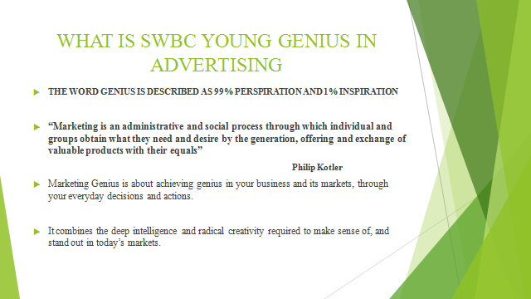
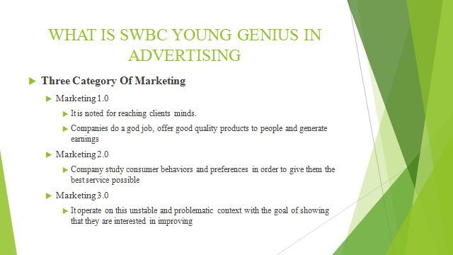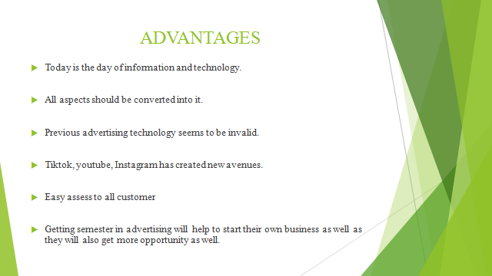
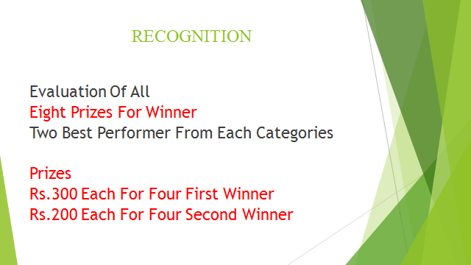
S. No | Name of Students | 18/12 | 20/12 | 22/12 | 26/12 | 28/12 | winner | Prize Amt | Remark
1 | AkritiRai | p | p | p | p | p | winner | 300 | 1st
2 | Anish Bogati | p | p | p | p | p
3 | AnuskaKc | p | p | p | p | p
4 | Ashish Giri | p | p | p | p
5 | BarshaGurung | p | p | p
6 | BinitaMalla |  | p | p | p | p | winner | 200 | 2nd
7 | Chime Dorge Lama |  |  | p | p | p
9 | Juhigiri |  | p | p | p | p | winner | 300 | 1st
10 | Juju Gurung | p | p |  |  | p
11 | Karina Bhujel | p | p | p |  | p | winner | 200 | 2nd
13 | LalitGotame | p | p | p | p
14 | Manisha Khatri | p | p |  | p | p | winner | 300 | 1st
15 | Monika Gurung |  | p | p
16 | NabinBasnet |  | p |  | p
17 | Nabin Shrestha | p | p | p | p
18 | NishaThapa | p |  |  | p | p
19 | PoojaGurung |  | p | p | p | p
20 | SabiraAdhikari |  | p | p | p | p
21 | SajanaKhadka | p | p | p | p | p
22 | Sajita Shrestha | p | p | p | p | p
23 | SamarpanaRaut | p
24 | ShanishaMaharjan | p | p | p | p | p
25 | ShrutiGurung | p | p | p | p
27 | SoniyaThapa |  |  | p | p | p
28 | SrijanaChaudary | p | p | p | p | p | winner | 300 | 1st
29 | Sudip Pun |  | p | p | p
30 | SumanaSenchuri |  | p |  | p | p
31 | Supraj Shrestha | p | p | p | p
32 | SushmitaPyakurel |  | p | p | p
33 | SwostikaBaral | p | p | p | p | p
34 | YujinaBasnet |  |  |  | p
 | Total no. of students | 19 | 26 | 24 | 26 | 19

COMMUNICATION GAME : 4th Semester, 2079.09.28 In total, 23 students were present to play the roles of employees from Top to Bottom in hierarchical order. A case was taken in which Short Message, Long Message and Medium Message were circulated from BOD to Helper, and the EDUCATION was: Medium/ moderate message can be circulated correctly if the receiver and the sender are actively participating in communication – even though the management hierarchy is longer/ higher.

THREE DAYS SHORT INTERNSHIP at FOOTWEAR EXPO: Poush 21 to 23, Bhrikutimandap
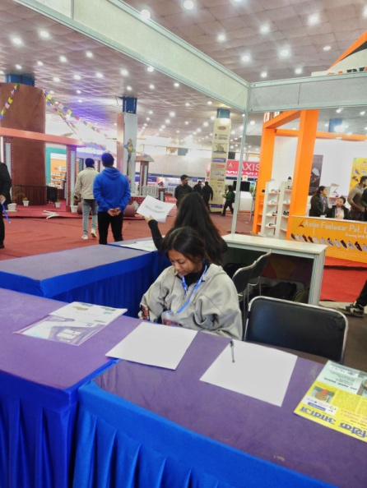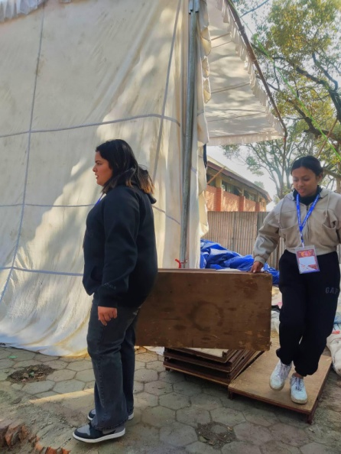
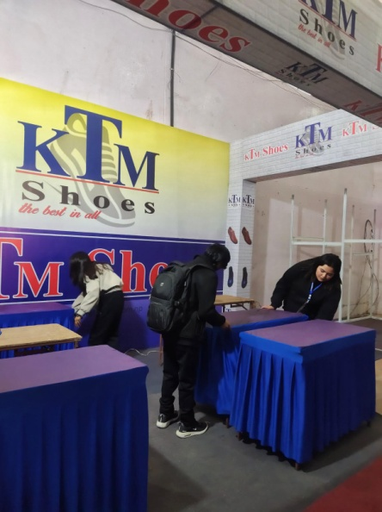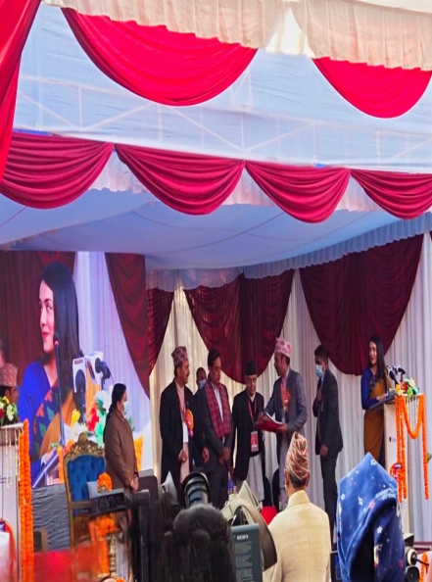
Report by: Ashrika Basnet, Sneha Khatri, Manisha Rana, Neha Shah and Asbin Shrestha
