Southwestern Business College
NEWSLETTER MAGHA 2079
INDIVIDUAL FOCUS SERIES—47
Dr. Jayahari Raj Pandey
With International Day of Education just behind us, we are reawakened about the power of digital space in education - in comparative terms, on progressive skills and creation of long-term values out of such experience. Today, students are highly suggested to grip digital form in their thinking pattern. That is the demand of time. And it is not new in any way. Human beings have shown the capabilities of tremendous transformations within these thousands of years, and have been able to prove that we have, perhaps no boundaries. Whatever new thinking, new scales of unimaginable imaginations, and heights of live dreams various bodies in different ages and periods have taken/ dreamt of, we have witnessed their achievements. Of course in many cases, they have taken long stretch of times, but eventually they have become possible. Hence, we can sense the powers that each of us have.

"If you look to others for fulfillment, you will never truly be fulfilled. If your happiness depends on money, you will never be happy with yourself. Be content with what you have; rejoice in the way things are. When you realize there is nothing lacking, the whole world belongs to you."
-- Lao Tzu

Human beings are labeled as wise due to innate intelligence within us. Such wisdom is the result of our thinking and the ability to put our thinking into action.
Our thinking can be said as having the result of two factors:
One is the outer formation connection with external forces (people or things), imagination within the framework of borrowed developments, and visualization through various senses.
Another is the inner thing to which many call unconscious mind or intuition.

Let’s take a look at what RAGINI RAO, Psycho-therapist, Trainer & Life Coach says ( in ‘Tapping the Power within us – By allowing our Intuition to work’ in Infinum Growth), as follows:
“Intuition is memory stored in our body, some of it through generations.
- It is a memory – from past experiences and cumulative knowledge; often not at a conscious level. This is many times revealed through dreams.
- Our brain processes information automatically even in our daily routines, which underlies intuition. The unconscious competence that we build while driving or cooking or any of the routine tasks we indulge in, is intuition.
- Even when we make complex decisions, this processing plays a big part. E.g. When we make crucial business deals or choose a life partner.”
As also emphasized earlier few times, Individual Focus has a lot to do with the above-mentioned Intuition. Human brain is very complex thing to understand fully. Research on it is a regular feature since hundreds of years at numerous places and institutions. There is a gradual phase of developments of newer information on human brain, but the knowledge gathered till now on it might not be even .oo1%. However, without totally understanding it and its total gamut, what is a common knowledge is that we all indulge in a process of intuition. Something suddenly comes in to our mind, and we are unknown of its source. As explained in the above quotation, memory accumulated in our brain might be generational also – meaning that there might be some data inherent in heredity of particular family – passing on through different generations. It is highly believed that the genetic material is existent or inbuilt inside our brains, which become the source of certain hunches building inside us. Similarly, many of the regular practices that we are doing for a long time lead to another pool of information inside the brain. Such storage of information leads to certain automatic behavior coming out of us. I would like to take one personal example. I am associated with the world’s largest service organization since last 23 years. For meticulousness and effective service delivery, it has a large base of volunteers (more than 1.4 million within 200 plus countries and geographical territories) with an annual fee system, and it has developed a system of getting its local representative as a leader (based on certain number of volunteers) to control and manage that area. For transparency and authenticity, an annual election system ensures that the International President, 3 Vice Presidents, 35 International Directors and more than 800 District Governors (local representative as a Leader) are duly elected on time. So, it was during the recent local election of the District Governor that a person who was humble, forward looking, and realistic got elected to the satisfaction of 99 percent voters. He had a long experience of working closely with the past representatives in different portfolios, and had made a kind of track record of maintaining an extra-ordinary working relationship with all. Normally, people like to work with their own type of people, and find it somehow difficult to get adjusted with people with varied behavior. So, with curiousness, I put a question to him on his ability to amend himself to new circumstances. His answer was quick! He, always, had an intuition on what way the person that he was dealing with would prefer to be dealt with. I understood! Through experiences of many years dealing with so many types of people, his brain had accumulated the data analyzed by him phase by phase, and that data was responding in the form of intuition.
For this reason, we are encouraging our students to go on accepting challenges, trust one’s inherent acumen, have good thinking, and be action-oriented.
"A good life is about accepting change, taking risks, falling and getting up again, appreciating people, and enjoying the memories."
-- Author Unknown

"Tough times don't last, but tough people do. Never give up!"
-- Robert Schuller

SCIENCE EXHIBITION – 26th – 27th Magha 2079 ( 9 – 10 February 2023)
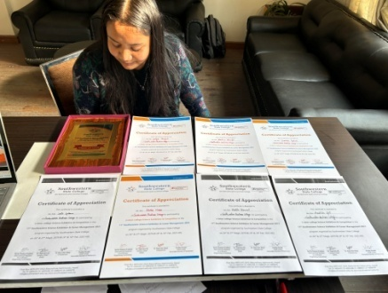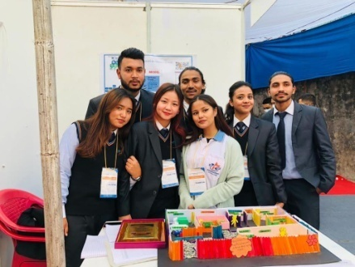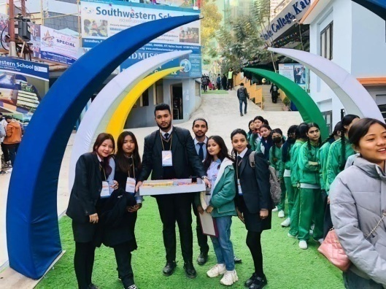
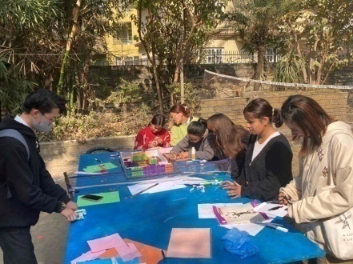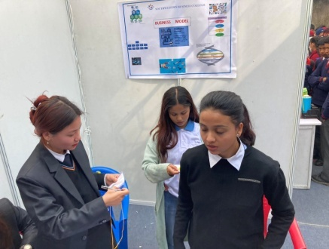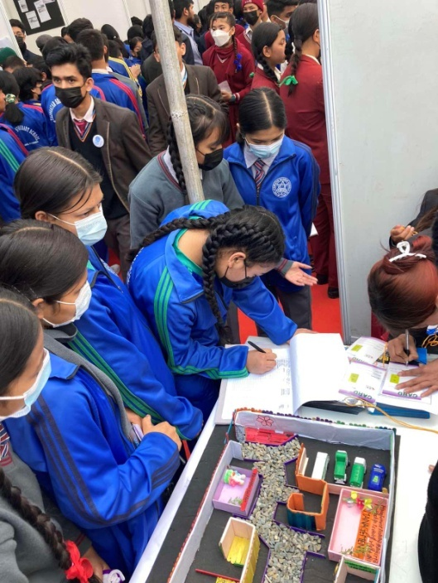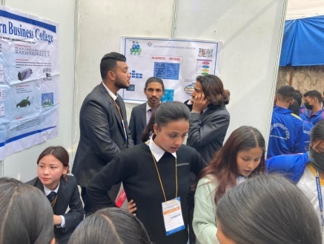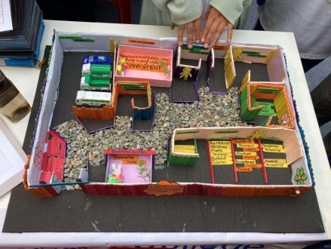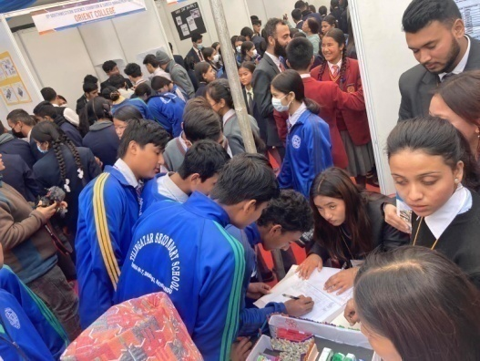
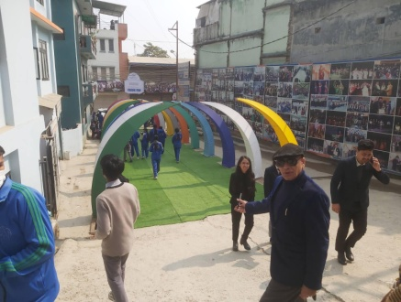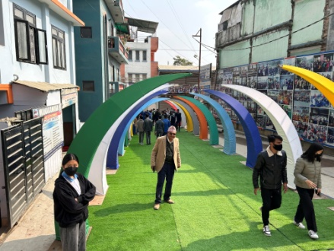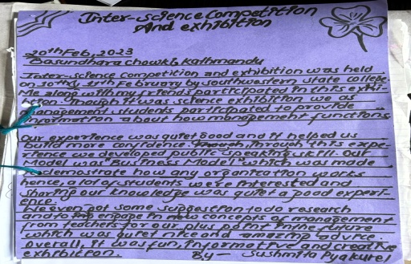
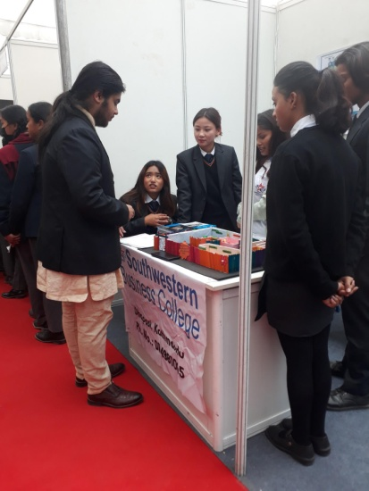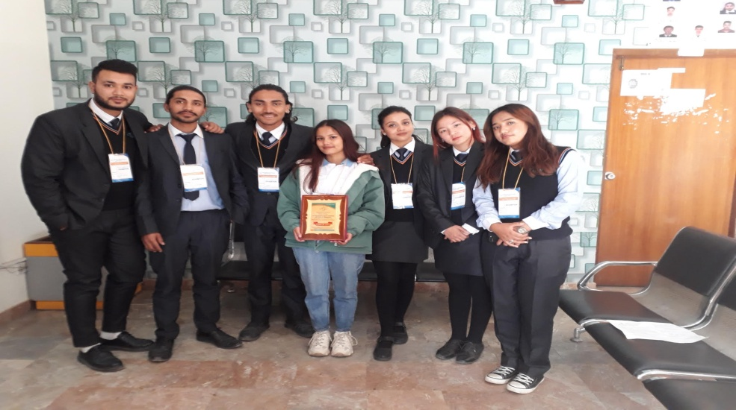

Product Dumb Charade: 4th Sem : Magha 10th
It is an original creation of some already existing subject matter. The idea is to gather and manifest various angles, issues, and curiosities of the subject matter. The competition intends to help the students to enhance their skills in expression, to have voice modulation and to have command on dialogue delivery.
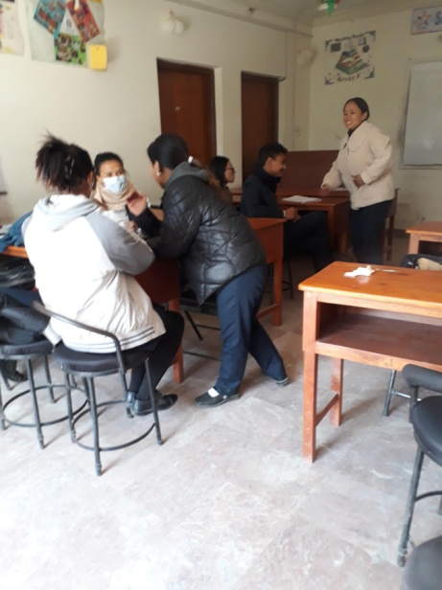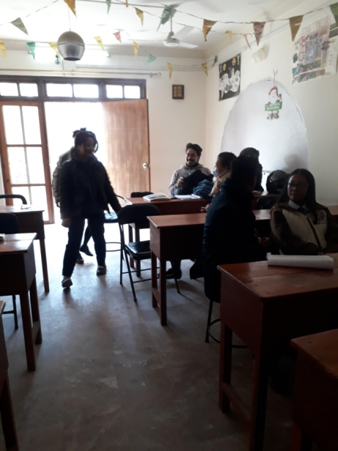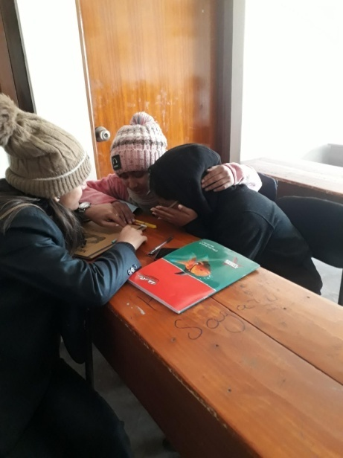
S.N. | GROUP | Names | Marks | Position | Remarks
1. | A | Shanti Gautam, Astha Karki and Nirmala Khadka | x |  | It was 3 rounds
2. | B | Sushma Lama, Aastha Subedi, and Reeyaz Manandhar | 05 pts | Third | Facilitated by:
3. | C | Ayush Shrestha and Shuvani Singh | 10 pts | Second | Nani Maiya
4. | D | Melina Magar, Sarita Dangol and Nisha Chhantyal | 15 pts | Winner | Dangol

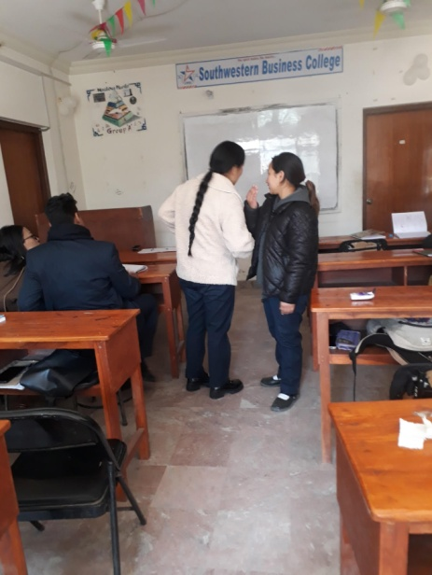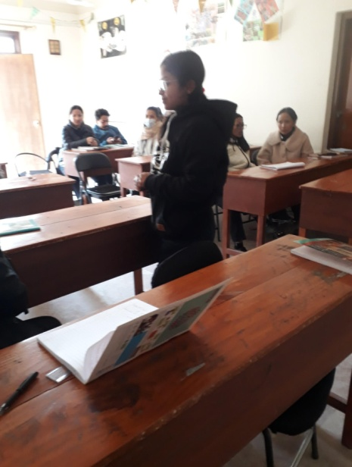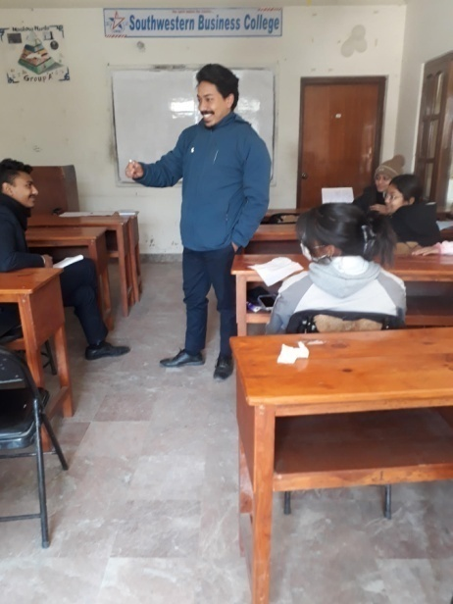

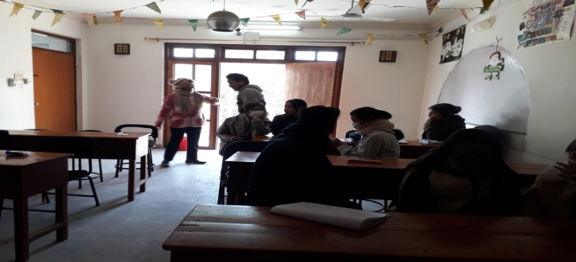

Business Proposal Program: 1st Sem : Magha 11 2079
29 students presented the proposals on various ideas which included: ‘Nepal Database’, ‘Internet Café’, ‘Flower Shop’, ‘Mobile – 3’, ‘New College’, ‘ Wine Shop’, ‘Unisea Salon’, ‘Café Bubbles’, ‘Coffee Shop’, ‘Gift Shop’, ‘Bike Assemble Workshop’ etc.
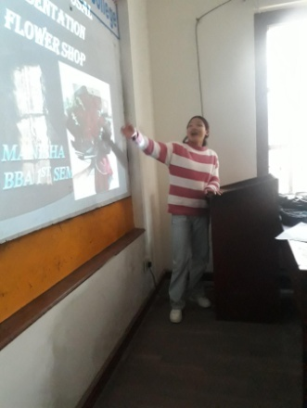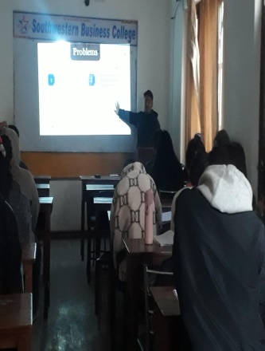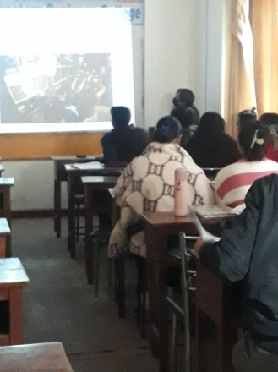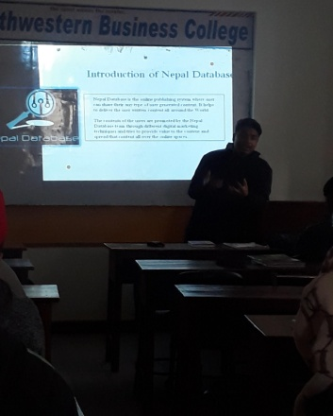
Business Proposal Program: 4th Sem : Magha 11 2079

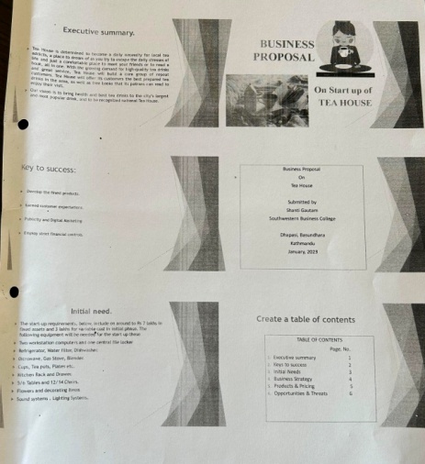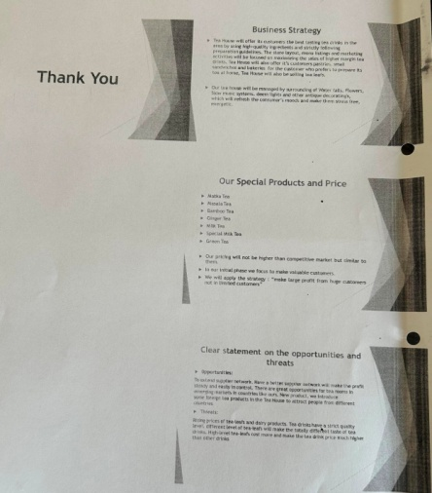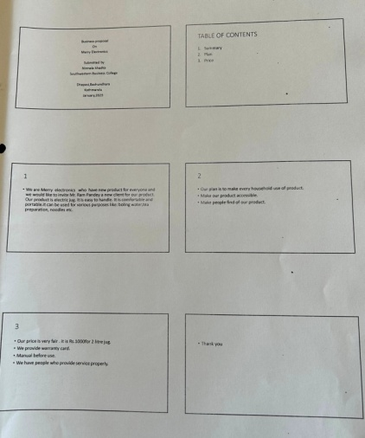

Saraswoti Puja: Basanta Panchami: Puja in honor of Hindu Goddess of Learning/ Intelligence/ Knowledge/Wisdom, Art, Music and Culture: 2079 Magha 12 (26th Jan 2023), Thursday
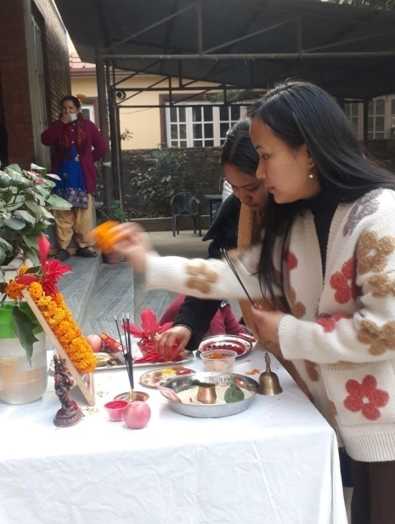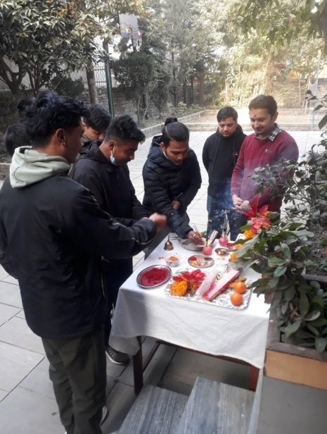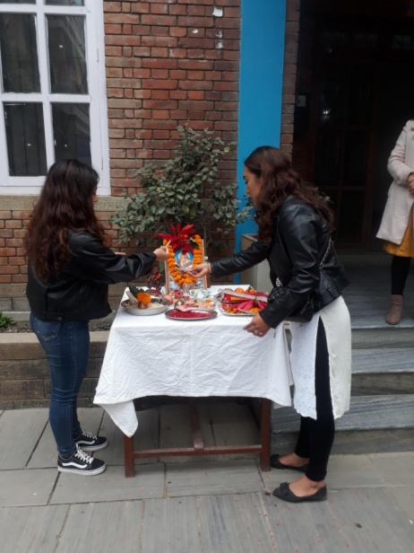
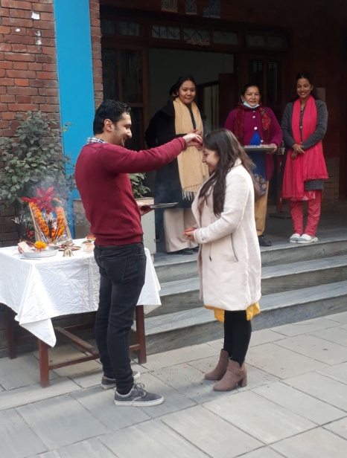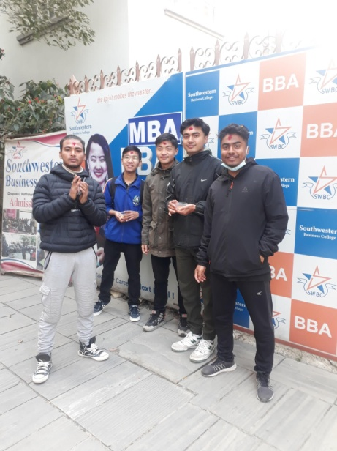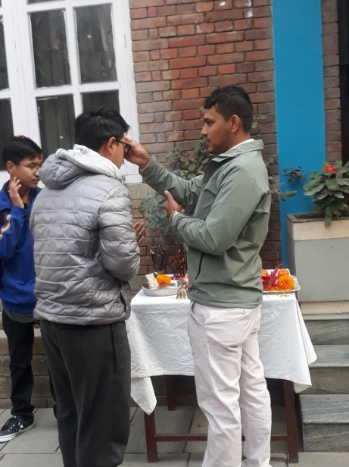
At 8.15, after the completion of the decoration through flowers / garlands, and arrangement parts consisting of mike, Prasad etc, the program got started through Saraswoti Bandana ( song with good lyrics ) followed by the worshipping of the Goddess by the teachers, staffs and the students. Tika and the Prasad were offered to all!

Product Dumb Charade: 2nd Sem : Magha 10th
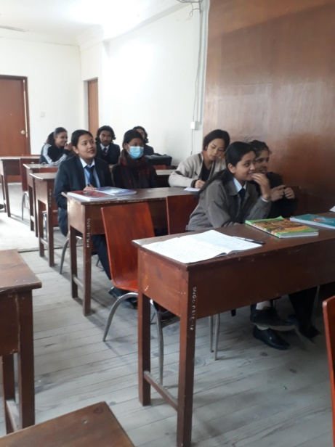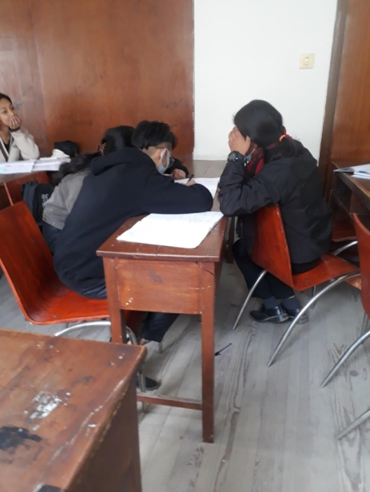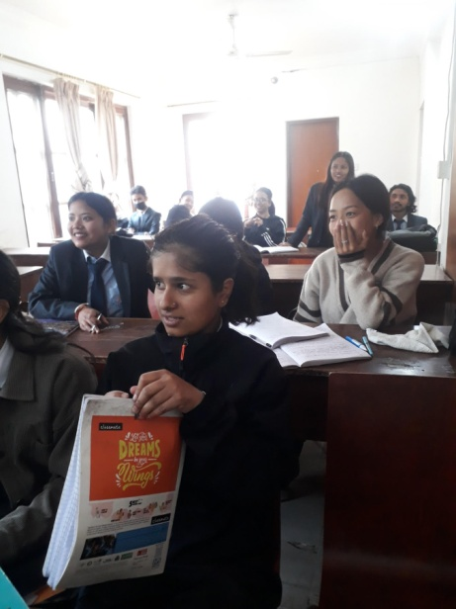
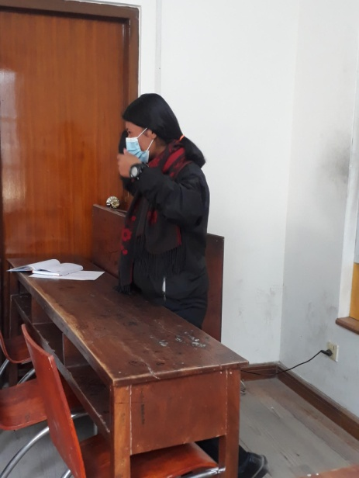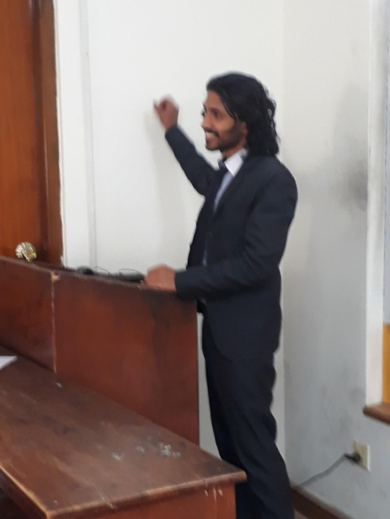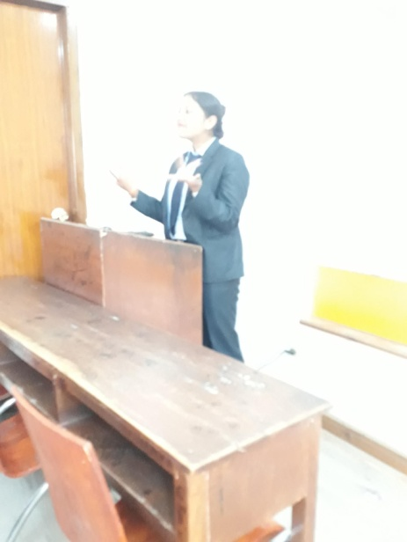

Product Dumb Charade: 1st Sem: Magha 10th
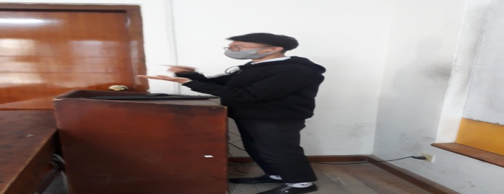
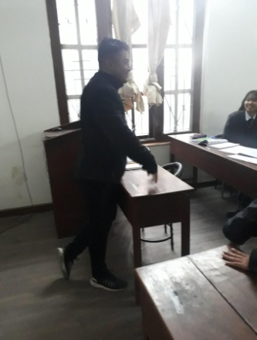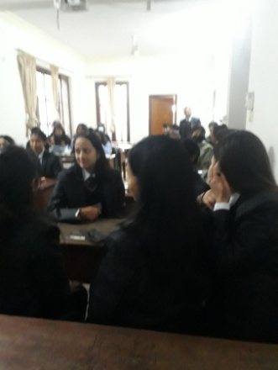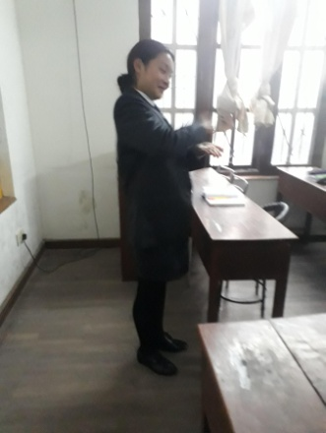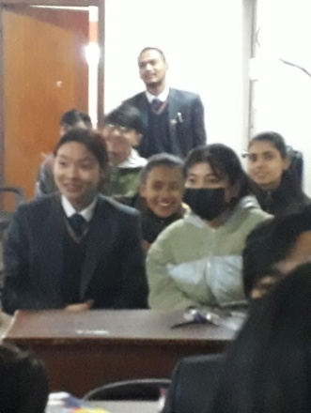
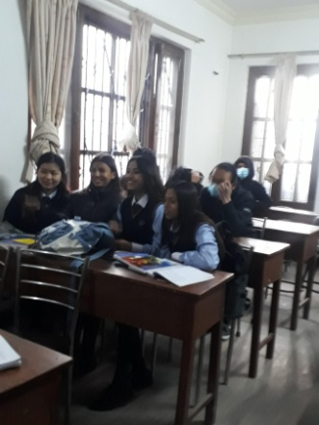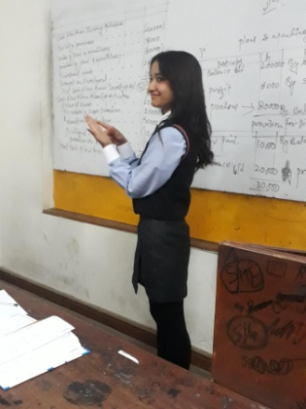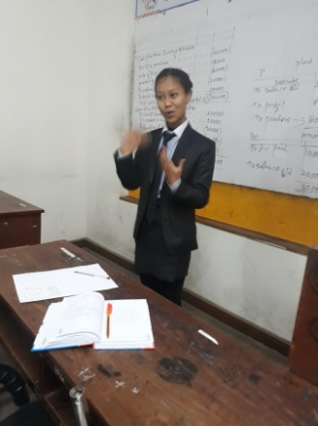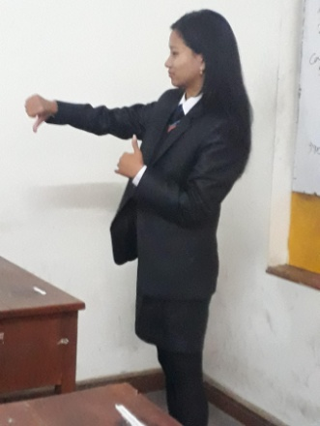
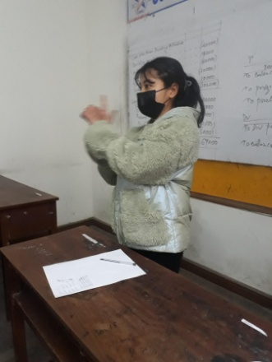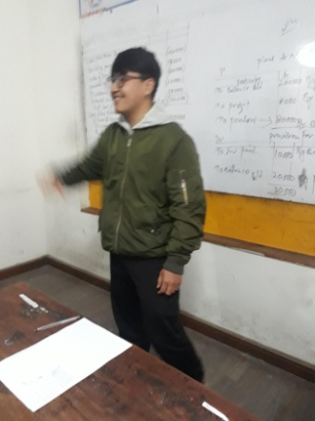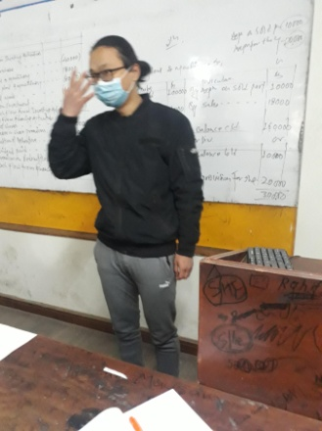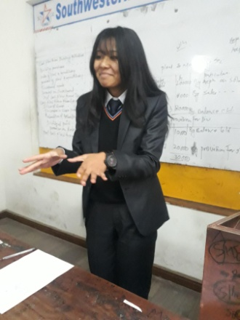
Business Proposal : 2nd Sem
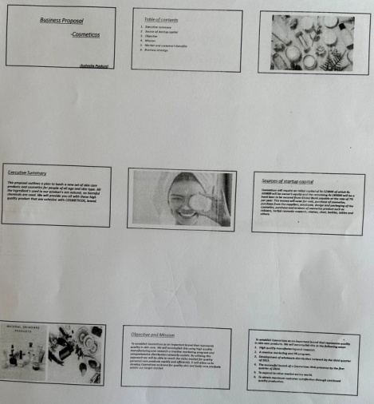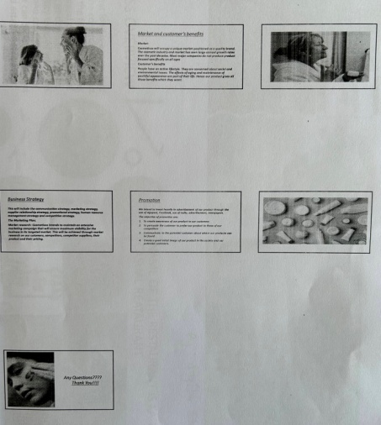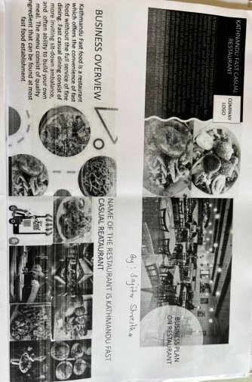
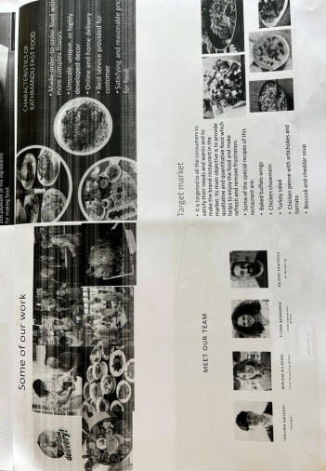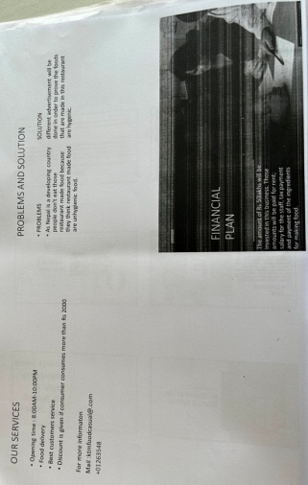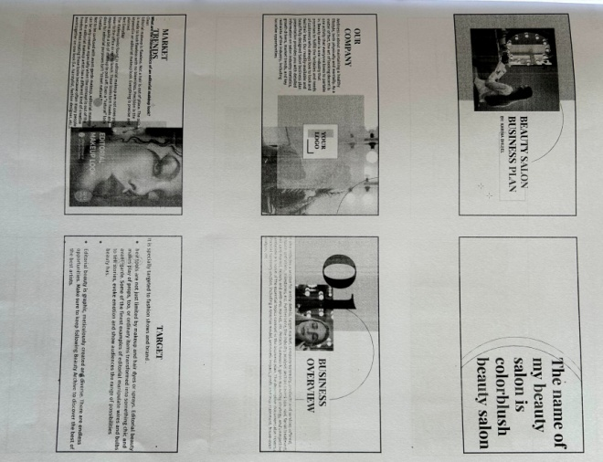
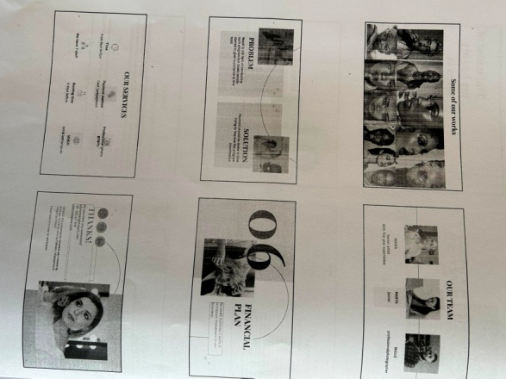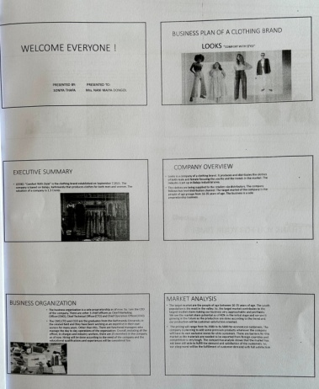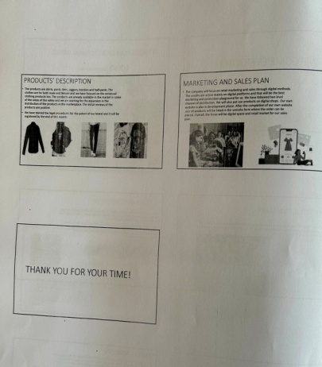
ONE DAY WORKSHOP of PU at Kathmandu
