Southwestern Business College
NEWSLETTER FALGUN 2079
INDIVIDUAL FOCUS SERIES—48
Dr. Jayahari Raj Pandey
In the last series, we had concluded by urging our students to go on accommodating challenge, have faith on one’s intrinsic intelligence, have high-quality thoughts, and be on the go. There are few suitable and applicable quotations in the same regard, as follows:
I challenge you to make your life a masterpiece.
I challenge you to join the ranks of those people
who live what they teach, who walk their talk. - Tony Robbins

"Dream big, but allow yourself the opportunity to start small, and have your share of struggles in the beginning. The world's greatest composers weren't writing symphonies the day they first sat at a Piano." -- Kevin O'Rourke
Now is the time to go back on what we focused upon till now!
To start with, we began with the identification of ‘Our Goal and Your Target’ which was two- fold namely: Abide by University Syllabus, and Become Unconsciously Competent Person. The students are recognized as the BBA students because of their commitment to go ahead as per the laid norms/ criteria/rules of the University. Naturally, that should be the prime goal of the students as well as of those who have taken the responsibility of guiding the students properly and exactly as per the syllabus (like us). In other words, we should be able to make the students conscious about on what they should focus upon mainly. Inter-disciplinary subjects of BBA are very well-designed and their dealing mechanisms crafted through theoretical and practical mediums are taken as enough to ensure their well-understanding. Then comes the other side, and that can be explained as the ability to utilize the understood matters in a most-productive way. That is smartness. Consequently, the mentioned capability or the smartness should be honed within the students through proper and enough practice in terms of exposure. When perfected, the needed behavior or style and thoroughness of action come out automatically from the students as per the then need/ demand of the hour or situation. For better perceptive, we had taken an example of driving, which when perfected through regular and continuous performance, needed no conscious or alert behavior of any kind after the needed course of practice completion.
Another key factor for all who want to apply the BBA education successfully as a career is the understanding of the social intricacies which is only possible through involvements. Such associations might be through visits, meetings, or lengthy connections from end to end joint works. Society has many layers, and complex forms. As we know, a social structure is based mainly on the patterns through which that society is organized. Our vision gets broadened when we pass through more social compositions. Our focus, in this connection, is to make the students aware of such significance as well as offer them opportunities of tours, short visits, local level joint-works of social importance ( in the past, many of them were environment/health-issues such as COVID-19 and Dengue/cleanliness), and participations in the programs having social implications. Volunteering for a social and community cause leads to familiarization with diverse livings. Such adaptation and the connection with the people and their ideas will have great influence in building a new perspective. I have myself, many a times, witnessed a new awakening which was quite different than my previous assumption built on the basis of readings and others’ narrations. An example can be the Beijing visit of 2019 May. Before that, I had been to China only once in 2013 May, and that had been to Chengdu the total period of seven days of which was spent inside the Hotel of our program. As for the background, my brother had graduated from China – with a study period of nearly six years, and I had built a kind of certain picture of China and its people through series of talks with him over the years (my own perception based on self-understanding and self-analysis of those talks). Similarly, I have had the chance of going through several China-related books. I was proud, in a way, that I possessed so much knowledge of China. However, from day one my spouse and I set our feet in Beijing, my original as well as the gradually developed form of a ‘this is what should be China exactly’ kind of a picture inside me changed completely. That image was nowhere to be seen or even sensed. The set image within me which could describe only one pattern of behavior or system or attitude or expression did not quite apply. Rather, it was like everywhere – as in other parts of the world. It was quite normal world with impressive developmental works, largeness in many infrastructures, and a state of discipline. As in also in many other parts of the world, the younger generation were smart, spoke English fluently, and in many cases they came forward, without any hesitation, to extend some cooperation ( mainly in finding the addresses - for outsiders like us). Since then, my understanding level on the subject has naturally increased and it has benefitted me in numerous ways. Simply, you know nothing unless you witness by yourself. Hence, the worth of social mingling! It has both mental and emotional values! Admiring many things within a place and its people, finding some people to share common curiosities, witnessing newer possibilities, or sometimes getting satisfied by a comparison of having got already ahead in some or more aspects are but few remarkable advantages of social interactions. Contacts built with the people met during certain visits are often deep and lasting - since suddenly we are able to find people whom we like instantly. For the students, they get the taste of real relationships. Unquestionably, the exchange of knowledge broadens the total mindset, and a new horizon of thinking space enters the brain. Also, gradually the students are able to develop interpersonal skills which enhance the roots of the senses of listening and communication. They are also the prime sources of happiness. There is one real happening occurred many years ago- related by a friend of mine. They (friend and his spouse) had a practice of taking their children (two sons) to some outer place/s for around two weeks during the winter vacation. This time, they went to Pokhara. They had arranged with a ‘Homestay’ the lodging and breakfast for 10 nights. They had a plan to utilize the days going to different places. The homestay had 10 rooms in total, and all of them were rented. The next day after their arrival to the town, they went to Fewa Tal and spent the entire day there in and around the water. During the second night, the boys were happy that they had 4 friends from 3 families from Tamilnadu, India – who had arrived only the previous day. All of them were between 9 to 14 years of age, and their bond seemed very intimate- developed within 3 hours. The parents noticed the newly blossomed friendship, and were quite happy as well. They also introduced with each other. On the insistence of the children, the programs from next day were designed for the entire four families – consisting of 8 adults and 6 children (four boys and 2 girls). The entire period of the visit was extraordinary for the children – they were excited, they were cheerful, and they were learning something quite new; as also for the parents because the children were happy and they also had entered into new friendship. As recited by my friend, the most precious life lesson that his two boys learnt was: they had got the sense of ‘that’s not mine’. They had learnt a great character building lesson! The wisdom dawn within the students at an early age on ‘differentiating own things and other people’s things’; and the development of the common sense that one should not take the things that belonged to others, rather one can take permission with the owner to borrow or take turn through some mechanism of ‘give and take’ can have marvelous results throughout the life since the basic principle of entrepreneurship, business, and creation of wealth is based on the theory of reciprocal approach.
Oratory Skill Enhancement Program: 2079.11.15
We are always emphasizing on the speech-making skills of our students. We come out with rhetoric competition semester-wise and inter-semester-wise regularly. Workshops like the one delivered by Mr. Ananta K.C. (who had provided training session in more than 200 schools and colleges) on 27th Feb 2023 help the students a lot towards improving their skills on public speaking. Our motto was the same, and the session of almost 2 hours was highly influential. Use of prepared slides, narration of stories (like the one in which a boy used to eat peanuts during his business hours), time-to-time questioning of IQs, examples of real-life situations made the session informative, interesting and valuable. His suggestion for the College was: enhance the IQ level of the students, and introduce Group Study Method.
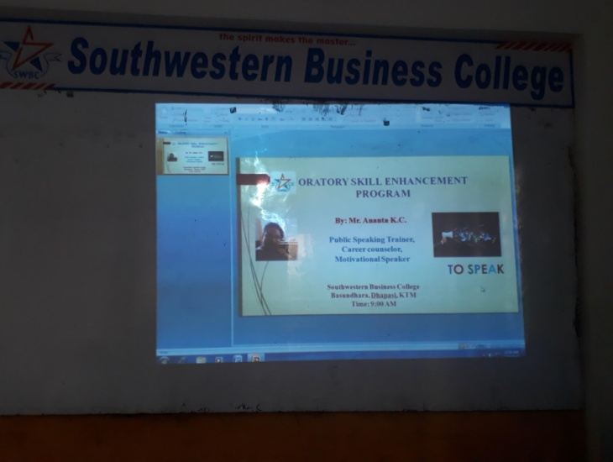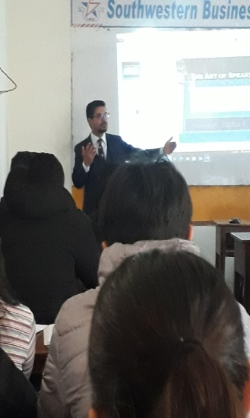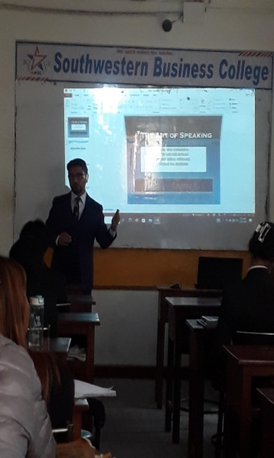
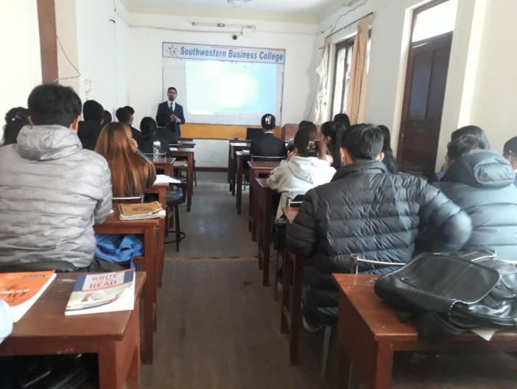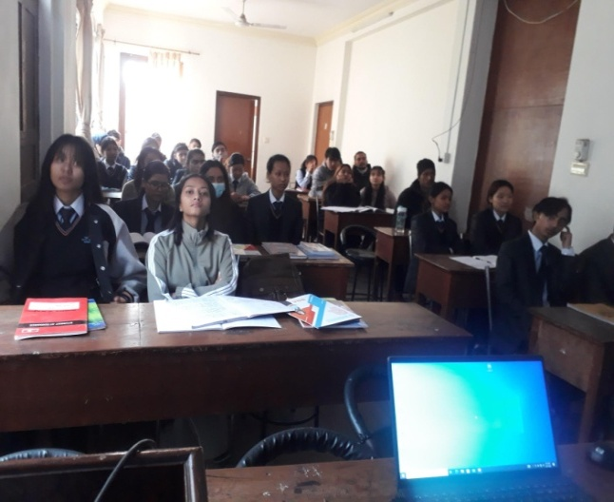

Sneha Khatri | Neha Shah | Samrat Shresth | Arbin Gurung | Hira Soleman | Sima Rana | Ram C Shresth | Manisha Rana
Divya Malla | Sabin Ghimire | Asbin Shrestha | Rupes Neupan | Anisha Majhi | Anisa lamicha | Swostika Acha | Karuna Karki
Sital maharjn | Pratima Upark | Tulasa Podar | Bal K Ghale | Rasmita Gurun | Sneha Tamang | Sujata Thapa | Dines Khadka
Sudin Dhakal | Suman Karki
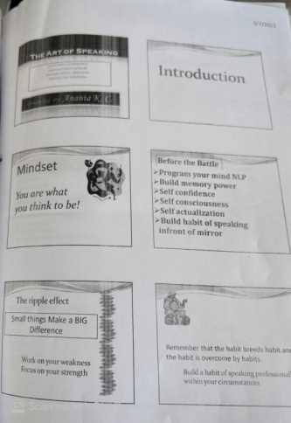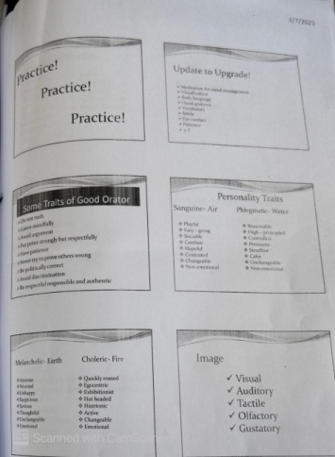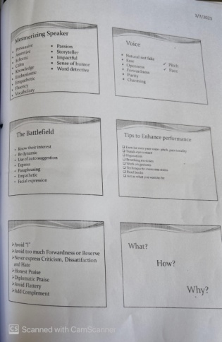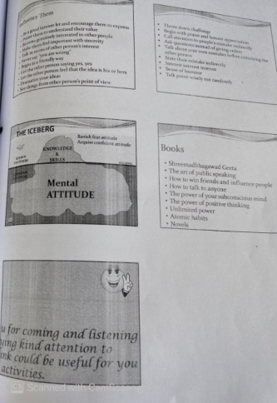
HULT INFO SESSION: Falgun 10, 2079
Bikas Gyawali (Campus Director, Purbanchal University) and his team members ( Akriti Thapa, Angel Karki, Sunil Lama) from Hult Prize Group conducted the session to the students of 1st, 6th and 8th semesters. Our students created a Team named ZARUS with Nabin Poudel, Usha Chhantyal, Anju Ghale, Dambar BK, and Usha Thapa as team members.
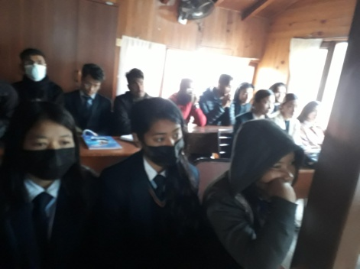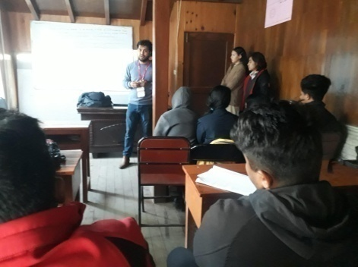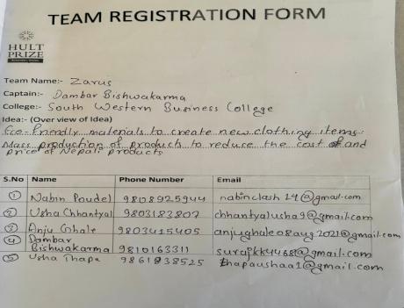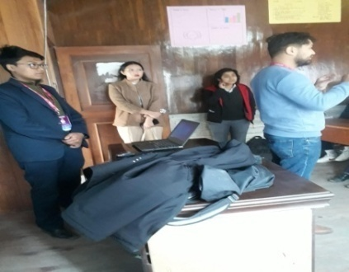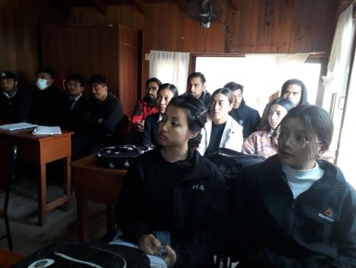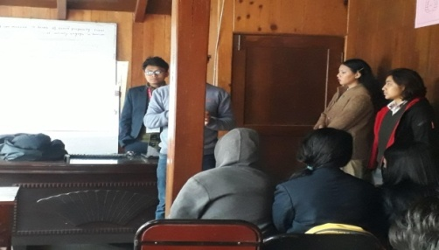
Nabina Ghale | Ronisha Sht | Anupa BK | Susmita Panjr | Sangam Achry | Sobit Pant | Laxmi Serma | Aayus Kharel
Susant Magar | Sagar Khadgi | Dipak Lamich | Nabin Poudel | Dambar BK | Usha Chhantal | Sunmaya Mag | Swastika Sht
Rohit Khadgi

FREE WRITING COMPETITION: 6th Sem : 2079.11.15
Given Subject: Education- The Light for Life ; Full Marks: 10
S.N. | Name | Marks | Position | S.N. | Name | Marks | Position
1. | Anju Ghale | 6 |  | 2. | Dambar BK | 5
3. | Nabin Poudel | 4 |  | 4. | Rachana Pokharel | 8 | Second
5. | Pooja Biswokarma | 9 | WINNER | 6. | Seema Bhurtel | 6
7. | Urkrist Shrestha | - |  | 8. | Usha Pokharel | 6
9. | Usha Thapa | 4.5 |  | 10. | Manisha Timalsina | 8 | Second
11. | Salina Pyakurel | 7 | Third | 12. | Swastika Shrestha | 7 | Third
13. | Usha Chhantyal | 6 |  | 14. | Sunmaya Gharti Magar | 6

FREE WRITING COMPETITION: 4th Sem : 2079.11.15
Full Marks: 10
S.N. | Name | Marks | TOPIC | Position | S.N. | Name | Marks | TOPIC | Position
1. | Angila Rai | 7 | Online Class | Third | 2. | Ashok Gurung | 4 | Hacking personal a/c
3. | Rojin Tamang | 7 | Cigarette | Third | 4. | Ayus Shrestha | 5 | Condition of airlines in Nepal | Second
5. | Shanti Gautam | 8 | Online Classes | Second | 6. | Nisha Chhantyal | 4 | Politics and Political situation in Nepal
7. | Sarita Dangol | 6 | 70% Driving Trial |  | 8. | Ghanendra K Panjiyar | 7 | Dowry System | Third
9. | Nirmala Khadka | 8 | Phone impact on children | Second | 10. | Amisha Tamang | 8 | Social Media | Second
11. | Ichchha Tamang | 5 | Domestic Violence in Nepal |  | 12. | Anuska Chand Thakuri | 8 | Online classes | Second
13. | Reeyaz Manandhar | 8 | Scams | Second | 14. | Sushma Lama | 9 | Gender discrimination | WINNER
15. | Astha Karki | - | Domestic Violence against women |  | 16. | Shrena Amatya | - | Education system of Purbanchal University

B
BUSINESS CROSSWORD PUZZLE GAME: 4TH Sem: Falgun 14
The puzzle game with all the words related with business and finance became very interesting one for all the 14 participating students. Result through the system of all complete and first to finish: Bibidh Khatri ( First ), Reeyaz Manandhar ( Second), and Sushma Lama ( Third).

BUSINESS CROSSWORD PUZZLE GAME: 1st Sem: Falgun 24 Wednesday
15 participating students from the First Semester showed their grasp of the theme. However, unlike the same event held in the 6th semester the previous week, the marking system this time was based on most solves within prescribed time. Chetan Gharti Magar and Rupesh Neupane became FIRST with 17 marks each; Rasmita Gurung, Dinesh Khadka and Balkumari Ghale became SECOND with 16 points; and Sushma Shrestha became THIRD with 15 points.

PRESENTATION COMPETITION: 23rd Falgun 2079
Notice!!
This is to inform that presentation competition is going to be held on 23rdFalgun 2023, Tuesday. Interested candidates from all semesters (1st, 2nd, 4th, 6th and 8th) can register their name for the same. Last date for registration: 19thFalgun, 2023 Friday.
Topics for:
1st Semester – How Women can bring change in the Nepalese business market? (Presentation must specify the sector, highlight women’s edge in that sector, and suggest needed ways of doing things!)
2nd Semester – Pathao and Taximandu (Reasons of their growing share in the market)
4th Semester – Marketing strategies for a small restaurant in Kathmandu (Supposing you are buying one such restaurant)
6th Semester – Effectiveness of recruitment and selection in the banking sector of Nepal (In light of how one should prepare to get enrolled in the sector)
8th Semester – Situational analysis of one industry that you know (It should be recently established, and a successful one) Venue: Southwestern Business College Time: 10 AM

Presentation tips:
- While preparing a presentation, keep focus on key point
- Keep it simple
- Focus on your core message
- Manage your presentation for about 10 minutes
- Make sure to have large visible fonts
- Use key phrases instead of sentences.
- Follow the structure
  - Introduction
  - Discussion/ Result
  - Conclusion

6th Semester : Subject- Effectiveness of recruitment and selection in the banking sector of Nepal (In light of how one should prepare to get enrolled in the sector)
S.N. | Name | Presentation skill | Content | Voice | Time | Ending Style | Total Marks | Position
1. | Sunmaya Gharti Magar
2. | Usha Chhantyal | 6 | 8 | 9 | 9 | 8 | 40 | THIRD
3. | Rachana Pokharel | 8 | 9 | 9 | 8 | 8 | 42 | FIRST
4. | Pooja Biswokarma | 8 | 9 | 9 | 7 | 8 | 41 | SECOND
5. | Nabin Poudel
6. | Manisha Timilsina
7. | Usha Thapa
8. | Salina Pyakurel | 7 | 8 | 9 | 7 | 7 | 34

2nd Semester : Subject- Pathao and Taximandu ( Reasons of their growing share in the market)
S.N. | Name | Presentation skill | Content | Voice | Time | Ending Style | Total Marks | Position
1. | Srijana Chaudhary
2. | Puja Gurung
3. | Nisha Thapa | 7 | 8 | 8 | 9 | 8 | 40 | THIRD
4. | Karina Bhujel
5. | Sushmita Pyakurel | 8 | 8 | 9 | 9 | 8 | 42 | SECOND
6. | Binita Malla Thakuri
7. | Lalit Gotame | 7 | 8 | 8 | 9 | 8 | 40 | THIRD
8. | Kirti Waiba Lama
9. | Yujena Basnet
10. | Chime Dorjee Lama
11. | Shruti Gurung
12. | Sajana Khadka
13. | Sajita Shrestha | 8 | 8 | 9 | 9 | 9 | 43 | FIRST

BUSINESS PHOTOGRAPHY: 1st Semester
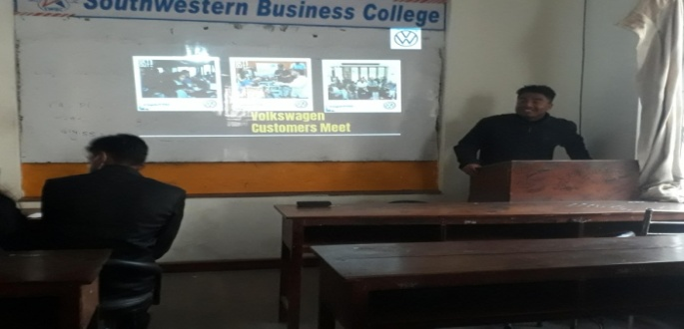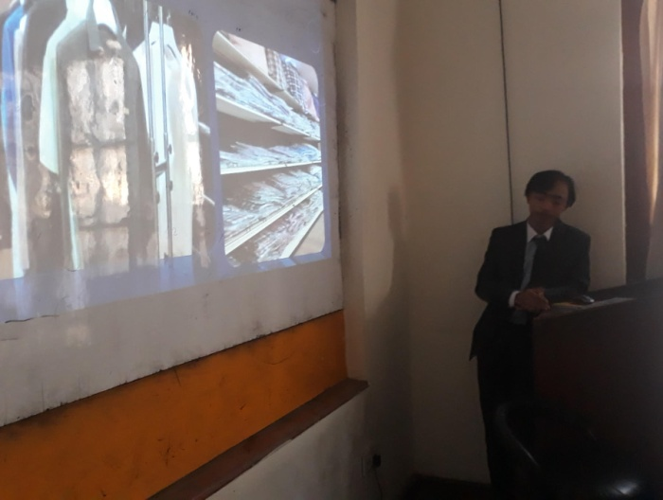

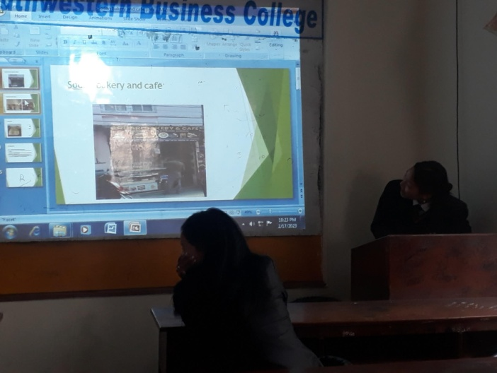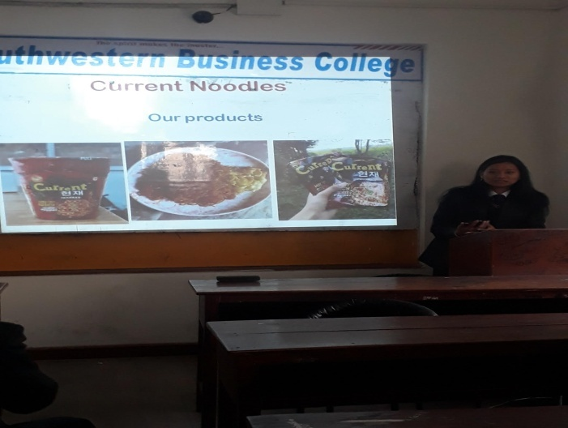
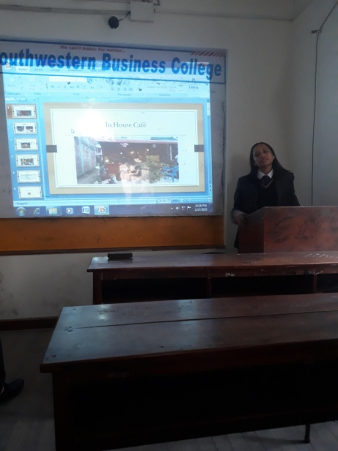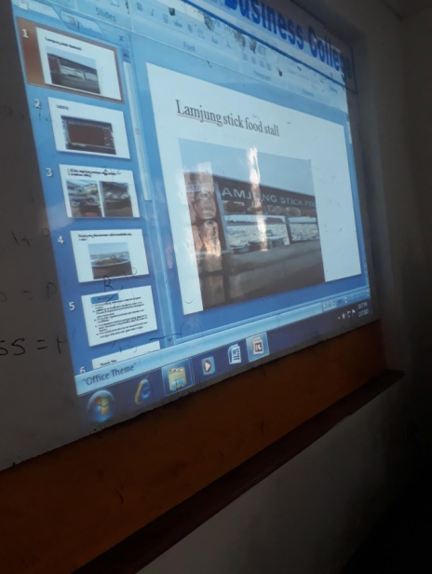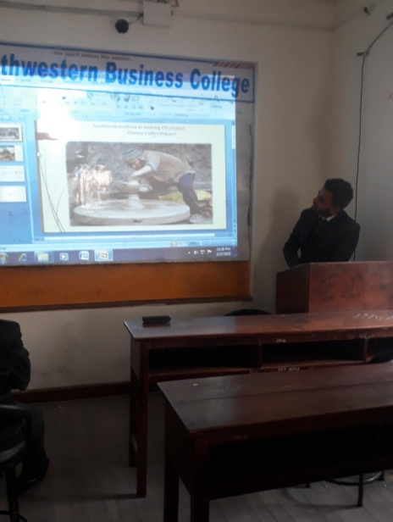
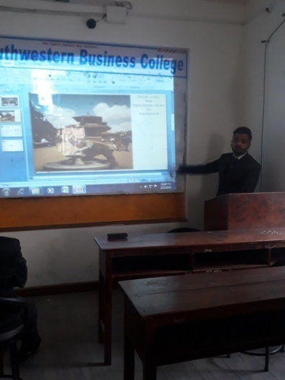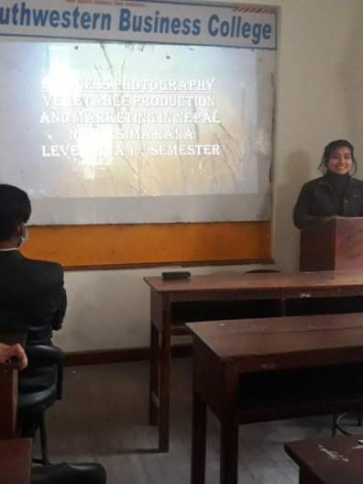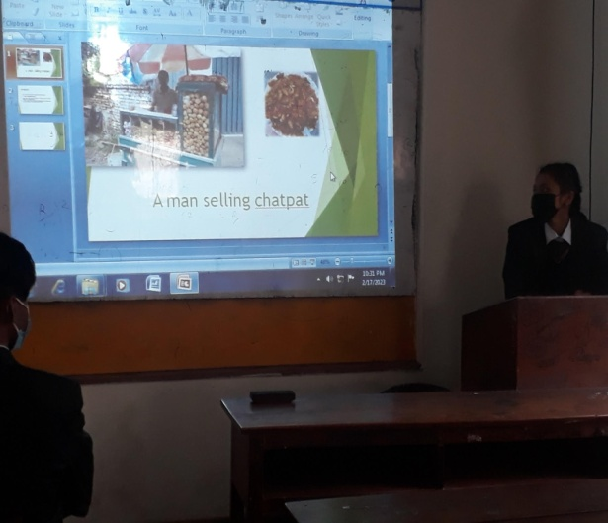

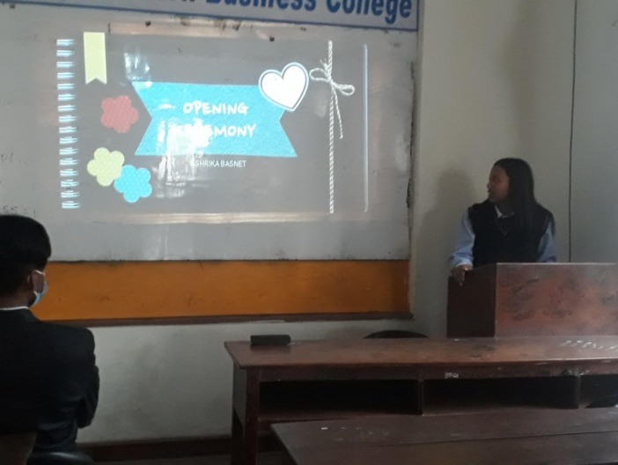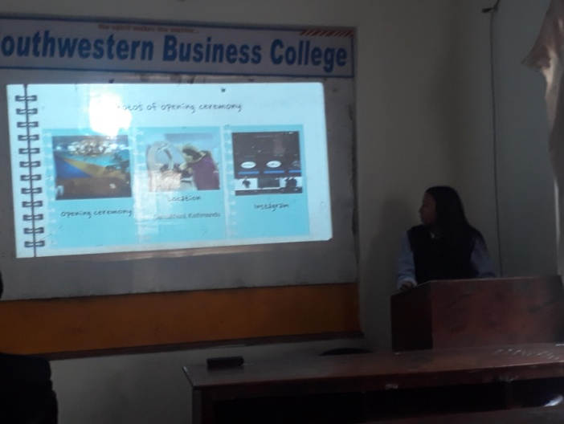

VC College Visit: 13th Falgun 2079; 25th February 2023
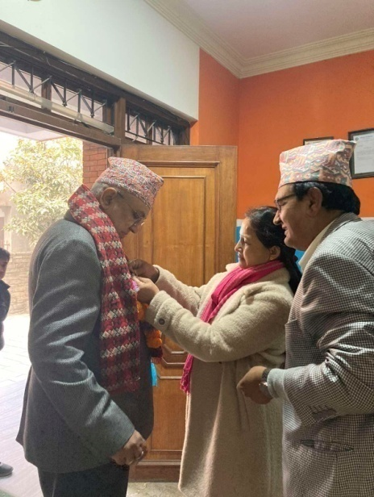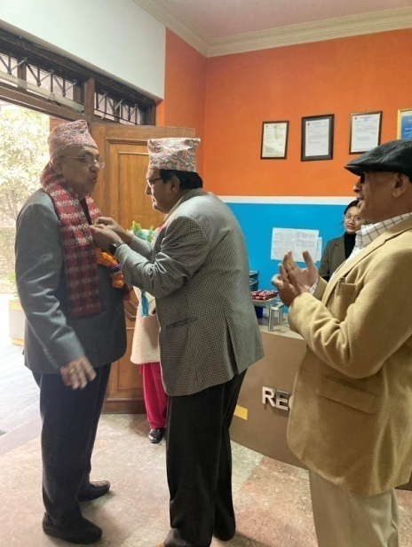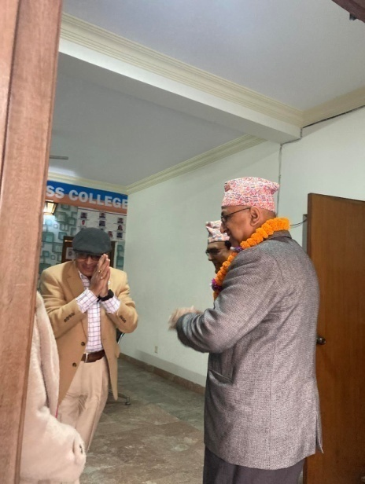
We are so grateful to our highly respected VC Prof Dr. Yadav Raj Koirala who took out his very precious time to make a visit to our College, and took the understanding of the current situation. We have taken such an exceptional visit as our good luck!
OUR GRATITUDE to our VC Sir: We, all the family members of Southwestern, appreciate your gallantry in addressing various academic concerns of prime significance. Now, we have a renewed sense of Hope and Aspiration! Thank you so much!

